Town of Middleborough, MA

COMMUNITY DEVELOPMENT PLAN
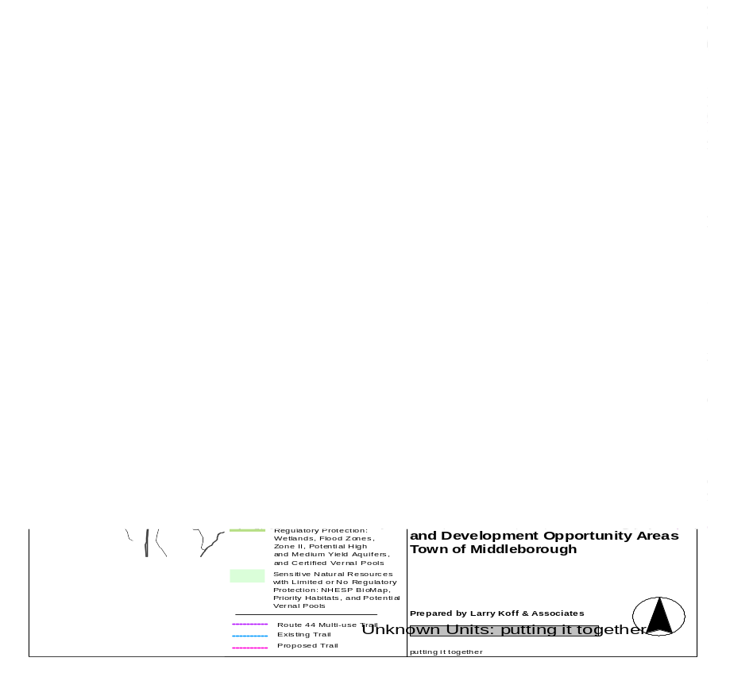

June 7, 2004

Town of Middleborough

John F. Healey, Town Manager
Ruth M. Geoffroy, Town Planner
Bruce M. Arons, Director OECD

Larry Koff & Associates

This project was funded by a 418 Community Development Grant awarded by the Executive Office of Environmental Affairs, the Department of Housing and Community Development, the Department of Economic Development, and the Executive Office of Transportation and Construction with assistance from the Southeastern Regional Planning and Economic Development District.
TABLE OF CONTENTS

Page

Putting It All Together: Implementation Strategies 1
I. Introduction 2 3
II. Building Blocks for a Community Development Plan 2
Putting It All Together: Action Plan Map 8

Housing Plan 9 9
I. Housing Supply Inventory 9
II. Needs Analysis 17
III. Goals and Objectives 26
IV. Implementation Strategies 33
Housing Opportunities Map 37

Economic Development 38
Executive Summary 38
I. Economic Profile 40
II. Needs Assessment 46
Topic 1: What mix of jobs would best meet the needs of local residents? 46
Topic 2: What land use mix is needed to retain fiscal balance? 52
Topic 3: How much commercial growth is feasible? 58
Topic 4: Issues and Opportunities: Where can/should economic growth go? 63
III. Vision and Goals 66
IV. Recommendations 68
Existing and Proposed Commercial Opportunities Areas Map 72

Appendices 73
1. EOEA Buildout Analysis 73
2. Middleborough Zoning Summary 74
3. EO 418 Profile for Middleborough 76
4. Grant Programs Subject to Executive Order 418 77
5. Standards for Housing Affordability 78
6. EO 418 Strategies to Develop Affordable Housing 79
7. Chapter 40B Sample Development Evaluation Checklist 85
8. Checklist of Affordability Issues Under Chapter 40B (Includes Use Restrictions) 86
9. Chapter 40B Guidelines for Planned Production Regulation 89
10. Local Initiative Program Guidelines 92
11. Chapter 40B Sample Development Evaluation Checklist 94
12. Housing Questionnaire 96
13. Housing Demand Analysis 98
14. Additional Economic Profile Data 99
15. Lodging Properties in Plymouth County 101
16. Regional Competition for Development 102
17. Tax Incremental Financing Guidelines, Town of Middleborough 104

Additional Maps 105
Vision Plan: Resource Protection, Trails, Development Opportunity Areas 105
Future Land Use Under Existing Zoning 106
Maps, continued
Land Use 107
Land Use Suitability 108
Zoning 109
Core Habitat Areas 110
Water Resources 111
Water Lines 112
Existing Sewer Lines 113
Regional View 114
Members of the Planning Board

Barry T. Heidke, Chairman

Patrick J. Gaughan, Clerk

William B. Garceau

Paul Colarusso

David J. Maddigan, Jr.

Members of the Housing Committee

Bruce Arons

Bruce Atwood

Paul Colarusso

Darren DeGrazia

Karen Gallipoli

Ruth M. Geofrroy

Jack Healey

Stuart Kirsch

David Maddigan, Jr.

Eddie Medeiros

Patrick Rogers

Neil Rosenthal

Linda Vintro

Jonathan White
“PUTTING IT ALL TOGETHER”: ACTION PLAN

Introduction

The following Community Development Plan was prepared under the direction of John Healey, Town Manager, Ruth Geoffroy, Town Planner, and Bruce Arons, Director of Office of Economic and Community Development. The Town’s Housing Committee and Planning Board participated in a review of the plan elements.

The planning process was initiated with a review of the Middleborough Master Plan, Findings and Alternatives. In addition a land use suitability analysis of resource areas as well as areas suitable for residential and commercial development was carried out. A network of trails and open spaces and areas for new residential and commercial development was suggested. This analysis was presented in the Map: Vision Plan: Resource Protection, Trails, Development Opportunity Areas

Two separate community Development Plan elements were subsequently prepared, Housing and Economic Development. These reports provide a profile of relevant background information, an analysis if critical needs, issues and opportunities, a vision and goal statement and an implementation strategy to achieve the stated goals.

The following section, “Putting It All Together” serves as an Executive Summary. The results of this community development planning process are presented. An Action Plan Map highlights the priority areas for housing and economic development.

Building Blocks for a Community Development Plan

The Town of Middleborough’s capacity to manage resource protection, housing, economic development, and fiscal balance is at a crossroads. Regionally oriented commercial and residential development along Route 44, residential subdivisions in the town’s rural agricultural areas of Thompson Street and increasing sprawl of residential and lower quality commercial uses along Route 28 threaten the town’s natural resources, rural landscape and capacity of the town to properly maintain basic municipal services and infrastructure. This section of the Community Development Plan, “Putting It All Together,” lays out a series of five key building block strategies for the various Boards and Committee to address. Working together, the residents can find solutions to the current problems with the same level of confidence and imagination symbolized in the historic and now restored Town Hall.

1. Recodify the existing zoning bylaw and rewrite subdivision regulations.
Regardless of the proposed zoning changes which the Boards will consider, the existing Zoning Bylaw and Sub-division regulations need to be recodified. In their current form, residents and investors are discouraged from undertaking new projects in the community because these regulatory documents are disorganized and difficult to navigate. Unnecessary staff and Board time is devoted to their interpretation. Recodifying the zoning bylaw and subdivision regulations will up-date these documents so that they conform to current State regulations, eliminate inconsistencies, incorporate all the previously passed amendments into a new text, present the town’s bylaw and sub-division regulations in a manner which can be readily understood by the public, and incorporate any new zoning such as an Affordable Housing Overlay District.

Neither the Planning Board nor the Board of Selectmen alone can initiate this recodification effort. A joint undertaking must begin with first revising the current outdated bylaw and subsequently drafting new zoning for priority zoning districts. As part of this process, the Planning Board will also be able to up-date the current sub-division regulations.
2. Reconstitute the Housing Committee and the Business & Industrial Commission.
The Town of Middleborough should formally reconstitute two citizen committees, the Housing Committee and the Business and Industrial Commission (B&I), in order to provide public oversight in addressing the needs for affordable housing and the adoption of an economic development strategy.

While the Housing Committee has provided sufficient leadership to generate the proposed Affordable Housing Plan, its status is uncertain and lacks staff support. A permanent committee is needed with planning and community development staff support to ensure that these draft recommendations are discussed, refined, and adopted.

Creating and carrying out economic development policy is an equally challenging assignment. The shape of this structure will depend upon the economic development priorities established by the Board of Selectmen.

The first priority should be to establish public consensus with respect to housing and economic development next steps. This will require a joint effort by the existing Housing Committee and B&I Commission, the Town Planner, the Director of the Office of Economic and Community Development (OECD), and the Town Manager. Under this scenario, the Housing and B&I Committees would be reconstituted so that they could initially jointly work on this task.

Two subsequent priorities might be established which would impact the future committee organization; the establishment of a Downtown Affordable Housing Overlay District and the development of a public Southpointe Industrial Park. If these are determined to be the first two priorities, then a committee structure will need to be organized to address these concerns. Under this scenario, the role of the Housing Committee would be assumed by the Planning Board as rezoning would be the priority. If, on the other hand, the Housing Committee is to take a more active role in reviewing 40B and Local Initiative projects and submitting a 40B Affordable Housing Plan, then a permanent Housing Committee will be need to be formed.

If the establishment of a Southpointe Industrial Park is to become the town’s economic development priority, then this would require a much more focused organization than the B&I. If this is not the priority, then several additional options are possible. A proposal has been prepared to create a combined OECD and Middleborough Industrial Development Finance Authority. This organizational structure would require the Town to commit to the formation of a more fully staffed office of Housing and Community Development. A third option would be to incorporate marketing and promotion activities into the current OECD dedicating some of the hotel tax to fund this initiative. A fourth option would be to combine the planning and community development departments and provide the staffing needed to address housing and economic development activities. The Planning Board would, under this scenario, have a clear mandate to address community development planning issues in addition to permitting development activities.

Without these suggested funding and organizational changes and the delegation of responsibility to new organizational forms, the recommendations contained in this report will continue to languish.

3. Establish public consensus with respect to priority areas for housing and economic development; Prepare new housing and economic development zoning districts.
The Action Plan map identifies 11 new zoning districts which the town should consider as a vehicle for organizing growth: four commercial, five mixed use and two residential. The commercial and mixed use districts would replace, for the most part, the GU district. In addition, new districts are proposed for the Route 44 Corridor and the Thompson Street Agricultural area. Table 1 summarizes the district types, existing zoning, and the proposed vision. A number of these districts are mapped in more than one location as identified in the parentheses following the district identification below.

New/Modified Commercial Districts
- Highway Commercial Development Area (4 locations)
- Development Opportunity Area (2 locations)
- Agriculture (1)
- Tourism Study Area (1)
New Mixed Use Districts
- Downtown (1)
- Retail/Service/Residential (2)
- Village Center/Retail Focus (3)
- Live/Work Space Estate Areas (1)
- Affordable Housing Overlay (1)
New Residential Districts
- Historic Village (4)
- Transferable Development Rights Village (2)

The Planning Board supported by the Selectmen and Town Meeting need to establish a unified vision for how and where new growth would be accommodated. The establishment of these districts would represent both a codification of current policy as well as the establishment of new land use policies

A starting point would be to build consensus around a vision for those priority areas for new development. The Affordable Housing Target Area is a first step for accommodating residential growth. This concept now needs to be formalized in new zoning. A similar priority area(s) needs to be established for economic development. A number of possible options have been suggested in the Economic Development element and are identified again in this section.

A broad public process of education is also needed at this preliminary stage. A dialogue needs to be undertaken to discuss the needs for and opportunity areas for affordable housing and economic growth.

4. Broaden staff and funding support for carrying out housing and economic development programs.
Without the additional coordination and funding support from the Board of Selectmen and Town Meeting, the recommended planning and community development program activities cannot be carried out. Current Planning Department and OECD funding levels do not adequately support a planning staff. The town needs to dedicate and/or supplement existing review fees and hotel tax revenues now going to General Revenue for the purposes of economic development planning.

The Planning Department and OECD are two distinct departments; the latter primarily secures grants and does not receive any Town financial support. This Office is financially separate from the Town administrative structure. The staff administers the housing and community development grants which it is able to obtain. The Office is able to provide limited community development planning services at no cost to the town.

The hotel tax which in FY 2003 amounted to $141,131 now, unlike most towns, goes directly into General Revenue. Because this is a stream of revenue, it could be used to fund a tourism and economic development marketing program, planning, land acquisition or infrastructure improvements.

As with economic development, the Town of Middleborough makes a marginal contribution to supporting planning activities in the Planning Department. The Town limits department funding to the staff needed to review residential and commercial sub-division and development plans. About 85% of the current department budget is covered by the review fees charged developers. These fees are deposited into the General Revenue account and the town makes only a minor contribution to supplement these fees in order to support Planning Department staff salaries.

Additional funding for planning is needed beyond that which may come from review fees, grants and negotiated development agreements. One option is for these two departments to continue functioning separately, in which case the OECD would need to seek additional grants and to receive financial support from the town to carry out the recommended housing and economic development activities. The Town could dedicate some proportion of the Hotel Tax to economic development planning activities. It might also be possible, as in Taunton, to utilize the services of SRPEDD to obtain staffing support for the preparation of grants leading to the development of a public industrial park.
Another option is to fund a staff position in the Planning Department to carry out planning activities. Grants may be available to support some of the needed technical support such as recodifying the zoning bylaw. The Town may need to supplement these grants. A third option is to combine the two departments and provide sufficient funding to adequately staff these responsibilities. Again, the Hotel Tax could be utilized for this purpose.

The critical issue is whether the Selectmen can provide the leadership in identifying the priority tasks and subsequently in obtaining Town Meeting support for needed changes in funding and organization to support housing and economic development planning.

5. Adopt policies and incentives to govern housing and economic development
The Board of Selectmen has adopted an Affordable Housing Policy Statement. In order to qualify as an Affordable Housing Action Plan which will allow the Town to deny 40B permit applications for a one or two year period, the Housing Committee with the support of the Planning Board must make additional refinements to this plan and have it adopted by the Board of Selectmen. This plan can then be reviewed and submitted to DHCD.

In similar fashion, the Board of Selectmen, working with an Economic Development Committee, need to identify an Economic Development strategy which confirms needs, priority locations, and incentives. The proposed economic development plan has also suggested a number of policies which should be discussed and refined:
- Tax Increment Financing (TIF) and District Improvement Financing (DIF)
- Balanced land use/Split Tax Rate
- Water and Sewer service to industrial areas
- Agricultural Protection
- Streamlined Permitting

The subsequent reorganization and funding of the housing and economic development activities will determine the extent to which the town can address the preceding concerns.
Table 1, Housing and Economic Development Districts: Existing and Proposed

Location |  | Existing Zoning | Proposed Zoning | Vision
1 | Downtown | B, RB | Mixed Use Business/  Residential | Downtown with mix of single family and multifamily residential; retail with residential uses above; commercial and institutional uses  Downtown overlay to encourage affordable housing, infill housing, greater densities.
2 | Route 28/Downtown West | General Use | Highway Oriented Mixed Use | Highway oriented commercial and multifamily residential; buffers, shared parking, shared curb cuts, pedestrian connections to Downtown; bonus for inclusion of affordable housing
3 | Route 44/Route 18 Rotary | General Use, Development Opportunity District | Highway Oriented Commercial | Highway oriented commercial, hospitality, retail
4 | Downtown Affordable Housing Study Area | Business, General Use, Residential Business | Mixed Use Business/  Residential | Downtown overlay to encourage affordable housing, infill housing, greater densities
5 | DOD, North | Development Opportunity District | Campus Industrial/  Commercial | Planned, campus style industrial park; office, light manufacturing, warehouse, with accessory commercial
6 | North Middleborough  Historic Village | RA | Village Ctr./ Residential | Adopt a Historic District Overlay to promote flexible, village type zoning within existing Historic Districts
7 | Warrentown Historic Village | RA | Village Ctr./ Residential | Adopt a Cluster Zoning Overlay to promote flexible, village type development
8 | The Green Historic Village | RR,  WRPD #2, #3 | Village Ctr./ Residential | Adopt a Cluster Zoning Overlay to promote flexible, village type development
9 | Eddyville Historic Village | RR | Village Ctr./ Residential | Adopt a Cluster Zoning Overlay to promote flexible, village type development
10 | Agricultural District (Thompson Street) | RR | Agriculture | Adopt an overlay district which will provide through Transfer of Development rights and other measures a strategy to preserve agriculture land.
11 | Oak Point Village | RR  (Rural Residential) | Village Ctr./ Residential | Through zoning change, allow the development of neighborhood servicing commercial uses
12 | Tourism Study Area (Route 44–Everett St. to Plymouth St.) | RA | Planned Development Area | Encourage large scale use which could preserve and protect resource areas concentrating tourist/convention orientated facilities on upland portion of site
13 | Route 44/Everett St. | GU RA | Highway Commercial | Business services
14 | Route 44/Plymouth St. | RA, RR | Highway Commercial | Quality R&D office park, large scale commercial uses, and retail uses in a planned campus setting
15 | Route 28/Downtown Southeast | General Use | Highway Oriented Mixed Use | Highway oriented commercial and multifamily residential; buffers, shared parking, shared curb cuts
16 | Route 28/Rock Village | General Use, GUX, WRPD Z 2 | Village Center/Retail | Create a new residential/business zoning district for village centers (Rock Village and South Middleborough) that allow for a mix of commercial and residential uses. Allow for a Planned Unit Development (PUD) within these areas.
17 | Route 28/Wareham Street | GUX | Highway Commercial | Larger scale commercial uses, retail, and support services
18 | Route 28/South Middleborough | GUX | Village Center/Retail | Create a new residential/business zoning district for village centers (Rock Village and South Middleborough) that allow for a mix of commercial and residential uses. Allow for a Planned Unit Development (PUD) within these areas.
19 | DOD, South (Routes 495/28) | GUX, GUA | Campus Industrial/  Commercial | Planned, campus style industrial park; office, light manufacturing, warehouse, with accessory commercial
20 | Taunton River Live/Work Space | Industrial | Live/Work Space | Estate lots for environmentally sensitive live/work space
21 | TDR Village | GU, RR | Residential Village | Allow higher density village setting housing in exchange for acquisition of development rights within Agricultural District



HOUSING ELEMENT

Housing Supply Inventory
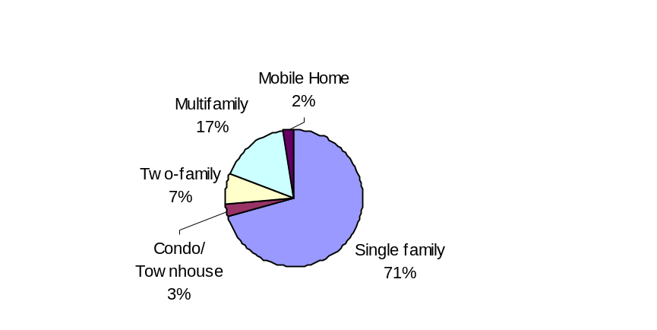
HOUSING INVENTORY
Figure 1, Housing Types, 2000
According to the U.S. Census, there were 7,249
housing units in Middleborough in 2000, an increase
of 1,061 units since 1990. The distribution of units
by types is shown in Figure 1.

The town’s housing stock is relatively young;

Over half of the homes were built after 1960.

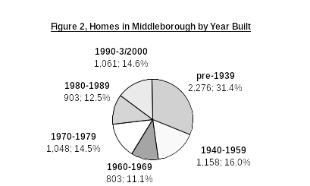
- 74% of the units are owner occupied, while 26% of the units are renter-occupied. (2000 U.S. Census).
- Middleborough has a relatively high rate of construction in recent years, trailing only Plymouth in the number of average building permits issued. Although the Town issued permits for a small number of condos and two-family structures, this is not reflected in the average. The majority of building permits continue to be issued for single family homes, and recently for mobile homes.
- Construction of owner-occupied housing was higher than for renter-occupied housing throughout the past decade; the number of building permits for single family homes was considerably greater than those for multifamily units.
Table 1, Regional Housing Growth, 1996-2001

Municipality | Bldg. Permits/ Year | Total Units Permitted/ Year*
Bridgewater | 114 | 116
Carver | 42 | 42
Lakeville | 72 | 72
Middleborough | 147 | 183
Plymouth | 295 | 312
Raynham | 74 | 76
Wareham | 86 | 90
*Includes multi-unit buildings

- 1,224 mobile homes have been permitted for construction in Oak Point and Edgeway. To date, 442 homes have been completed. When these developments are built out they will represent about 13% of the town’s total housing stock. These units are all age-restricted.

Table 2, Middleborough Housing Growth

 | 1990 | 1991 | 1992 | 1993 | 1994 | 1995 | 1996 | 1997 | 1998 | 1999 | 2000 | 2001 | 2002
Single Family units | 53 | 70 | 103 | 78 | 106 | 97 | 85 | 62 | 81 | 97 | 103 | 115 | 96
Multifamily units | 12 | 4 | 16 | 12 | - | - | - | - | - | - | - | 2 | 13
Mobile Homes |  |  |  |  |  |  |  |  |  | 91 | 111 | 134 | 106
Total Units | 113 | 87 | 125 | 90 | 106 | 97 | 85 | 62 | 81 | 188 | 214 | 251 | 215
Source: SOCDS Building Permits
HOUSING COST
The average assessed value of all single family homes in Middleborough in FY2001 was $173,688. The 2000 U.S. Census reports the median value for owner-occupied housing units to be $159,200.

In 2002 there were 463 properties sold in Middleborough, including 216 single family and 34 condominium residences. The median sales price for single family homes was $229,500, while the median sales price for condominiums was $176,200. Home prices have been rising steadily over the past five years, with a 70% increase between 1998 and 2002 for single family homes, and an increase of 78% for condominiums.

The 2000 Census reported average rent for all apartments was $680. This figure is typically lower than the going rate, because it includes many households who pay below market rent. Currently, one-bedroom apartments typically rent for $1,000/month, while the average rent for a two-bedroom is approximately $1,200/month. The “fair market rent” that HUD currently allows for housing vouchers is $809 for one bedroom units and $993 for two bedroom units, including utilities.

There were 96 new single family homes, 13 condominiums, and 106 mobile homes constructed in FY2002. Through July of 2003, building permits for 41 single family homes and 96 mobile homes have been issued. Local realtors report the average selling price of new single family homes is just under $300,000.

Local realtors have estimated that the vacancy rate is low; at any given time, there is an average of 23 homes on the market, and homes stay on the market for an average of 40 days. The 2000 U.S. Census reports the vacancy rate to be 3.7%; the homeowner vacancy rate is 0.5% and the rental vacancy rate is 4.3%. This low vacancy rate and the increases in local and regional employment contribute to the escalating sales and rental prices described below.

Affordable/Subsidized Housing Units
- Middleborough has one of the highest percentages of affordable (subsidized) housing units of any of the neighboring communities, only trailing Raynham and Wareham.
- According to the standards set by Massachusetts Chapter 40B, Middleborough should have 720 subsidized housing units, or 10% of the number of permanent residences counted in the 2000 census. Unfortunately, this standard does not credit the town with having provided affordable unsubsidized homes.

Table 3, Comparison of Affordable Housing Availability*

 | Ch. 40B Units | Total Units in 2000 | % total units
Bridgewater | 206 | 7,639 | 2.70%
Carver | 76 | 4,063 | 1.87%
Lakeville | 8 | 3,385 | 0.24%
Middleborough | 302 | 7,195 | 4.09%
Raynham | 197 | 4,197 | 4.69%
Wareham | 477 | 8,650 | 5.51%
*Does not include Section 8 Mobile Vouchers or Massachusetts MRVP vouchers
Source: State Department of Housing and Community Development
- Moreover, the 1,200+ mobile homes that have recently been constructed or are under construction will all count towards the town’s total housing stock, but are contrarily disqualified from gaining affordable housing status because they are not considered “permanent”. These homes are currently priced in the range of $220,000 to $240,000, which is affordable to families earning approximately 100% of median income. This will substantially set the town back in terms of meeting the 10% affordability standard, while the town lacks the option to ask the developers to set aside units for low and moderate income households.

Middleborough has a total of 302 units of subsidized housing (units considered to be affordable under Chapter 40B), or 4.1%. An additional 418 units of 40B housing is needed to attain the 10% requirement.

Table 4, Middleborough Chapter 40B Subsidized Housing Inventory

Name | Address | Funding Agency | 40B Units | Year End
Archer Court | Archer Court | DHCD | 28 | perp
 | Frank/Park/Sprout | DHCD | 40 | perp
 | Off Sproate & Maple | DHCD | 50 | perp
Riverview | 8 Benton St. | DHCD | 64 | perp
 | Woodland Ave. | DHCD | 8 | perp
12 South Main St. | 12 South Main St. | DHCD | 7 | 2021
15 Centre St. | 15 Centre St. | DHCD | 7 | 2020
ARC of Greater Fall River | Pierce Lane | EOEHHS | 4
East Grove St. Apts. (Striat Apts.) | 158-160 East Grove St. | RHS | 8 | 2004
Middlebury Arms | 89 East Grove St. | MFHA | 64 | 2018
Oak Street Apts. | 101-103 Oak St. | RHS | 8 | 2000
Section 8 Mod Rehab |  | DHCD | 3
Windsor Village | 23 Taunton St. | DHCD | 3 | perp
Graystone Estates |  | New England Fund | 8 | perp?
Total |  |  | 302
Source: Massachusetts Department of Housing and Community Development

The Middleborough Housing Authority owns three housing complexes that contain Chapter 40B housing: Riverview, a 64-unit complex funded under Section 8 new construction; 8 special needs units (4 female and 4 male) at Woodlawn; and Archer Court, a 14 two-bedroom and 14 three- bedroom Veterans Family Housing complex. The Housing Authority also owns Nemasket, a 90-unit elderly/disabled housing development funded under DHCD’s Chapter 667.

Applications to be placed on the waiting list for Housing Authority units are accepted on a rolling basis, and the list is purged every few years. When units become available, preference is given to Middleborough residents, people residing in shelters, or who have other criteria. Approximately 165 applicants are currently waiting for the 28 family housing units, 22 of which are residents of Middleborough. (Separate waiting lists are kept for the two and three bedroom units.)

Additionally, Middlebury Arms, which is not run by the Housing Authority, contains 64 one, two, and three bedroom units. According to the Middleborough Housing Authority, there are at least 66 people on the waiting list for these 154 units of elderly housing, of which 13 are Middleborough residents.

The major privately owned subsidized housing development comprises 154 units and is funded by a Section 8 Rental Assistance program. Section 8 certificate holders, of which there are approximately 160 administered by the Middleborough Housing Authority, are not counted in the Subsidized Housing Inventory. Moreover, the development of the Oak Point senior mobile housing park, when completed, will have added 1,150 households and approximately 1,920 residents. These units are all affordable to middle-income families (see definition of middle income on page 11), but do not count toward the 40B inventory.

REGULATORY AND PHYSICAL ENVIRONMENT
Existing Development
- The Town of Middleborough is a rural community. Approximately 13% of the land area is developed for low density single family homes, mostly on 20,000-80,000 square foot lots. Less than 2% of the Town is developed for industrial and commercial uses.
- Middleborough was originally settled with small clusters of “villages” or hamlets, each with its own name and history. Some of these villages were substantial, containing a mixture of commercial, residential, and rural uses, while others were simply a concentration of farms and residences. The remnants of this scattered pattern of clustered settlements are visible in many locations today, although in many cases their identities are threatened by more recent development which does not correspond to historic patterns.
Historic villages include Titicut Green (or North Middleborough Green), centered at the intersection of Pleasant and Plymouth Streets; Eddyville, centered at the intersections of Plympton, Cedar and Carmel Streets; Waterville, located along Plymouth Street between Carmel and Wall Streets south of Route 44; Middleborough Center; Rock Village, located along Miller and Smith Streets in the southern part of Middleborough; and The Green, located at the intersection of East Main Street and Plymouth Street. South Middleborough, located further to the south at Wareham and Locust Streets, has the elements of a village but not the historic resources that the other villages have (1989 Historic Preservation Plan).
- The topographical and geological history of Middleborough has resulted in small upland areas used for farming, housing, and commercial development and large tracts of lowlands containing swamps, wetlands, ponds, bogs, and major lakes. The Town contains a large amount of preserved land, including the Rocky Gutter Wildlife Management Area, the Assowompset Pond complex, and land along the Taunton and Nemasket Rivers.
- Route 28 was once an important connector road to Cape Cod, which spurred business development along this road; the building of major regional highways such as Routes 495 and 44 currently support regional accessibility and economic development. The commuter rail connection to Boston has also enhanced Middleborough’s accessibility. These highways and rail have fostered a concentration of commercial development along interchanges and highways and encouraged the development of subdivisions.
- While the table below identifies 77% of the town land area as undeveloped, much of the area is not developable because of environmental constraints or restrictions (i.e., wetlands). Moreover, 6,684 acres of undeveloped or agricultural land are protected through government ownership or conservation restrictions. 972 acres of agricultural land classified under Chapter 61, Chapter 61A or Chapter 61B are not permanently protected. Some open space parcels owned by private individuals or organizations may also be vulnerable to future development if they do not have permanent development restrictions, even if the owner currently intends to preserve them as open space.

Table 5, Existing Land Use

Land Use Category | Area (Acres) | % of Town Area | % of Developed Area
Residential (Single Family) | 5,707.54 | 12.72 | 69.02
Residential (Multifamily) | 68.41 | 0.15 | 0.83
Commercial | 326.13 | 0.73 | 3.94
Industrial | 332.68 | 0.74 | 4.02
Public/Recreation | 592.26 | 1.32 | 7.16
Transportation/Utilities | 1243.13 | 2.77 | 15.03
Total Developed | 8270.16 | 18.43 | 100.00
Agriculture | 2792.89 | 6.23
Vacant | 31,892.37 | 71.09
Total Undeveloped | 34685.26 | 77.32
Water | 1904.07 | 4.25
Total Town Area | 44,859.49 | 100.00
Source: MassGIS, from Aerial photography

Zoning
The Town of Middleborough has three exclusively residential districts, and three general use districts which allow residential uses as well as non-residential uses. A summary of allowed uses and density restrictions for both residential and nonresidential uses is provided in Appendix 2.

Residential
Residence A | RA
Residence B | RB
Residence Rural | RR

General Use
General Use | GU
General Use District A | GU-A
General Use District X | GU-X

Nonresidential
Business | BD
Industrial | I

Overlay Districtss
Development Opportunities District | DOD
Open Space and Resource Preservation Development District
Flood Plain District
Water Resource Protection District | WRPD
Adult Entertainment District

Single family homes are permitted in all of the residential districts, as well as the general use districts. Minimum lot sizes for residential districts range from 20,000 square feet in RB, to 60,000 square feet in RA, to 80,000 square feet in RR. Within the WRPD Zone 2, the minimum lot size is 60,000 square feet.

New multifamily units may be created in the GU and GUX districts, with a minimum lot size of 30,000 square feet per unit in the General Use District and 40,000 square feet in the General Use X District. Multifamily units may also be created through the conversion of single family homes to up to three units within the Residence and General Use Districts, and the creation of dwelling units in upper floors of pre-existing buildings in the Business District.

Age restricted mobile home parks are allowed by special permit in the RR District and General Use Districts. A minimum of 20 acres is required, and the number of homes cannot exceed two units per acre. Each unit is required to have a minimum of 10,000 square feet, and an additional 10,000 square feet per unit must be set aside as common area.

The Open Space and Resource Preservation Development Overlay District allows for an alternative to conventional subdivision within the RA, RR GU, and GUX Districts. (Although stated as an overlay district, its area is defined as the entire area within these zoning districts.) A minimum of 5 acres is required. All dwelling units must be detached single family homes. The number of buildings may not exceed the number of lots that could be constructed with a conventional subdivision. The minimum lot size is 30,000 square feet, while 40% of the land area must be set aside as open space.

- Over 84.2% of Middleborough is zoned for residential uses; including 15.5% in RA, 3.1% in RB, and 65.6% in RR. In addition, 14.3% of the town is zoned for mixed residential and commercial use, in the GU, GUA, and GUX districts.
- The BD, which comprises only 0.2% of the Town, is located in the downtown, and is mostly built out. The Industrial district, which comprises 1.4% of the town, does not allow residential uses of any type, although most pre-existing development is residential, and the area is inappropriate for most types of development.
- In the DOD, which overlays areas in the RA and GU districts, parcels with 10 acres or more may be developed as commercial/industrial parks. Currently the town has three such industrial developments which were converted from residential zoning.

Buildout Analysis

In 1999, EOEA oversaw the preparation of a buildout analysis for the town of Middleborough. This exercise provides an estimate of what might result if all of the remaining land in town were developed under existing zoning regulations. The potential for redevelopment of underutilized properties, or development that does not conform to zoning is not accounted for. The buildout analysis estimated that a total of 10,588 dwelling units could be created, only 5% of which might be two-family, with the remainder single family. (The distribution between single family and two-family development is based upon an assumption of market conditions, rather than zoning requirements.) Given an average household size of 2.86, the population could grow by an additional 30,280 residents or a total population of at least 50,220 persons.
A buildout analysis provides an estimate of what might result if all of the remaining land in town were developed under existing zoning regulations. The potential for redevelopment of underutilized properties, or development that does not conform to zoning is not accounted for.

Table 6, Summary of Buildout Capacity

Zoning District | Single Family (d.u.) | Multifamily (d.u.) | Total (d.u.) | Commercial/ Industrial (sq. ft.) | Potential Employees
Residence A | 2,097 | - | 2,097 | 2,442,806 | 6,107
Residence B | 699 | - | 699 | - | -
Residence Rural | 6,271 | - | 6,271 | - | -
Business | - | - | - | 118,299 | 296
Industrial | - | - | - | 4,262,082 | 4,262
General Use | 614 | 328 | 942 | 12,156,136 | 30,390
General Use X | 430 | 149 | 579 | 12,395,018 | 30,988
Total | 10,111 | 477 | 10,588 | 31,374,341 | 72,042
*d.u. = dwelling unit
Note: Potential employees based on 1 employee per 400 square feet for commercial use and 1 employee per 1,000 square feet for manufacturing/warehousing uses.
Source: EOEA Buildout Analysis, 1999

The buildout analysis also finds the potential for an additional 31.4 million square feet of commercial and industrial space. This could provide jobs for about 72,042 new employees, who need to have residence in and around Middleborough.
Table 7, Summary of Buildout

Buildout Impact
Additional Residents | 30,387
Additional Students (K-12) | 5,908
Additional Residential Units | 10,588
Additional Developable Land Area (acres) | 21,254
Additional Commercial/Industrial Buildable Floor Space (sq. ft.) | 31,374,341
Additional Water Demand (gallons/day) | 4,632,066
Residential | 2,278,990
Commercial and Industrial | 2,353,076
Additional Solid Waste (tons/year) | 15,588
Recyclable | 4,497
Non-recyclable | 11,091
Additional Roadway (miles) | 90

This analysis does not give any indication of the rate of development or the time frame for reaching full buildout. It is likely that residential zoning districts will be built out in a much shorter time frame than commercial and industrial districts, especially given the household projections for 2020.

Is the Buildout Analysis Accurate?
The methodology for completing a build-out analysis is necessarily abstract.
- Land is often identified as developable which could not support new development
- However, especially as communities approach their full development capacity, they often experience increases in density which are not accounted for in the build-out analysis, through infill development, redevelopment, Comprehensive Permits, and zoning changes.

An alternate buildout scenario was considered by the town, taking into account the potential for development beyond what is allowed by zoning. If 25% of all new development is done under Chapter 40B and each project provides 25% affordable units with a density bonus of 400% (typical of recent development trends), then at full buildout the total dwelling units would reach 25,000, with a population of 72,900. This would provide approximately 10% affordable units.

Barriers and Development Context
Middleborough is adjacent to Interstate 495 (State Route 25), State Routes 28, 18, 79, and 105, as well as U.S. Route 44, which connects Plymouth with Providence, Rhode Island. The community is located on the Middleborough commuter rail line to South Station in Boston, which runs to Lakeville right on the Lakeville/Middleborough border. The Bay Colony Railroad (BCRR) and Conrail provide freight rail service and interchange traffic to the Town. Additionally, Middleborough is a member of the Greater Attleboro-Taunton Regional Authority (GATRA), which provides Dial-A-Ride service to the elderly and disabled. Bay State Commuter Lines, provides commuter bus service to Boston. These transportation enhancements, the large amount of land available for development, and a relatively affordable housing market make Middleborough an attractive location.

Middleborough does not contain a widely varied housing stock, as most of the housing is single family homes. There is only one market rental housing development of over 50 units, Talbot Woods, although there are two and three family rental units and condos in the downtown area. Outside of the downtown, most of the town does not have sewer service.

The Land Use Suitability map identifies those areas of town which are best suited for various types of land uses. For purposes of analysis, the town can be divided into areas with development potential and areas with barriers to development. Areas with development limitations (barriers) include those natural resource areas with regulatory protection, i.e., wetlands, flood zones, Zone IIs, and potential high and medium yield aquifers. Resource areas with limited or no regulatory protection are shown in pink and include BioMap habitat areas, priority habitats, potential and certified vernal pools. Taken together with protected open space and surface water bodies, one can block out areas where development is unsuitable. The remainder of town can than be divided into four distinct areas for potential development.

A preliminary Vision Plan map has been prepared based on this assessment of protection and development areas. The characteristics of these areas need to be further described by the Town.

1. Corridor Development Areas: 2,354 acres in size, these areas are located along Routes 28 and 495, south of Cherry Street, and extend northeast towards Chestnut Street. They are adjacent to the villages of South Middleborough and Rock Village and zoned for General Use. The area located south of Cherry Street has excellent access. This is primarily vacant land with few environmental constraints; however there are no sewers available to service this district.

- Outer Core Development Areas: This area is comprised of three small sub-areas with a total area of 273 acres. All three are located in the interior of the town some distance from major arterials. These areas are comprised of parcels that are, for the most part, less than 50% built out and have development potential.

- Infill Development Areas: A number of smaller sub-areas grouped in three general districts with a total area of 2,427 acres. Two of the areas are adjacent to Core Development Area south of Cherry Street and along Route 44 at the Route 44/Route 18 and Route 44/Route 105 intersections. A third area follows the Nemasket River north of Route 44. These areas are generally at least 50% or more developed.

- Historic District/Cluster Zoning Overlay: Historic village areas which can be protected and enhanced by encouraging the use of cluster subdivisions that reflect historic development patterns. These areas include North Middleborough (Titicut Green), The Green, Eddyville, Warrentown, and Rock Village.

5. Town Center West Triangle Development Area: An Affordable Housing Policy Statement was approved by the Selectmen, Planning Board, and Zoning Board of Appeals which identified an area where the availability of Town services (water, sewer, gas, parks and playgrounds, schools and library) supports the development of higher density subsidized housing. While this “triangle” takes into account the location of services and infrastructure to support new higher-density development, it does not fully reflect land use suitability considerations discussed above. Taken together, the “housing triangle” and Vision Plan Map indicate the highest priority locations for new housing development.
The Housing Policy Statement also suggests criteria for high-density development within priority areas, and proposes changes to Town-wide zoning to ensure a range of housing options, including establishing “estate lots”, encouraging cluster development, in-law/ accessory apartments, and inclusionary housing within mobile home parks.

Needs Analysis

HOUSING DEMAND
Population Growth
Population in Middleborough has steadily increased over the past thirty years, with a total gain of 6,334 persons (47%) between 1970 and 2000. SRPEDD predicts that the population growth will level off and increase slightly in the coming decades, approaching over 24,583 residents by the year 2020.

Figure 3, Population Estimates and Projections in Middleborough
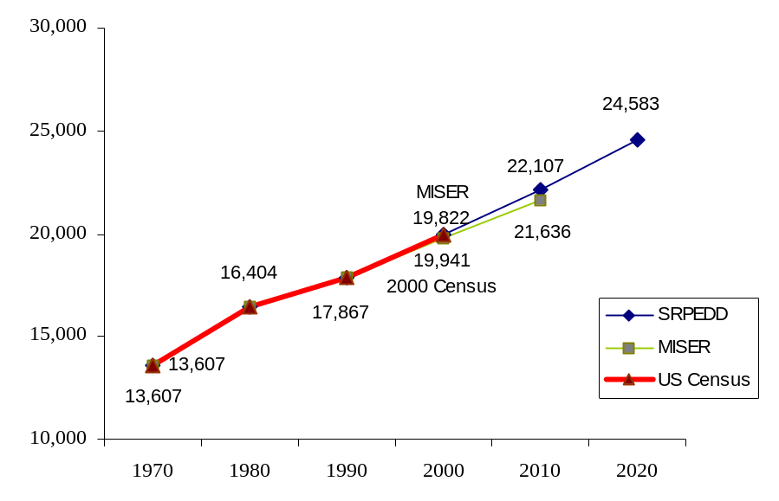

Table 8, Comparison of Population Growth in Middleborough and Region

Municipality | Population  2000 | 1980 - 2000
Municipality | Population  2000 | Population Change | % Change
Bridgewater | 25,185 | +7,983 | 46.4
Carver | 11,163 | +4,175 | 59.8
Lakeville | 9,821 | +3,890 | 65.6
Middleborough | 19,941 | +3,537 | 21.6
Plymouth | 51,701 | +15,788 | 44.0
Raynham | 11,739 | +2,654 | 29.2
Wareham | 20,335 | +1,878 | 10.2
Source: U.S. Census

Population growth is not unique to Middleborough; it is a phenomenon shared by other adjacent suburban communities in the area. In the past decade surrounding communities of Bridgewater, Carver, Lakeville, Plymouth, Raynham, and Wareham all experienced growth as well. Out of these towns, Middleborough is one of the slowest growing communities, ranking only above Wareham in terms of percent change in population from 1980 to 2000.

Both the population and the number of households in Middleborough have been steadily increasing over the past few decades, as average household size shrinks. This trend is also expected to continue (see Table 9).

Table 9, Population and Household Growth, 1970-2020

 | Population | % Change | Households | % Change | Total Additional Households | Persons per Household
1970 | 13,607 |  | 4,153 |  |  | 3.28
1980 | 16,404 | 20.6 | 5,409 | 30.2 | 1,256 | 3.03
1990 | 17,867 | 8.9 | 5,898 | 9.0 | 489 | 3.03
2000 | 19,941 | 11.6 | 6,981 | 18.4 | 1,083 | 2.86
2010 | 22,415 | 12.4 | 8,639 | 23.8 | 1,658 | 2.60
2020 | 24,889 | 11.0 | 9,763 | 13.0 | 1,124 | 2.55
Source: U.S. Census, SRPEDD

Demographics
The population of Middleborough is aging. Youth (aged 0-19) are continually accounting for a smaller percentage of the total population, a trend which the SRPEDD predicts will continue. SRPEDD’s projections (shown in Table 8 are out of date, as SRPEDD has not updated these figures recently) do not take into account the growth in the older population that will result from the large-scale expansion of age-restricted housing. When the two mobile home parks are completed, they will comprise close to 13% of the town’s total housing units, and are expected to house approximately 2,000 residents over age 55 (close to 10% of the projected 2010 population).

Table 10, Town of Middleborough Age Profile, 1980 – 2020

 | 1980 | % | 1990 | % | 2000 | % | 2010 | % | 2020 | %
0 – 19 years | 5,760 | 35.1 | 5,611 | 31.4 | 5,936 | 29.8 | 6,034 | 29.1 | 5,648 | 25.8
20 – 34 years | 4,161 | 25.4 | 4,378 | 24.5 | 3,816 | 19.1 | 3,513 | 17.0 | 4,266 | 19.5
35 – 59 years | 3,891 | 23.7 | 5,340 | 29.9 | 7,526 | 37.7 | 7,991 | 38.6 | 7,173 | 32.8
60 – 74 years | 1,706 | 10.4 | 1,640 | 9.2 | 1,597 | 8.0 | 2,537 | 12.3 | 4,037 | 18.5
Over 75 | 886 | 5.4 | 898 | 5.0 | 1,066 | 5.4 | 615 | 3.0 | 752 | 3.4
Total | 16,404 |  | 17,867 |  | 19,941 |  | 20,690 |  | 21,876
Median Age | 29.4 |  | 31.8 |  | 35.6
Source: U.S. Census, SRPEDD
Figure 4, Middleborough Age Profile, 1980 – 2020

- Approximately 40% of the households in Middleborough have children, which is on par with other communities in the region.

School Enrollment
- Although the data presented above shows a 5% increase in the number of children aged 0-19 between 1990 and 2000, the school enrollment data presented below shows that there has been a substantial increase in the percentage of school children in Middleborough over the same time period. Preprimary and kindergarten enrollment has increased by over 90% and elementary and high school enrollment has increased by 16%. This discrepancy could be explained by a substantial influx of young families into town.
- The number of pupils enrolled in college has decreased 8%.

Table 11, School Enrollment in Middleborough, 1990 and 2000
Grade Level | 1990 Enrollment |  |  | 2000 Enrollment |  |  | % change ‘90 to 2000
Grade Level | Public | Private | Total | Public | Private | Total | % change ‘90 to 2000
Preprimary |  |  |  | 240 | 250 | 490
Kindergarten |  |  |  | 216 | 22 | 238
Preprimary/Kindergarten | 217 | 165 | 382 | 456 | 272 | 728 | 90.6%
Grades 1-4 |  |  |  | 1,194 | 74 | 1,268
Grades 5-8 |  |  |  | 1,303 | 65 | 1,368
Grades 9-12 |  |  |  | 1,053 | 137 | 1,190
Elementary/High School | 3,122 | 160 | 3,282 | 3,550 | 276 | 3,826 | 16.6%
College Undergraduate |  |  |  | 500 | 265 | 765
College Graduate |  |  |  | 50 | 114 | 164
College Total | 804 | 202 | 1,006 | 550 | 379 | 929 | -7.7%
Total | 4,143 | 527 | 4,670 | 4,556 | 927 | 5,483 | 17.4%
Source: U.S. Census

Income
- Middleborough residents are likely to be low to moderate income. A smaller percentage of residents are upper income. Among renters, who comprise 26% of households in town, low and moderate incomes are much more prevalent, while relatively few households have upper and middle incomes.
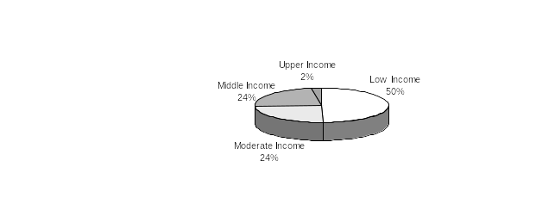
- Income levels used in this analysis are based on the 2000 area-wide median income for a family of four for the Brockton PMSA (of which Middleborough is a part) of $63,500.
Figure 5, Middleborough Residents by Income Level (2000, family of 4)
*Income data is from 2000 U.S. Census.
*Definitions for income levels are taken from EO418 Housing Certification requirements. Low Income is defined as under 50% of median income, Moderate is 80% of median income, and Middle Income is up to 150% of median income.

Homeowners
(5,171 households)
Renters
(1,810 households)
- By this definition, the proportion of the population that is low or moderate income may be slightly overstated because households in Middleborough typically have fewer than four people. The average household size for households who own their homes in Middleborough is 2.9, while the average size of renter households is 2.4. The median income for a household of 2 in 2000 was $50,800; for a family of 3, median income was $57,150.

Employment and Labor Force
Table 12, Jobs to Labor Force Ratio

Middleborough jobs | 7,704
Middleborough resident labor force | 10,080
Jobs/Labor Force Ratio | 0.76

Businesses in Middleborough employed a total of 7,704 people in 2001. The number of jobs in town exceeds the number of people in the Middleborough labor force by a ratio of approximately 0.76.

Middleborough jobs provided an average annual wage of $36,109 in 2001. Over 85% of the jobs are in industries where the average annual wage falls within low and moderate income guidelines. (Many employees live in households with more than one income, thus they may fall in a higher income bracket, and/or residents may not be employees in the town.) Only one industry, Management of Companies and Enterprises, provides an average annual wage that exceeds the median income for the Brockton PMSA ($63,500).

According to SRPEDD, the number of jobs in Middleborough is expected to grow by 50% between 2001 and 2025. Naturally, people who occupy these new positions will need to find housing within the region.

HOUSING AFFORDABILITY/GAP ANALYSIS
For a housing unit to be affordable, a household should spend no more than 30% of its household income on housing costs. In Middleborough, nearly 30% of all household units spend more than 30% of their incomes on housing costs, making them technically unaffordable. 25% of households in owner-occupied housing units spend more than 30% of their incomes on housing, while 33% of households in renter-occupied housing units spend more than 30% of their household incomes (U.S. Census).

Table 13, Housing Costs as Percent of Household Incomes in Middleborough
% of income spent on housing costs | Homeowners |  | Renters |  | Total
% of income spent on housing costs | # of units | % of total units | # of units | % of total units | # of units | % of total units
Under 15% | 1,074 | 24.4% | 349 | 19.6% | 1,423 | 22.0%
15.0-19.9% | 766 | 17.4 | 215 | 12.1 | 981 | 14.7
20.0-24.9% | 928 | 21.1 | 275 | 15.5 | 1,203 | 18.3
25.0-29.9% | 534 | 12.1 | 249 | 14.0 | 783 | 13.0
30.0-34.9% | 400 | 9.1 | 115 | 6.5 | 515 | 7.8
35.0 and above | 686 | 15.6 | 468 | 26.3 | 1,154 | 21.0
Total Households with High Cost Burden | 1,086 | 24.7% | 583 | 32.8% | 1,669 | 28.8%
Not computed | 14 | 0.3 | 108 | 6.1 | 122 | 3.2
Median monthly costs | $369 |  | $681 |  | $459
Source: 2000 U.S. Census

In order to afford the median 2002 selling price of single family homes in Middleborough of $229,500, a household must have an annual income of $75,800. Between 1990 and 2000, the average selling price of single family homes rose by 34% ($119,900 in 1990, $160500 in 2000), while over this same period the median income in Middleborough increased by 43% ($32,003 in 1990, $45,906 in 2000). By 2002 the average selling price for single family homes rose an additional 43%, and continues to climb. Accurate data on average rents is not available for comparison. While the U.S. Census reports an average rent of $681 in 2000, the market rent for a typical two bedroom apartment is at least $800.

Housing Gap: Homeowners
Gap Analysis
A gap analysis looks at what types of housing are available in Middleborough in comparison to what the population can afford, based on median household incomes, and what types of housing might be desired, based on household types. The analysis considers both home-owners and renters.
Especially within the low income range, there is a gap between the number of houses available and the number of households with incomes large enough to pay for the available housing. Figure 8 illustrates this concept. While 25% of the households have low incomes, only 3% of homes in Middleborough are affordable to low income households. This results in many current homeowners facing high cost burdens (see Table 13 above) and would-be first-time homebuyers who cannot find affordable homes.

Figure 6, Homeowners Affordability Index
Source: 2000 US Census
Calculated assuming 5% down, 7.5%APR mortgage for 30 years, 30% of income for housing costs and $300/month for taxes and insurance.

In fact, the number of low and moderate income renters who could potentially become first time homebuyers far exceeds the number of homes that are reported to fall within an affordable price range. This data may understate the lack of affordable ownership housing, as the home values reported to the Census are frequently below the potential selling price if the homes are placed on the market.

Table 14, Homeowners Housing Gap¹
Income Group | Maximum Affordable Home² | Households in Income Range |  |  |  | Owner-Occupied Units in Price Range
Income Group | Maximum Affordable Home² | Owners | Renters | Total | % of Households | Number | % of Owner Units | Cumulative | Cumulative  %
Low Income  50% of median | $75,000 | 863 | 900 | 1,763 | 25% | 120 | 3% | 120 | 3%
Moderate Income  80% of median | $147,000 | 1,050 | 430 | 1,480 | 21% | 1,600 | 36% | 1,720 | 39%
Middle Income  150% of median | $315,000 | 2,323 | 435 | 2,758 | 40% | 2,602 | 59% | 4,322 | 98%
Upper Income  >150% of median | >$315,000 | 935 | 45 | 980 | 14% | 80 | 2% | 4,402 | 100%
 |  | 5,171 | 1,810 | 6,981 | 100% | 4,402 | 100%
¹ Based on 2000 household income and home values, the last year for which town-level data is available. From 2000 to 2002, median sales price for single family homes in Middleborough rose by 43%, while incomes in the Brockton PMSA have risen by only 11%.
² Price calculated for 30 year mortgage at 6.25% rate with 5% down payment and $200/month for mortgage insurance and property taxes, such that monthly housing costs do not exceed 30% of income.

The number of homes in the middle income price range (between $147,000 and $315,000) appears to meet the demand for households within the town. However, many of these homes are likely occupied by upper income households who could afford to purchase more costly homes than the town has to offer.

Housing Gap: Renters
Currently market rate one-bedroom apartments rent for about $1,000/month and two bedrooms rent for about $1,200/month. At these rates, typical market-rate apartments fall within the moderate-income affordability range defined for 4 person households (at $40,000, households can afford to pay $1,000/month). However, over 60% of renter households in Middleborough have only one or two members, hence a lower standard for affordability should be considered, as shown in Table 15.
Table 15, Income and Rental Affordability¹
(Income standard for 2-person households)

 | Income | Affordable Rent | House-holds | Units²
Very Low Income  below 30% of median | $15,240 | $381 | 505 | 350
Low Income  below 50% of median | $25,400 | $635 | 227 | 500
Moderate Income  below 80% of median | $40,640 | $1,016 | 369 | 820
Median Income | $50,800 | $1,270 | 230 | 81
Upper Income  above median | >$50,800 | >$1,270 | 479 | 36
¹ Income levels for EO418 Housing Certification specify a lower threshold for upper income renters, equal to 100% of median income. Note: Housing subsidy programs use their own eligibility standards.
² Reported in the US Census by gross rent; gross rent was not determined for a small number of units.

There is a substantial shortage of housing affordable to households with very low incomes, while low-income and moderate-income households are apparently adequately served in the Middleborough rental market. According to the U.S. Census, 33% of renters (583 households) spent more than 30% of their income on housing in 2000 (see Table 13). In addition, while many renters may currently be paying below-market rents for their apartments, such low rents are often not transferable to new tenants if the apartment turns over, so that the availability of apartments that are available to very low income households is probably less than indicated by Census data.

Housing Needs by Age
When these households are examined in terms of age, it is possible to determine which subsections of the population are carrying more of the burden. 37.5% of homeowners aged 75 and older spend over 30% of their income on housing costs, the highest percentage of all age groups. They are followed by those between the ages of 55 and 74. Middle-aged (35-53 years) Middleborough residents have the lowest percentage of homeowners with a high cost burden, although the percentage is still relatively high at over 22%.

Table 16, Homeowner Housing Costs as Percent of Household Income by Age

% of income spent on housing costs | 15-34 years |  | 35-54 years |  | 55-74 years |  | 75 years and older
% of income spent on housing costs | # of units | % of units | # of units | % of units | # of units | % of units | # of units | % of units
Under 20% | 121 | 17.9% | 997 | 41.4% | 581 | 55.8% | 141 | 51.2%
20.0-24.9% | 241 | 35.7 | 530 | 22.0 | 132 | 12.7 | 25 | 9.1
25.0-29.9% | 139 | 20.5 | 349 | 14.5 | 46 | 4.4 | 0 | 0.0
30.0-34.9% | 86 | 12.7 | 210 | 8.7 | 87 | 8.3 | 17 | 6.2
35.0% and above | 81 | 12.0 | 323 | 13.4 | 196 | 18.8 | 86 | 31.3
Total Homeowners with High Cost Burden | 167 | 24.7% | 533 | 22.1% | 283 | 27.1% | 103 | 37.5%
Not computed | 8 | 1.2 | 0 | 0 | 0 | 0 | 6 | 2.2
Source: U.S. Census

The percentage of elderly renters spending over 30% of their income on housing costs is 37.3%, almost the same percent as elderly homeowners. However, the highest percentage of renters with a high cost burden is those aged 35 to 54.

Table 17, Renter Housing Costs as Percent of Household Income by Age

% of income spent on housing costs | 15-34 years |  | 35-54 years |  | 55-74 years |  | 75 years and older
% of income spent on housing costs | # of units | % of units | # of units | % of units | # of units | % of units | # of units | % of units
Under 20% | 263 | 39.0% | 209 | 33.4% | 65 | 22.6% | 27 | 14.1%
20.0-24.9% | 98 | 14.5 | 94 | 15.0 | 29 | 10.1 | 54 | 28.3
25.0-29.9% | 74 | 11.0 | 62 | 9.9 | 90 | 31.2 | 23 | 12.0
30.0-34.9% | 36 | 5.3 | 31 | 5.0 | 15 | 5.2 | 33 | 17.3
35.0% and above | 145 | 21.5 | 211 | 33.7 | 74 | 25.7 | 38 | 20.0
Total Renters with High Cost Burden | 181 | 26.8% | 242 | 38.7% | 89 | 30.9% | 71 | 37.3%
Not computed | 58 | 8.6 | 19 | 3.0 | 15 | 5.2 | 16 | 8.4
Source: U.S. Census

Alternative Housing Options
The existing supply of housing types does not meet the current demand. There are many households which, given their income and household composition, would like to have alternative housing types than what currently exists in the housing supply, such as condominiums, apartments, assisted living facilities, and in-law apartments. The current Zoning Bylaw does not allow the construction of all of these alternative housing types, or limits where they are acceptable.

The second pie-chart in Figure 7 depicts a mix of housing types that might meet the needs of all of Middleborough’s residents. This illustration is not intended to represent a goal for the town’s future housing mix, but rather to suggest the direction that the town needs to move in, in order to ensure that housing needs are addressed. For example, almost all of the recent housing development in Middleborough has been in single family homes and mobile homes. If this trend continues, these two types of housing will form an increasing portion of the town’s housing stock, while the need for two-family homes and condominiums continues to go unmet.

Figure 7
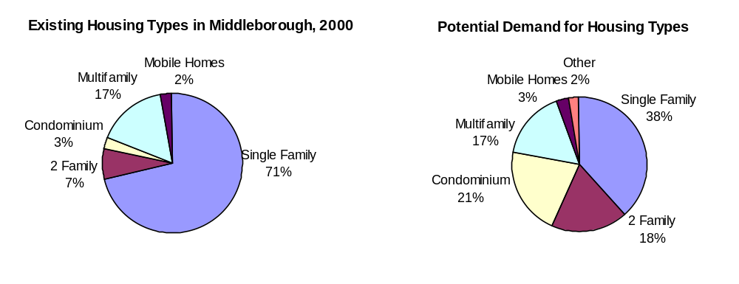Potential Demand for Housing Types in Figure 7 is derived from an estimate of what percentage of households in Middleborough would desire to live in each type of housing, if it were available, shown in Table 18. Appendix 11 provides a blank table for the Committee to utilize in estimating demand for alternative housing types.

Table 18, Housing Demand: Alternative Housing Types
Household Types | Total House-holds | Actual % of HH (2000) | Estimated Housing Type Preference⁽¹⁾
Household Types | Total House-holds | Actual % of HH (2000) | Single Family Homes | Two Family Homes | Condo | Multi-family | Mobile | Other⁽²⁾
Individuals or Couples, Age 85+ | 113 | 1.6% | 11  (10%) | 11  (10%) | 11  (10%) | 11  (10%) | 23  (20%) | 46  (40%)
Individuals or Couples, Age 65-84 | 1,075 | 15.4% | 322  (30%) | 108  (10%) | 215  (20%) | 108  (10%) | 215  (20%) | 107  (10%)
Indiv./Couples, Age 35-64, No Children | 1,544 | 22.1% | 772  (50%) | 154  (10%) | 464  (30%) | 154  (10%) | (0%) | (0%)
Young Adults, up to age 34 | 1,439 | 20.6% | 216  (15%) | 360  (25%) | 432  (30%) | 432  (30%) | (0%) | (0%)
Households with Children/Families | 2,082 | 29.8% | 1,250  (60%) | 416  (20%) | 208  (10%) | 208  (10%) | (0%) | (0%)
Single Parent Families | 736 | 10.5% | 110  (15%) | 221  (30%) | 147  (20%) | 258  (35%) | (0%) | (0%)
Total (% of total) | 6,989 | 100.0% | 2,681  (38%) | 1,270  (18%) | 1,477  (21%) | 1,171  (17%) | 238  (3%) | 153  (2%)
⁽¹⁾ Approximately half of the two-family homes and all of the multifamily homes are assumed to be rental units. Condos and single family homes are assumed to be for ownership.
⁽²⁾ Includes mobile homes. May include assisted living, or other group living arrangement.

QUALITATIVE NEEDS ANALYSIS
A summary listing of affordable housing needs follows. This list needs to be adjusted by the Housing Committee, possibly with the input of a questionnaire filled out by community leaders, the building inspector, and realtors familiar with housing issues. A sample questionnaire can be found in Appendix 10.

- Current trends predict that population expansion will be mainly young families and the elderly, two populations that require a wide variety of housing options in terms of cost and type.
- There is insufficient public housing for low income families, demonstrated by the fact that there are 150 people on the waiting list for subsidized housing.
- Despite the construction of the Oak Point and Edgeway senior mobile home parks, there are few alternative housing types for elderly residents, such as assisted living, accessory/in-law apartments or condo units.
- There are no assisted living options available in the Town.
- There are nine nursing homes in Town including the Montgomery Home. The Shaw Home is both a nursing home and an assisted living facility.
- There is a lack of rental opportunities as nearly 75% of homes are owner-occupied.
- Downtown is a good location to continue to encourage higher density housing to meet the needs of the elderly and young families.
- The downtown area contains some under-utilized properties that could be redeveloped as multifamily housing.

Goals and Objectives

The vision, goals, and strategies which follow are developed to meet the requirements for housing plans under Executive Order 418. While EO 418 is concerned with the creation of housing that is affordable to households earning up to 150% of the median income, Chapter 40B has more stringent requirements for units to be counted as affordable. Targets for the number and types of units to be created differ between the two mandates; however, many of the same strategies will satisfy both.

This vision has been compiled by viewing Town documents and reports (Open Space Plan, Master Plan, etc.), and needs to be approved by the Housing Committee. A range of strategies to achieve this vision must be assessed and put into action. On the basis of this assessment the goals identify those strategies that will best assist the town achieve that mix of housing to meet Middleborough's future needs. Photographs should be taken by Committee members to represent housing types which would be welcome in town.

HOUSING VISION

A family-oriented community with an abundance of open space and valuable natural resources, the Town of Middleborough maintains its small-town character, provides a wide variety of housing options for its population, and balances the preservation of its natural resources and historic villages with the housing and economic needs of the community.

418 HOUSING PLAN AND CHAPTER 40B REQUIREMENTS
An Affordable Housing Plan addresses the following topics: Identification of Housing Needs, the Number and Types of Units Required, the Location of Affordable Housing, as well as recommendations for implementation of the Plan. Due to revisions issued by the Department of Housing and Community Development’s Housing Appeals Committee in December 2002, the Affordable Housing Plan must also incorporate a “Planned Production Development Rate” provision. This provision allows a local Board to deny or grant with conditions a comprehensive permit for up to a two year period if the community has adopted an affordable housing plan approved by DHCD. The plan must stipulate an increase in the community’s number of low or moderate income housing units by at least three-fourths of one percent of total units every calendar year until that percentage exceeds 10% of total units. In subsequent years, the community will have to demonstrate continued progress toward implementing the housing plan.
A Local Board may deny a Comprehensive Permit if the community has an affordable housing plan approved by DHCD, and succeeds in increasing the number of low or moderate income housing units by at least three-fourths of one percent per calendar year. If the number of units in increased by 1.5 % in one year, then the community may deny Comprehensive Permits for up to two years.

The affordable Housing Plan shall address the following:
To meet Chapter 40B requirements, Middleborough needs to develop a plan to construct 54 units of affordable housing per year (0.75% of total 2000 housing units) until it achieves a total of 720 units, or 10% of its 2000 housing stock.

Populations that should be served by affordable housing include:
- Families | - Persons with special needs
- Individuals | - Elderly

The following are some types of housing that now qualify as affordable under Chapter 40B:
- Local, state or federally subsidized units
- Privately funded units in a variety of building types, renovated or new housing, assuming costs are within affordable housing cost limits (80% of median income) and there are use restrictions to maintain affordability (Local Initiative Program).
- Units created through Community Preservation Act funding that serve low and moderate income households
- Group homes
- Accessory apartments created after July 2002 under LIP guidelines

- A mix of housing opportunities for families, individuals, persons with special needs, and the elderly that are consistent with local and regional needs and feasible within the housing market in which they will be situated
- Strategies by which the municipality will achieve its housing goals established by its comprehensive needs assessment (See Appendix 8)
- A description of the use restrictions which will be imposed on low or moderate income housing units to ensure that each unit will remain affordable long term to and occupied by low or moderate income households

The Affordable Housing Plan shall include one of more of the following, but shall not be limited to:
- The identification of zoning districts or geographic areas which will permit the proposed residential uses

An approved plan shall take effect only when the Department certifies that the municipality has approved permits resulting in an initial annual increase in its low or moderate income housing units of three-quarters of one percent of total housing units.

- The identification of specific sites for which the municipality will encourage the filing of comprehensive permit applications
- Characteristics of proposed developments that would be preferred by the municipality (cluster, mixed use, etc)
- Municipally owned parcels for which the municipality commits to issue request for proposals to develop low or moderate income housing.

According to the standards set by Massachusetts Chapter 40B, Middleborough should have 720 subsidized housing units, or 10% of the number of permanent residences counted in the 2000 census. Utilizing this standard, Middleborough should consider encouraging the development of an additional 418 units of affordable housing to meet its local housing needs. There are currently 302 units of affordable housing in town–4.2% of the existing housing stock.
To gain a reprieve from Comprehensive permit applications, Middleborough would have to create at least 54 affordable housing units per year (3/4 of 1% of 7200). Development of 108 units, or 1.5% of the housing stock, in one year would enable the community to gain a reprieve from Comprehensive Permit applications for two years. Amendments to Chapter 40B were under review by the legislature but have since been tabled. The proposed amendment to include mobile homes did not get the support of the Governor’s Advisory Committee. The development of the Oak Point senior mobile housing park will add 1,150 homes, and Edgeway Estates will add an additional 74 units. These units will all be owner-occupied, but do not count on the 40B inventory. Should this change to the law occur, Middleborough might be able to count these units as affordable housing, bringing the total affordable housing stock over the required 10% limit.
Communities can use the development rate provision as a tool to encourage Chapter 40B development that meets stated planning objectives, while ensuring that they can reject more undesirable development proposals.

Middleborough has eight Comprehensive Permit developments in various stages of consideration as show in the following table; four are officially filed and four are under discussion. In addition, the OECD has, working with a local property owner, obtained subsidies to finance the renovation of 10 South Main Street into 7 affordable one and two bedroom rental apartments. If all of these developments were to be processed, the town would gain an additional 147 of the 552 total units as affordable housing. Due to the mix of rental and ownership units, 345 units would potentially qualify for 40B status as all rental units, both market and affordable, count as 40B units in a rental development. With the submission of an Affordable Housing plan and the careful scheduling of these projects, the town would be able to gain at least a two year reprieve from less desirable Comprehensive Permit applications.

Table 19, Proposed Chapter 40B Developments

40B Project | Types of Units | Total # Units | # Affordable  Units* | # 40B Units
MBC/Tispaquin Street | Single Family | 20 | 5 | 5
Barges/West Grove Street | 120 Condos, 80 Apts. | 200 | 50 | 110
Blais/West Grove Street | 48 Apts., 60 Townhouses | 108 | 27 | 63
St. Lukes Hospital | 27 Apts., 43 Condos | 70 | 18 | 38
Gerson** | 10 townhouses | 10 | 3 | 10
Adams Circle** | 100 Apts. | 100 | 25 | 100
Bay State Specialty** | 33 units | 33 | 8 | 8
May Institute** | 4 DMR rooms | 4 | 4 | 4
10 S. Main Street*** | 7 1 and 2 BR units | 7 | 7 | “7”
Total Units |  | 552 | 147 | 345
*The number of affordable units comprises 25% of the total number of units in the development.
**Under discussion
*** Not a 40-B development, Special Permit issued, DHCD approved funding
Source: Middleborough Zoning Board of Appeals

QUANTIFYING AND LOCATING HOUSING NEEDS: A SUMMARY
Given the gap analysis and discussion of community development constraints, the location, type, and quantity of affordable and market-rate housing units that Middleborough should see developed are summarized below. An additional 418 units of 40B housing are needed to get to a total of 10% affordable housing. Eight 40B projects currently being discussed will help close the housing gap, as shown in Table 19. If these developments are all permitted, the gap (418-345) would be reduced to 73 40B units. This gap could not be reduced by having the developer of Oak Point agree to make 10% of his total units affordable as DHCD does not consider a mobile home permanent housing.

Since not all these 40B project will, in all likelihood happen, the town needs to identify desirable alternative housing types, specific strategies, and locations for affordable housing. The following table suggests the number of needed affordable units for various household types. The estimation for various housing types most needed in Middleborough represents a reasonable scenario based on the Town’s demographics. The Housing Committee should review this allocation. See Appendix 5 for a discussion of various standards or definitions of housing affordability that the town might use in defining its goals for affordable housing creation.

In addition, following the recommendations of the Housing Policy Statement and the
Middleborough Master Plan, a variety of sites have been identified that might be appropriate for the types of structures listed. The Housing Policy Statement suggested that Town Center West, the triangular shaped area bounded roughly by Route 25 on the west, Route 44 on the north, Everett and North Street on the east, and South Main Street be considered as a target area for the development of higher density, affordable housing. Outside this area a number of new zoning tools establishing “retreat lots”, encouraging cluster development, in-law/accessory apartments, and inclusionary housing within mobile home parks and subdivisions, and density bonuses for voluntary affordable apartments and condos in the General Use district would be considered. See maps in the Appendix for carrying out this exercise.

The following table shows a preliminary plan for developing additional affordable and market-rate housing in Middleborough. A total of 2,088 units are shown, of which 17% would be rental housing and 83% ownership housing. The table is still incomplete. The number of 40B affordable units shown totals some 345 units, some 73 units short of what would be required to meet the 10% goal. This figure could be increased if one assumed that certain other types of housing such as single family townhouse cluster and in law apartments, for example, were approved locally as state qualified (LIP) affordable units. Also, the mix of housing shown on the table may not reflect the town’s objectives to provide a range of housing options to meet the needs of residents. The table should be reviewed/adjusted and the blank spaces, where appropriate, filled in to reach the 10% goal of affordable housing stock.

Table 20, Five Year Plan: Summary of Middleborough’s Housing Needs (Draft)
 | Market | Affordable | Total | Household Type | Location
Rental Units Subtotal | 269 | 87 | 356
Mixed residential/ commercial |  |  |  | young adults | Downtown  Village Centers
Multifamily (proposed 40B) | 229 | 76 | 305 | young adults,  older adults, seniors | Barges/West Grove St., Blais/West Grove St.  St. Lukes Hospital  Adam’s Circle
Additional multifamily |  | 7 | 7 |  | 10 S. Main St.  Target Area  TDR Villages
In-law apartment | 25 |  | 25 | elderly | Town-wide
Other* |  | 4 |  | Elderly  Special Needs | May Institute DMR
Retreat Units | 15 |  | 15 | families | RR District
Ownership Units Subtotal | 1,506 | 226 | 1,732
Single Family  (proposed 40B) | 15 | 5 | 20 | families | MBC/Tispaquin St.
Townhouse/condominiums (proposed 40B) | 189 | 64 | 253 | young adults, older adults, seniors, families | Barges/West Grove St., Blais/West Grove St.  Gerson  Bay State Specialty
Additional townhouse/ condominiums |  |  |  |  | Target Area  Village Centers  TDR Villages  Historic Villages
Open space cluster  (single family/townhouse) | 200 | 30** | 230 | families,  older adults | Village Centers, Historic Districts  Historic Villages
Live/work space |  | 5 | 5 | young adults, | Downtown
Mobile home park  (age restricted) | 1,102 | 122*** | 1,224 | seniors | TDR Villages
Total Units | 1,775 | 313 | 2,088 | 345 units in proposed 40B developments would count toward 40B inventory

* Other rental units may include assisted living or other group living arrangement

** Inclusionary Housing; 15% affordable units
***Voluntary 10%, does not count toward 40B inventory

IMAGES

A picture is worth a thousand words. Following are pictures of housing developments which characterize the types of housing desired by Middleborough's residents.

Images of New Housing types Desired in Middleborough

Mixed Use Housing
Cluster Housing
Multifamily
Townhouse Condominiums
HOUSING GOALS

Provide a variety of housing opportunities that serves all segments of the community
- Identify opportunities to develop housing units that are both affordable and desirable to young families, the elderly, and those with special needs
- Modify land use regulations to accommodate a wider range of housing types
- Expand availability of apartments and condominiums in the Downtown or the GU district
– Redevelop existing commercial and/or residential space
– Modify zoning to allow for more single family conversions to condominiums
- Explore zoning changes necessary to encourage development of accessory apartments
- Promote assisted living opportunities and any land use regulations needed for such development
- Encourage the construction of smaller, compact units suitable for the elderly
- Create incentives for developers to include affordable housing in their developments
- Consider using Town-owned land for affordable elderly and assisted living housing
- Work with local banks on a First Time Homebuyer Program
- Continue participation in the Community Development Block Grants (CDBG) Program

- Maintain the rural, residential, and historic character of town as more development occurs
- Encourage appreciation of historic homes
- Encourage preservation of architectural character and diversity of style
- Promote the use of cluster zoning to create higher density subdivisions to protect open space for conservation and recreation
- Manage housing development in environmentally sensitive areas to protect the Town’s environmental assets

- Identify a range of public and private sector strategies to foster a needed mix of an additional 418 units of housing so that the Town can address the 40B requirement of 10% affordability.
- Utilize Local Initiative and “friendly” 40B projects to create non-state and federal subsidized affordable units

Implementation Strategies

STRATEGIES
Four basic strategies are highlighted below each of which includes a number of activities that would assist in the planning, financing, and/or development of affordable housing. Public Education is one of the most important activities the town can do to build support for undertaking the other actions which follow. Modifying the Zoning Bylaw is one of these primary strategies. It is also one of the most difficult as a two-thirds vote is needed at town meeting. A large number of possible bylaw changes are suggested. Working with the Planning Board and the selectmen, the Housing Committee will need to prioritize these strategies. An activist Housing Committee will be needed to move the affordable housing agenda forward. A number of actions are identified which could be taken by the Committee to build its credibility in town. Housing Production type strategies are also a viable direction to undertake. A number of these strategies such as the use of town-owned land are identified.

- Raise public awareness of housing issues.
- Questionnaire
- Publicize Plan
- Cable TV
- Guest Speakers
- Newspaper
- Interview knowledgeable individuals to assess the needs in the community.
Possible people to speak with include:
- Regional Housing Authorities
- Housing and social service providers in town and in the region

  - Provide Zoning Incentives by drafting and presenting new bylaws to the Planning Board and Town Meeting to encourage a mix of housing that meets the town’s needs.
- Accessory Affordable Housing Apartment Bylaw: Should this be the priority zoning bylaw change for encouraging affordable housing?
- Assisted Living Bylaw: Town officials feel this use should be defined in bylaw in order to better respond to certain development proposals.
- Adopt Inclusionary Housing requirement for all housing developments over 6 units and a subdivision waiver for the number of lots on a dead end. For every 4 additional units beyond 12 units, require that one of the homes be affordable, allow maximum of 32 homes in the subdivision subject to affordability requirement.
- Legalize Live Work Space
- Create new zoning districts: (See Housing Opportunities Map)
- Town Center GU Overlay
- Highway/Commercial,
- Retail/Service/Residential
- Village Center/Retail Focus Area
- TDR Village
- Agriculture/Eco Tourism PDA District

- Reconfigure the GU district by creating an overlay district that takes into account a variety of uses and needs within the district
- Allow for development by special permit of multifamily and condominiums in the GU district at a density of 5 units/acre all of which must be upland (the GU district within the Downtown Affordable Housing Target Area) subject to special permit with an affordable housing requirement of 15-20%.
- Allow for the conversion of single family with an affordable housing component (the Accessory Housing Affordable Housing bylaw)
- Adopt special permit requirements to include a minimum lot requirement of 15,000 sq. ft./unit with 12,000 sq. ft/unit of upland building area (30,000 sq. ft./unit current requirement), approval of septic plan by BOH, appropriate buffering from commercial and other residential uses, submission of a suitable drainage plan.
- Address parking requirements to facilitate shared parking in the GU
- Dedicate protected resource and agricultural areas and/or affordable housing units while allowing higher density development in limited areas. A number of strategies are identified below for consideration/editing; all are by special permit:
  - Transfer of Development Rights zoning to protect agricultural land in RR zoning district and encourage higher development in the GU Housing Target Area (4-5 units/acre) or higher density within the designated TDR village areas (see Housing Opportunities map)
  - Smaller lot sizes within RR: If RR or RA lots served by Public Water, allow 20,000 sq. ft. lots for single family, condo or townhouse development using the open space bylaw in exchange for dedication of open space for conservation and recreation and/ or the set aside of inclusionary affordable housing units.
  - Create an Agriculture/Ecotourism/Residential Planned Development Area (PDA) District. Require a minimum lot size (10-20 acres) which mandates at least 50-70% of the site be preserved as open space with the balance developed for specific uses (ecotourism, live/work space, a mix of residential uses, a conference center/cultural use)all such uses to be compatible with agriculture
- Create a new residential/business zoning district for village centers (Rock Village and South Middleborough) that allow for a mix of commercial and residential uses. Allow for a Planned Unit Development (PUD) within these areas.
- Adopt a Historic District Overlay to promote flexible, village type zoning within existing Historic Districts
- Repeal the Mobile Home Park Bylaw due to current over-supply compared to anticipated needs for this type of housing
- Draft a site plan bylaw that specifies Planning Board design review criteria for multifamily housing (over two units) and all commercial development over 2,000 sq. ft.
- Live/work spaces: Create new zoning provisions in low density areas for properties that are simultaneously used as residences and businesses provided

3. Mandate the Housing Committee to work with the Selectmen, ZBA, and Planning Board on friendly 40B and Local Initiative Program (LIP) developments which address the town’s goals for affordability.
- Adopt 40B use restrictions
- Adopt requirements for 40B submissions to ZBA. Include requirement for Planning Board to carry out site plan review of all 40B developments
- Adopt LIP guidelines, i.e., affordability, duration, marketing
- Work with the Housing Authority on expanding their role, i.e. obtaining grants, developing new housing and/or establishing a local non-profit housing corporation
- Explore use of new TIF legislation permitting establishment of an Urban Center TIF Plan to encourage mixed use growth including affordable housing
- Maintain compliance with 40B conditions approved by ZBA
- Work with the Planning Board on possible zoning changes

4. Facilitate new construction and re-use of under-utilized property
- Identify and dedicate municipally owned parcels to development of affordable housing

Apply for grants through the OECD
- Work with OECD, the Housing Authority and regional housing non-profit groups such as South Shore on housing production strategies
- Encourage redevelopment or re-use of existing underutilized commercial and/or residential space

Table 21, Proposed Residential and Mixed Use Districts

District |  | Existing Zoning | Proposed Zoning | Vision
1 | Downtown | Business, Residential Business | Mixed Use Business/  Residential | Downtown with mix of single family and multifamily residential; retail with residential uses above; commercial and institutional uses
2 | Downtown West | General Use | Highway oriented mixed use | Highway oriented commercial and multifamily residential; buffers, shared parking, shared curb cuts, pedestrian connections to Downtown
3 | Affordable Housing Study Area | Business, General Use, Residential Business | Mixed Use Business/  Residential | Downtown overlay to encourage affordable housing, infill housing, greater densities
4 | Downtown Southwest | General Use |  | Highway oriented commercial and multifamily residential; buffers, shared parking, shared curb cuts
5 | Rock Village | General Use, General Use X, WRPD Z 2 | Village Center/  Residential | Create a new residential/business zoning district for village centers (Rock Village and South Middleborough) that allow for a mix of commercial and residential uses. Allow for a Planned Unit Development (PUD) within these areas.
6 | South Middleborough | General Use X |  | Create a new residential/business zoning district for village centers (Rock Village and South Middleborough) that allow for a mix of commercial and residential uses. Allow for a Planned Unit Development (PUD) within these areas.
7 | North Middleborough | RA |  | Adopt a Historic District Overlay to promote flexible, village type zoning within existing Historic Districts
8 | Warrentown | RA | Village Center/  Residential | Adopt a Cluster Zoning Overlay to promote flexible, village type development
9 | The Green | RR,  WRPD  #2, #3 | Village Center/  Residential | Adopt a Cluster Zoning Overlay to promote flexible, village type development
10 | Eddyville | RR | Village Center/  Residential | Adopt a Cluster Zoning Overlay to promote flexible, village type development
11 | TDR Village  (Transfer Devel. Rights) | GU, RR | Residential Village | Allow higher density village setting housing in exchange for acquisition of development rights within Agricultural District
Table 22, Housing Action Plan

 | Action | Number of Affordable Units | *Development Rate Provision  Number of Affordable Units
Year 2003 | Adopt Accessory Apartment bylaw
Year 2003 | Adopt Retreat Lot bylaw
Year 2003 | Adopt Draft Housing Policy Statement
Year 2004 | Complete Affordable Housing Plan
Year 2004 | Submit Affordable Housing Plan to DHCD
Year 2004 | Request DHCD Housing Certification of Compliance with Approved Plan
Year 2004 | Housing Committee to manage 40B
Year 2004 | Become familiar with the Local Initiative Program (LIP); negotiate LIP units with developers including “Friendly 40B’s”.
Year 2004 | Seek one to two-year reprieve from 40B depending upon construction and Development Rte Provision (Planned Production Regulation)
Year 2004 | Adopt other zoning bylaw changes
Year 2004 | Subtotal Affordable Units
Year 3 – Year 5 | Seek one to two-year reprieve from 40B depending upon construction and Development Rte Provision (Planned Production Regulation)
Year 3 – Year 5 | Negotiate Local Initiative Program Units under Town’s Inclusionary Bylaw
Year 3 – Year 5 | Subtotal Affordable Units
Year 3 – Year 5 | Total Affordable Units | 418

*Note: The requirements for Development Rate Provision are currently being modified by DHCD in terms of the percentage of units required (1/2 to 3/4th % as well as the timing of qualifying units. Communities need to request approval of their plan and review at that time what units might qualify under the Development Rate Provision.


ECONOMIC DEVELOPMENT

Executive Summary

INVENTORY
- Labor force mirrors that of the Southeastern Massachusetts region, manufacturing only 25% of employment; service and trade the major sectors.
- Unemployment is comparable to that of the state.
- Local jobs meet residents’ needs for low skill/low wage jobs, but majority of residential labor force commutes long distances outside of town for more professional high-skilled jobs.
- Basic industry, agriculture, is declining.
- Resident labor force needs growth in trade and service industries
- A rough estimate of the development potential within each of the suggested commercial districts projects a total of approximately 10 million square feet of space primarily located within the DOD districts and the Wareham Street area
- The largest number of Middleborough residents is employed in retail, manufacturing, health care, and construction industries. Women outnumber men in the growth industries of health care and education while men far outnumber women in construction, manufacturing, and transportation/utilities industries
- Demand for professional and technical workers should increase the fastest and create the most jobs, accounting for 48% of the forecasted new jobs in the South Coastal region
- Historically, Middleborough receives about 20% of its tax revenue from Commercial, Industrial and Personal property.
- In spite of its large land area, Middleborough ranks fourth out of ten surrounding towns in the percentage of commercial/industrial/property

NEEDS/ISSUES
Topic 1: What mix of jobs would best meet the needs of local residents?
Topic 2: What land use mix is needed to retain fiscal balance?
Topic 3: How much commercial growth is feasible?
Topic 4: Issues and Opportunities: Where can and should economic growth go?

VISION

Promote the growth of commercial activity which addresses the town’s need for a mix of high quality employment for local residents, provides for the expansion of the tax base, protects the environment, facilitates the expansion of tourism and the protection of a productive and sustainable base of local agriculture, without unduly impacting the town’s rural character and limited infrastructure.

GOALS

Continue Middleborough’s historic role as both a regional commercial center and a rural community
- Designate areas of town that would be most suitable for commercial development for uses which require the workforce skills of local residents as well as provide fiscal benefits to the town government
- Maintain the town’s rural character by providing the opportunity to combine natural resources with economic development such a recreation, eco-tourism, and agribusiness
- Prepare strategic economic development plans for priority economic development areas
- Aggressively pursue and support appropriate business development which provides quality jobs for Middleborough residents
- Adopt an economic development strategy which makes Middleborough a tourist destination

Recommendations
The Town of Middleborough’s economic development strategies should be targeted to promote five types of growth within priority sub areas so as to not overly tax the town’s infrastructure, fiscal capacity, and diverse natural and historic resources.
- Industrial Development with a focus on build to suit light manufacturing and R&D
- Mixed Use Village Centers
- Tourism
- Commercial Development with a focus on hospitality, regional retail, medical office
- Agriculture

The following strategies are recommended.

Zoning changes to promote appropriate growth
1. Industrial Development
2. Mixed Use Centers
3. Tourism: Modify zoning to encourage tourism and ecotourism
4. Highway Commercial and Downtown development

Organization to Facilitate Investment and Public Support
1. Business/Industry Committee
2. Consider establishment of a Town-sponsored Industrial Park
3. Work with local Agricultural Commission

Incentives to attract private investment
- TIF Program
2. Identify State and Federal infrastructure grants
3. Use Community Preservation Act

Marketing/Promotion to attract business and investment
1. Tourism
2. Economic Development areas

Fiscal Policy to support economic growth
1. Maintain equitable but competitive tax rate
2. Capital budgeting for infrastructure and acquisition of 61A property

- Economic Profile

Overview
The Town of Middleborough is the second largest community in the Commonwealth in terms of land area. It is a municipality undergoing severe financial stress as it seeks to preserve its identity and resources while responding to regional growth pressures. In preparing an economic development plan for the town, four key concerns will be addressed, as noted below.

Key Concerns and Questions

- Existing Conditions
What types of commercial development exist in Middleborough?

- Needs and Opportunities
Do the commercial districts meet the employment needs of Middleborough’s residents?

Do the commercial districts meet the tax base needs of Middleborough’s residents?

How much commercial development (retail commercial, office, industrial, agricultural, tourism) is appropriate?

Issues and Opportunities: Where can/should growth go?

- Implementation tools
What Strategies should the town consider?

Should the Town consider development of a municipal industrial park?

- Action Plan
What are the priority next steps?

Existing Commercial Areas, Zoning, and Potential Buildout
Determining the appropriate amount of economic development requires examining the existing business mix and potential areas for commercial development, market opportunities, and needed types of businesses. A starting place in this discussion is an overview of existing commercial areas, zoning and projected buildout.

Commercial Areas: Existing Conditions
The areas of the town zoned for commercial activity are the downtown, a portion of which is zoned Business, the land area zoned General Use which traverses the town in a north west/southeast direction following the transportation corridor of Routes 495 and 28, and an additional area which falls within the Development Overlay District, located along Route 44.

The vast majority of the town’s commercial base is zoned General Use. Because this designation allows single family, multifamily, commercial and light manufacturing uses, the district is evolving with an often haphazard mix of uses and a lack of strong sub-area identity. This sprawling land use pattern is having a negative impact on traffic flow and visual identity and it discourages high quality new investment. Route 44 which traverses the town east/west is proposed for a substantial widening but currently is not zoned for commercial use except around the rotary at Route 18.

The existing and proposed commercial sub areas are identified below by the current mix of land uses. In order to describe and understand the existing commercial land uses, the following sub-areas were identified with the assistance of the town’s Planning and Economic Development staff.
Table 1, Commercial Areas

Sub-Area Designation |  | Mix of Uses
1 | Downtown | Retail, Commercial, Residential, Mixed Commercial/Residential, Public/Institutional
2 | Downtown West | Retail, Office, Restaurant, Service, Auto, Grocery, Cranberry bog
3 | Route 44/Route 18 Rotary | Restaurant, Convenience, Hotel
4 | DOD North | Light manufacturing, Warehouse distribution, Service
5 | Route 44 (Everett St. to Plymouth St.)  Tourism Study Area | Campground, Residential, Undeveloped land
6 | Route 44/Everett St. Intersection | Undeveloped land, Farming, Auto
7 | Route 44/Plymouth St. | Residential, Farming
8 | Downtown Southeast  (proposed) | Residential, Auto, Office, Service, Grocery, Restaurant, Convenience, High School, Mobile Home Park
9 | Rock Village | Neighborhood Retail, Residential, Auto, Service
10 | Wareham Street Highway Commercial | Residential, Auto, Service
11 | South Middleborough | Commercial, Grange Hall, Church, Fire Station, Vacant land and buildings, Auto, Office
12 | DOD, South (Proposed) | Residential, Auto, Junkyard, SEAMASS, Vacant restaurant, Cranberry bogs, Outdoor storage
13 | Oak Point village | Mobile Home Age Restricted Residential Community, no retail

A windshield survey of the areas where commercial activity exists indicates the following vacancy rate (generalized) and building condition.

Table 2, Business District Characteristics: Vacancy and Building Condition

Location |  | Zoning District | Vacancy Rate* | Building Condition**
1 | Downtown | Business, General Use, Residential Business | Medium | Fair-Poor
2 | Downtown West | General Use | Low | Fair-Good
3 | Route 44/Route 18 Rotary | General Use, Development Opportunity District | Low | Fair-Good
4 | DOD North | Development Opportunity District | Low | Good
5 | Route 44 (Everett St. to Plymouth St.)  Tourism Study Area | General Use, Residential A | n/a | n/a
6 | Route 44/Everett St. Intersection | Residential A | Medium | Fair-Poor
7 | Route 44/Plymouth St. | Rural Residential | n/a | n/a
8 | Downtown Southeast  (proposed) | General Use | Low | Fair-Good
9 | Rock Village | General Use, General Use X, WRPD Z 2 | Low | Fair
10 | Wareham Street | General Use X | Medium | Poor
11 | South Middleborough | General Use X | Medium | Poor
12 | DOD South (Proposed) | General Use X, General Use A | Low | Poor (industrial)-  Good
*Low = 5 % vacancy rate; Medium = 5%-15%; High = 20% and over

Zoning
Middleborough has a complex zoning map which does not clearly reflect the areas of focus for future commercial and industrial development. There is a business district, an industrial district, and three mixed-use general use districts as described in Table 3 below (and in further detail in Appendix 2). In addition to these underlying zoning districts, the Development Opportunity Overlay District (DOD), which covers portions of the RA and GU districts, provides for larger scale commercial and industrial development opportunities.

- The Business District, which comprises only 0.2% of the Town, is located in the downtown, and is mostly built out.
- The Industrial District, which comprises 1.4% of the town, does not allow residential uses of any type, although most pre-existing development is residential, and the area is inappropriate for most types of development.
- In the DOD, parcels with 10 acres or more may be developed as commercial/industrial parks. Currently the town has three such industrial developments which are located in areas with underlying residential zoning.
- The General Use district allows commercial and light manufacturing uses by special permit, in addition to single family and multifamily residential uses. The district covers a large area of the town along Route 28. As it is currently defined, the district allows for an uncontrolled mix of uses along the town’s primary commercial corridor, contributing to problems with traffic flow, poor identity, and lack of investment opportunities.

Table 3, Summary of Zoning Districts
Zoning District | Primary Function
Business | Retail, commercial, light manufacturing, allows upper floor residences
General Use | Mixed use – single family, mobile home parks and multifamily by special permit, and institutional, commercial and light manufacturing uses
General Use A | Same as GU, except no multifamily
General Use X | Same as GU
Industrial | Agriculture, institutional uses and manufacturing
Development Opportunity District | Commercial and industrial parks on parcels with 10 acres or more
Residential A (RA) | Single family residential 60,000 SF
Residential B (RB) | Single family residential 20,000 SF
Residential Rural (RR) | Single family residential 80,000 SF, mobile home parks

SRPEDD, under the direction of EOEA, prepared a buildout analysis for Middleborough in 1999 to provide an estimate of what might result if all of the remaining land in town were developed under existing zoning regulations. Due to the complexity of Middleborough’s zoning and the lack of a quality zoning map when this analysis took place, the analysis for Middleborough cannot be interpreted with a high degree of accuracy. Still, the estimate does provide a reasonable indication of the scale of development that the town can expect.

The buildout analysis identifies the potential for approximately 31.4 million square feet of new commercial and industrial space, as well as 10,600 new residences. This could provide jobs for about 72,042 new employees, who need to have residence in and around Middleborough, while the residential buildout might increase population by 30,400.
Table 4, Summary of EOEA Buildout

Buildout Impact
Additional Residents | 30,387
Additional Residential Units | 10,588
Additional Developable Land Area (acres) | 21,254
Additional Commercial/Industrial Buildable Floor Space (sq. ft.) | 31,374,341

In the absence of an official zoning map, this analysis was based on a close approximation of the underlying zoning districts and the Development Overlay District (DOD). Although it accounted for major environmental constrains (i.e., wetlands and flood zones), it largely overlooked infrastructure limitations that may impact the potential for commercial and residential development in some areas of the town. Nevertheless, the EOEA buildout analysis fairly indicates the magnitude of the development potential that exists in the town. The vast majority of potential commercial/industrial development, 24.6 million square feet, can take place in the GU and GUX districts (about equally divided). Of this, 2.2 million square feet is located in the DOD, which together with the portion that overlays the residential district totals 4.6 million square feet of developable space. The Business district accounts for just close to 100,000 square feet of buildable space, while the Industrial District is estimated to allow another 4.3 million square feet.

A more focused estimate of the development potential within each of the suggested commercial districts identified in Table 5 below finds potential for new commercial development totaling approximately 10 million square feet of space primarily located within the DOD districts and the Wareham Street area. We anticipate the pressure for commercial development in some areas that are not currently zoned for commercial use, (i.e., the Route 44 Corridor in the Plymouth Street areas), or areas that might be considered for zoning changes to allow limited commercial, mixed use, and ecotourism, in which cases we report the acres of developable land rather than square feet of commercial space. Other districts have opportunities for redevelopment and infill which may not be sufficiently reflected within the EOEA buildout analysis. Most of this development would be severely constrained by limitations of water and sewer capacity. Other areas currently zoned GU such as the Downtown West and Southeast we have not projected additional commercial development. This focused analysis excludes many areas currently zoned for commercial use that fall outside the focus areas we have defined.

Table 5, Estimated Business District Commercial/Industrial Development Potential

Location |  | Primary Commercial Development Potential | Amount
1 | Downtown | Redevelopment | 100,000 sq .ft.
2 | Downtown West | Infill/Redevelopment | 25,000 sq. ft.
3 | Route 44/Route 18 Rotary | Redevelopment and  New Development | 525,000 sq. ft.
4 | DOD North | Industrial Park  build to suit | Campanelli Business Park=1,000,000 sq. ft. Middleboro Park=750,000 sq. ft. Southpointe=1,800,000 sq. ft.
5 | Route 44 (Everett St. to Plymouth St.)  Tourism Study Area | New development | *300 acres (land)
6 | Route 44/Everett St. Intersection | New development | *14 acres (land)
7 | Route 44/Plymouth St. | New development | *50 acres
8 | Downtown Southeast | Infill/Redevelopment | n/a
9 | Rock Village | New development/  infill | *50 acres
10 | Wareham Street | New development | 3,300,000 sq. ft.
11 | South Middleborough | New development | 550,000 sq. ft.
12 | DOD South (Proposed) | New development | 3,400,000 sq. ft.
13 | Oak Point Village | New local retail development | 10-20,000 sq. ft.
TOTAL BUILDOUT (Generalized) |  |  | 10 million sq. ft.
Note: Units in sq. ft. represent buildable floor area; units in acres represent developable land.
*Areas designated by acreage are proposed for commercial, mixed use or ecotourism; estimates not made for projected square footage.

Needs Assessment

Overview

Middleborough needs to support its economic base and attract new businesses in order to maintain a sustainable balance, serve community needs for employment and goods and services, and help cover the cost of local government. Middleborough competes with surrounding communities for new commercial development, all of which must face market conditions such as a huge surplus of developable and reusable commercial space and limited growth potential in many industries.

Potential growth areas for Middleborough are health services and build-to-suit light manufacturing. The best strategy for attracting these types of businesses is to provide infrastructure and streamline permitting to attract these types of businesses. Tax Increment Financing might be tailored to the town’s priorities as a more directed tool for economic development.

In the interest of maintaining a sustainable fiscal balance, the Town needs to be careful about the extent of new residential development. There is not sufficient capacity to service new residential and commercial development all over town which would result from unmanaged growth, and would lead to the requirement for substantial new infrastructure investment. To avoid this situation, the Town must plan to focus commercial and residential development in the most appropriate areas where infrastructure exists or can be developed at less cost, while ensuring the preservation of open space in other locations.

The following four topics consider the specific needs of the community and highlight strategies to meet those needs.

Topic 1: What mix of jobs would best meet the training, Educational and salary needs of local residents?

Existing Conditions
- Unemployment is comparable to that of the state.
- The Middleborough labor force mirrors that of the Southeastern Massachusetts region; service and trade are the major sectors with manufacturing jobs comprising 25% of employment opportunities.
- Local jobs meet the needs of residents for low skill/low wage jobs but the majority of the residential labor force commutes long distances outside of town for more professional high-skilled jobs.
- Basic industry and agriculture are declining.
- Resident labor force needs growth in trade and service industries.

Resident Labor Force and Local Employment

Table 6, Jobs to Labor Force Ratio

 | 1991 | 2001 | % change
Middleborough jobs | 6,328 | 7,704 | 22%
Middleborough resident labor force | 9,360 | 10,080 | 8%
Jobs/Labor Force Ratio | 0.68 | 0.76 | 12%

Source: Mass DET

The ratio of jobs to labor force in Middleborough is approximately 0.75, which means that there are about 25% fewer jobs than residents in Middleborough. However, this ratio is increasing as the town’s job base rises faster than the growth of its labor force. In terms of employment opportunities, Middleborough falls between the neighboring towns of Raynham and Carver (1.2 and 0.35 jobs per resident, respectively).

On a positive note, Middleborough’s job offerings are growing relative to its population. However, the most pressing issue at this time is whether the employment opportunities provide sufficient wages and match the skills and training of people living in town.

Middleborough has recently experienced a significant increase in job growth: between 1990 and 2000, the number of jobs grew by over 1,000, an increase of 17%. This increase exceeded regional job growth during this decade; in the 27 communities serviced by the SRPEDD, job growth totaled 30,000, a 14% increase. Middleborough ranked among the top ten SRPEDD communities in terms of absolute job growth.

The 2002 unemployment rate for Middleborough is 5.6%, compared to 5.3% for the state of Massachusetts. These percentages are up from the 2001 rates of 3.9% and 3.7%, respectively. Middleborough’s annual wages continue to lag below those of the state; the average wage in Middleborough in 2002 was $37,388 in contrast to the state average of $44,980.

Employment Opportunities in Middleborough
The manufacturing, trade and services sectors each provide close to a quarter of the jobs offered in Middleborough. The town’s largest single employer is Ocean Spray, a food manufacturing establishment, followed by the municipal government. Jobs in the trade sector are predominantly in retail businesses located in the Downtown and in several shopping centers clustered along Route 28. A smaller but still significant number of jobs are available in the construction and finance, insurance and real estate industries. A survey of the largest employers, number of firms by industry, and average wages mirrors this pattern.

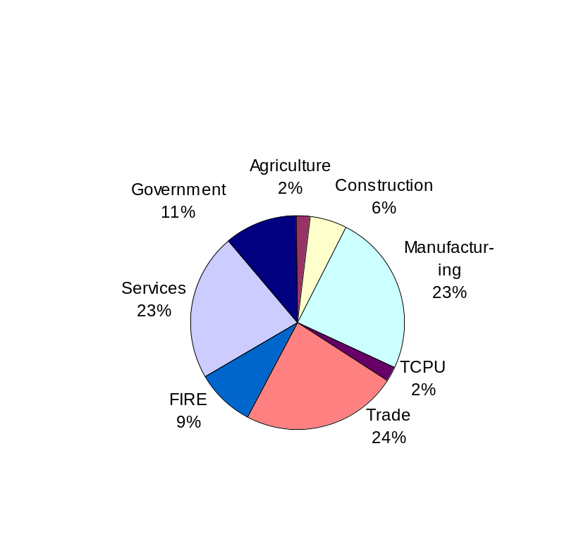
Figure 1, Employment by Industry, 2002
Table 7, Employment and Average Wage by Industry in Middleborough, 2002

Industry | # of employees | % of Total | Average Annual Wage | Average Annual Wage (MA)
Total, All Industries* | 7,039 | 100.0 | $37,285 | $45,383
Subtotal, Private Sector | 7,015 | 99.7 | $37,180 | $45,292
Natural Resources and Mining | 65 | 0.9 | $30,680 | $36,192
Construction | 412 | 5.9 | $40,196 | $52,156
Manufacturing | 1,206 | 17.1 | $44,356 | $55,224
Wholesale Trade | 144 | 2.1 | $47,112 | $61,100
Retail Trade | 901 | 12.8 | $26,000 | $25,168
Transportation and Warehousing | 149 | 2.1 | $32,864 | $35,776
Finance and Insurance | 402 | 5.7 | $40,976 | $85,384
Real Estate and Rental and Leasing | 89 | 1.3 | $43,888 | $44,460
Professional and Technical Services | 336 | 4.8 | $52,052 | $73,060
Management of Companies and Enterprises | 707 | 10.0 | $74,724 | $64,012
Administrative and Waste Services | 313 | 4.4 | $45,032 | $30,784
Education and Health Services | 910 | 12.9 | $30,160 | $38,584
Leisure and Hospitality | 946 | 13.4 | $12,740 | $18,148
Other Services, ex. Public Administration | 414 | 5.9 | $20,228 | $25,012
Note: Natural Resources and Mining includes Agriculture, Forestry, Fishing, and Hunting. Education and Health Services includes Health Care and Social Assistance. Leisure and Hospitality includes Accommodation and Food Services.
Source: Mass Division of Employment and Training (DET) NAICS

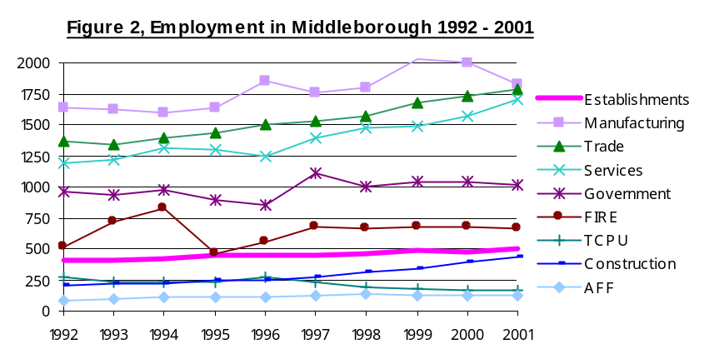In the last decade, Middleborough has seen steady growth in the number of business establishments. Recent increases in employment have been especially pronounced in the services sector, where the number of jobs increased by 42% between 1992 and 2001. Significant growth has also occurred in the construction industry where the number of jobs more than doubled in this same time period. The number of jobs in the agricultural sector has grown modestly.

The preceding figures understate the importance of agricultural employment in the town as many of the jobs are part time and many may not be reported to the Massachusetts Division of Employment and Training (DET). The salary scale in this industry is substantially above retail and segments of the service industry, which together provide nearly half of the town’s employment.

Ocean Spray Cranberries, Inc., the town’s largest employer, employs at least 750 workers in two plants. Many of these employees are seasonal. In addition, the Bridge Street facility is currently installing a new juice processing plant which will employ over 40 new positions of which 30 will be Middleborough residents. The remaining large employers (with 100 to 250 employees each) are a mix of banks, manufacturers, nursing care facilities, retail stores, and schools. Together, these businesses provide around half of the jobs in town.

Table 8, Largest Employers in Middleborough

Employer | Address | Type of Business | NAICS Code
500-999 employees
Ocean Spray Cranberries, Inc. | 1 Ocean Spray Dr. | Fruit & Vegetable Canning, Mfg., Merchant Wholesaler, | 31, 42, 54
Town of Middleborough |  | Municipal Government, Schools, Public Safety, Parks, Etc. | 61
250-499 employees
Ocean Spray Cranberries, Inc. | 152 Bridge St. | Packaged Frozen Food Merchant Wholesaler and Mfg. | 31, 42
100-249 employees
Plymouth Savings Bank | 151 Campanelli Dr. | Commercial Banking, Savings and Loans, Financing | 52
Pavestone Co. | 18 Cowan St. | Concrete Block & Brick Mfg. and Wholesaler | 32, 42
Brookfield Engineering Lab, Inc. | 11 Commerce Blvd. | Surgical & Medical Instrument Mfg. and Wholesalers, | 33, 42, 54
Glynn Electronics | 9 Clayton Rd. | Electric Components Mfg. and Merchant Wholesaler | 33, 42
Serta Mattress Co. | 61 Leona Dr. | Manufacturing and Distribution | 44
Stop & Shop Supermarket | 422 W. Grove St. | Supermarkets, Photographic Studios | 44
Victory Supermarkets | 8 Merchants Way | Supermarkets | 44
Winthrop-Atkins Co. | 35 E. Main St. | Commercial Printing, Office Supplies Mfg., | 32, 33, 54
Atrium Nursing & Rehab Center | 314 Marion Rd. | Nursing Care Facilities | 62
Oak Hill Nursing & Rehab Center | 76 North St. | Nursing Care Facilities | 62
Christmas Tree Shops | 64 Leona Dr. | Warehouse Distribution Center | 45
Fireside Grille | 30 Bedford St. | Limited Service Restaurant | 72
Middleborough Skilled Nursing | 23 Isaac St. | Rehabilitation Services | 62
Rockland Trust Co. | 10 John Glass Sq. | Commercial Banking, Consumer Lending, Real Estate Credit | 52
State Police | 326 W. Grove St. | Police Protection | 92
Source: ReferenceUSA 2003, Boston Public Library

Do Middleborough residents have access to the jobs and wage rates they want?

- According to the 2000 U.S. Census, the median household income in Middleborough was $52,755. The average annual wage in Middleborough for the same year was $33,139 (Mass DET). This indicates that few well-paying jobs were available at that time and a large percentage of residents either had two-income households or had to commute to other communities to find better wages. This is confirmed by household data shown in Appendix 2. Married couple families had a median household income of $65,000 in 1999 while the median income for single parent families was under $40,000. Middleborough’s median income in 1999 was slightly higher than the statewide median household income of $50,502.
- The median sales price of homes in Middleborough was $278,800 in 2003. To be able to afford this price, households need to earn approximately $89,500 per year, which is higher than what many people working in Middleborough can afford. Increasingly, residents either require two incomes or must work at higher paying jobs outside of Middleborough to meet basic living costs.

Where do Middleborough residents travel to find work? Who works in Middleborough?

See Appendix 14 for details. Despite the fact that more jobs are available in the town of Middleborough, fewer residents are working in their own community than a decade ago (2000 U.S. Census).

About one fourth of working residents have jobs in Middleborough, while the rest are employed in other towns.

About 30% find work in neighboring communities, including Brockton, Bridgewater, Lakeville, Taunton, Plymouth, Raynham, Quincy, and West Bridgewater.

The mean travel time to work is over a half hour, having increased by approximately 7 minutes over the last decade.
- Close to 40% of employees in Middleborough in 2000 were residents of the town.
- A third of employees came from nearby communities, including Lakeville, Taunton, Brockton, Wareham, Bridgewater, Plymouth, Carver, New Bedford, and Raynham.

Employment and Skills of Middleborough Residents
  - The largest number of Middleborough residents is employed in retail, manufacturing, health care, and construction industries. Women outnumber men in service industry jobs by more than 2:1, particularly in health care and education. On the other hand, men far outnumber women in construction, manufacturing, and transportation/utilities industries.
  - Approximately 36% of Middleborough residents have a high school diploma, while 22% have an Associate’s or Bachelor’s degree, and 5% have a graduate of professional degree. Women are slightly in the lead over men in higher educational attainment.

Figure 3, Industry of Employment, Middleborough Residents

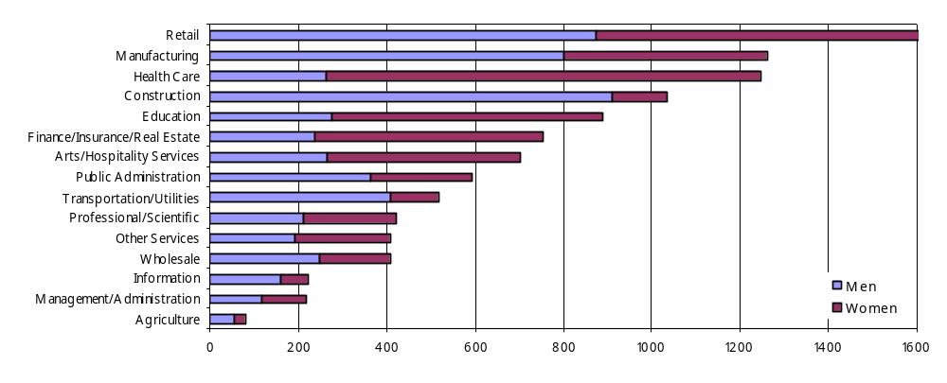Source: 2000 U.S. Census

Based on the skills of existing workforce in Middleborough, and the types of businesses which already have a strong presence in Middleborough, the town would be well poised to attract additional manufacturing, health care, construction, and other services.

Employment Projections
- The Mass DET report, SDA Long-Term Job Outlook Through 2008, predicts regional trends in 16 regional sections of Massachusetts. Middleborough is considered a part of the South Coastal SDA (Service Delivery Area, created for the purpose of allocating federal job training funds), which includes communities from Milton to Plymouth. It is expected that in the region, 24,300 new jobs will be created and 51,500 replacement jobs will open up by the year 2008. The South Coastal region is the fifth largest in the state, with 6% of the state’s jobs, and is expected to have the fourth largest number of new jobs created in the State.
- SRPEDD projects that employment in Middleborough will more than double by 2025, reaching a total of about 15,300 jobs. (Projections based on 2000 employment of 7,300 for Middleborough.) In contrast, MassHighway projects a more moderate employment growth of 32% in Middleborough to a total of 10,900 jobs (based on 2000 employment of 8,300). This figure is consistent with Mass DET projections of 11% employment growth in the South Coastal SDA by 2008.
- Infrastructure improvements including the widening of Route 44 and Rotary reconstruction will boost Middleborough’s economic growth potential.
Table 9, Projected Wage and Salary Job Openings by SDA and Industry
 | 1998 Wage and Salary Jobs | Projected 2008 Wage and Salary Jobs | Projected New Jobs | Growth Rate
Construction | 9,890 | 10,580 | 690 | 7%
Manufacturing | 16,300 | 13,860 | (2,440) | -15%
TCU | 7,690 | 8,090 | 400 | 5%
Trade | 56,950 | 60,230 | 3,280 | 6%
FIRE | 23,980 | 24,360 | 380 | 2%
Services | 62,670 | 81,580 | 18,910 | 30%
Government | 21,870 | 23,400 | 1,530 | 7%
Total (Nonfarm) | 199,350 | 22,100 | 22,750 | 11%
TCU = Transportation, Communications & Utilities, FIRE = Finance, Insurance & Real Estate
Source: Mass DET

- Employment is expected to grow by 11%, and 7% of the total new jobs in the state are expected to be generated in the region.
- Within the South Coastal region, DET predicts that the largest employment growth will take place in the Services industry, especially in health and social services (43%), and business (39%). Other sectors will provide moderate employment growth, with the exception of manufacturing, in which job losses are expected.
- Wholesale and retail trade is expected to diminish relatively in the amount of new jobs it creates, but these sectors are expected to remain as the SDA's second largest employer.
- Local and state government growth is predicted to follow growth in population and business, while federal government job growth is expected to decline.
- Manufacturing is expected to decline in the decade although not as rapidly as it has been in the past years.

Table 10, Employment by Occupation
 | 1998 Distribution | New Jobs | Growth Rate
Exec, Admin, Managerial | 10.3% | 2,720 | 12.3
Professional Specialty or specialization | 23.1% | 11,710 | 23.7
Marketing and Sales | 15.3% | 2,560 | 7.8
Admin Support and Clerical | 16.1% | 890 | 2.6
Service | 17.6% | 5,630 | 14.9
Production | 17.5% | 830 | 2.2

Impact on Workers
- Demand for professional and technical workers should increase the fastest and create the most jobs, accounting for 48% of the forecasted new jobs in the South Coastal region
- Demand for service workers will create the second largest number of new jobs in the South Coastal SDA, at 23% of new jobs.
- Much of the service-related growth is fueled by health services.
- The third largest number of jobs will be created for executive, administrative and managerial workers, followed closely by marketing and sales.
Topic 2: What land use mix is needed to retain fiscal balance?

A key issue to consider in the master plan is the fiscal condition of the town and the need to adjust the mix of land uses to provide additional tax revenue. Property tax provides approximately 40% of the town’s annual budget ($22 million out of $50 million), with State aid and local receipts covering most of the balance. It is important for Middleborough to maintain a diverse tax base, in part to balance the residential portion of the tax levy but also to give the town a good bond rating.

Indicators of Fiscal Health
The town of Middleborough must continually assess its mix of land uses with respect to how they contribute toward funding local services. The following five questions are of concern to the town:
- How is the Town’s bond reflected in the Town’s fiscal and economic condition?
- How do commercial and industrial properties contribute to the existing tax base?
- How much new growth in town is taking place and what is the mix, i.e., residential, commercial, industrial? How do mobile home parks affect the balance?
- Is the commercial tax rate appropriate? What other strategies can the town use to attract and support businesses?
5. What type of development is needed in order to improve the town’s fiscal condition?

A strong economy promotes a better bond rating which provides fiscal benefits.
The Town’s bond rating provides an indication of the town’s economic health. When setting the bond rating, agencies consider factors such as the diversity of the town’s tax base, the strength of the local and regional economic base, and municipal financial management to determine whether the town will be able to meet loan obligations. The bond rating directly impacts the town’s fiscal health as it affects the interest rate when the town needs to borrow money for infrastructure improvements.

The Town currently has an A2 Bond rating which is up from the A3 rating which the town had in the past four years. Throughout the 1990s the town maintained a higher “A” rating. The current rating is within the range of acceptable but below the three highest ratings of AAA, AA, and A.

The tax base is increasingly dominated by residential uses.
As of FY04, residential uses form approximately 84% of the town’s tax base. Commercial property represents close to 12% of valuation in the town while industrial property contributes approximately 3% of the valuation. These percentages have shifted in the past year as residential values have increased approximately 40% in contrast to a 20% increase in commercial values. Prior to the most recent revaluation in FY04, residential values comprised less of total valuations (81%).

Table 11, Middleborough Tax Base (FY 03 and FY04)

Tax Classification  FY 2004 | Assessed Valuation  FY2004 | % of Total Valuation | Tax Rate (per $1,000) | Tax Levy | % of Total Tax Levy | Assessed Valuation  FY2003 | % of Total Valuation | Tax Rate (per $1,000)
Residential | $1,549,405,274 | 84.3% | 11.67 | $18,081,556 | 82.9% | $1,074,256,244 | 80.6% | 15.29
Commercial | 214,275,417 | 11.7% | 12.90 | 2,764,147 | 12.7% | $192,740,471 | 14.5% | 16.99
Industrial | 47,706,648 | 2.6% | 12.90 | 615,407 | 2.8% | $37,249,649 | 2.8% | 16.99
Personal Property | 26,148,754 | 1.4% | 12.90 | 337,309 | 1.5% | $28,716,142 | 2.2% | 16.99
Total Taxable Property | $1,837,536,093 | 100.0% |  | $21,798,419 | 100.0% | $1,332,962,506 | 100.0%
The Town maintains a split tax rate, meaning that commercial and industrial property owners pay a higher rate than homeowners. In FY04, total tax revenue from commercial/industrial/personal property (CIP) uses comprised 17% of the tax levy which is raised by local property taxes, down from 21% in FY03.

In FY03, Middleborough’s receipts totaled $50 million, of which the tax levy contributed 41%. Middleborough’s budget ranks third in the region behind Plymouth and Taunton and closest to Wareham in scale. Table 12 shows that the proportion of the Town’s budget that is paid for by tax revenues is on the lower side of communities in the region and the statewide average. Middleborough receives a substantial portion of its budget from state aid (37%), which is lower or comparable to a few of the neighboring communities but higher than the state average.

Middleborough receives 13% of its budget from local receipts (including motor vehicle excise tax, "other charges for services" such as revenue from nursing homes, ambulance services, municipal light services and charges for water services, penalties, interest on taxes, payment in lieu of taxes, water, sewer and trash revenue, licenses and permits and investment incomes) and other sources.

Table 12, Municipal Revenues by Source (FY03)

 | Total Receipts | Tax Levy as % of Total Revenue | State Aid | Local Receipts | All Other
Plymouth | 139,814,532 | 56.29 | 20.78 | 14.28 | 8.65
Taunton | 130,798,530 | 33.66 | 38.16 | 19.00 | 9.18
Middleborough | 50,216,640 | 41.46 | 36.79 | 12.61 | 9.14
Wareham | 48,888,921 | 43.69 | 31.75 | 20.07 | 4.49
Bridgewater | 39,699,123 | 52.76 | 12.24 | 23.17 | 11.84
Kingston | 30,266,025 | 50.44 | 19.48 | 21.80 | 8.29
Carver | 27,051,829 | 45.05 | 43.81 | 5.83 | 5.31
Raynham | 23,599,184 | 64.69 | 7.47 | 14.92 | 12.92
Lakeville | 16,796,630 | 64.91 | 19.66 | 11.96 | 3.47
Plympton | 6,012,834 | 67.97 | 14.72 | 6.65 | 10.66
Average of surrounding communities | 513,144,248 | 52.09 | 24.49 | 15.03 | 8.40
State Average | 16,721,962,244 | 50.80 | 27.08 | 17.13 | 5.00
Source: Massachusetts Department of Revenue Division of Local Services Municipal Data Bank

The 2001 Master Plan undertook a fiscal analysis (based on FY2000 data) which determined that residences roughly break even given the town’s high level of State funding for schools. Important variables that determine the cost/revenue outlook are the number of school-aged children and the value of homes. The same study estimated that businesses generate a fiscal surplus.

New growth and inflation disproportionately increase residential valuation.
In the past year residential valuation has increased by 47%, commercial by 25% and industrial 8%. Personal property increased by 20%. The substantial increase in residential valuations resulted from both a regional inflation in values as well as new single family home construction.

Mobile homes have substantially increased the town’s housing units without contributing much to total residential valuation. Trailer owners must pay an excise tax currently set at $144/year. The developer who owns the land is required to pay property tax at the residential rate. For Oak Point, the property tax paid by the developer for the 385 units sold to date, together with excise tax receipts, is roughly equivalent to the tax revenue from 57 single family homes valued at $300,000, with approximately 25% of this revenue being collected through excise taxes. The lower revenue is somewhat mitigated by the fact that these units do not generate any school costs, and the developer provides some of the traditional municipal services to the development, such as road maintenance, snow removal, street lighting, security, etc.

The commercial tax rate is on target.
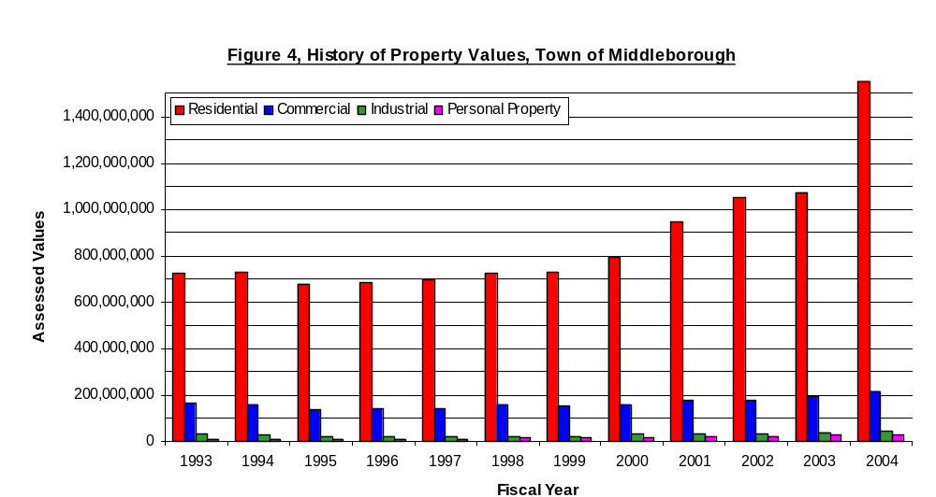It is essential that Middleborough continue to maintain both a balanced mix of land uses as well as reasonable revenues from property taxes to ensure sufficient funds to cover the expense of municipal services and education. The pressure for Middleborough to maintain a favorable tax rate, especially in order to attract commercial uses, is apparent when considering the tax structure of Middleborough’s neighbors.

- In 2003, Middleborough ranked fourth out of ten surrounding towns in the percentage of CIP valuation (see Table 9). In 2003, CIP properties comprise 19% of the total valuation in Middleborough, which was only surpassed by Plymouth (29%), Raynham (28%), and Taunton (23%).

- Middleborough receives just over 20% of its tax revenue from CIP property. Taunton, Raynham and Plymouth receive larger proportions of their tax levies from CIP uses (29-38%), while residences pay the bulk of the tax levies in all the other neighboring communities.

- Only three communities out of these ten have split tax rates for CIP property: Raynham, Taunton, and Carver. Furthermore, among these towns, Middleborough’s CIP shift is the smallest. Nevertheless, Middleborough’s commercial/industrial tax rate is the third highest among the ten towns.

- Despite ongoing concern against increasing the commercial tax rate, the town did increase commercial rates by 10% this past year. This was necessary because with a 40% increase in residential in contrast to a 20% increase in commercial valuations, there was added pressure to avoid giving homeowners a disproportionate tax increase.

- On the other hand, further increasing the commercial tax rate to alleviate the substantial pressure from residential property owners would be unwise, as it might hurt the town’s economic base without generating much tax relief.

Table 13, Valuation, Tax Rates and Shifts for Commercial, Industrial and Personal (CIP) Property (FY03)

 | CIP as % of Total Valuation | CIP Shift | Actual CIP Tax Rate | CIP % of Total Tax Levy
Plymouth | 28.7 | 0 | 12.30 | 28.7
Raynham | 28.1 | 1.88 | 16.31 | 30.7
Taunton | 23.5 | 12.47 | 24.99 | 38.0
Middleborough | 19.4 | 1.70 | 16.99 | 21.1
Kingston | 17.8 | 0 | 14.30 | 17.8
Carver | 13.0 | 6.22 | 20.86 | 17.6
Lakeville | 15.7 | 0 | 12.04 | 15.7
Wareham | 13.5 | 0 | 9.74 | 13.5
Bridgewater | 9.8 | 0 | 10.99 | 9.8
Plympton | 8.8 | 0 | 15.15 | 8.8
Average of surrounding communities | 17.8 | 5.57 | 15.37 | 20.2
Source: Massachusetts Division of Local Services

Alternative Strategies to Attract and Support Businesses
The difference between commercial and residential tax rates is only 10%. It is not clear that switching to a single rate would provide that much more incentive to attract commercial businesses. Continuing to utilize Tax Increment Financing (TIF) to reduce the tax burden for new businesses might be a more successful strategy for competing with neighboring towns to attract new commercial investment. Other issues such as infrastructure and permitting, if rationalized to encourage economic development, would probably have more long term benefit. In addition, the town needs to continue a policy of providing tax breaks in exchange for developers sharing in on and off site infrastructure costs. Education and training programs would not necessarily promote economic growth in Middleborough unless they were tied to businesses already located or newly locating in town. Moreover, the Town’s administrative capacity is limited to oversee such programs.

Focused commercial development and town-wide growth management are needed to maintain sustainable fiscal balance.

Should the town focus on maintaining the current balance of CIP versus residential tax levy or focus on promoting development that best meets community needs?
The scale of commercial development that would be required to keep pace with residential growth is unsustainable over time, and would likely be detrimental to the community. A strategy of protecting agriculture and other private open spaces, while promoting high-value commercial uses in areas that have infrastructural capacity will keep the town in fiscal balance.

Maintaining CIP Balance
From 1998 to 2003, Middleborough’s residential property valuation increased by an average of $80 million per year, including new growth and inflation. In order for CIP property to continue to contribute 20% of the town’s tax levy, roughly $15-19 million in new commercial valuation would be required.

Assessed value of a few sample businesses organized by business type provide a yardstick for identifying how many and what type of business would need to be attracted to Middleborough in order for the town to maintain the same ratio of residential/commercial valuation. To keep pace with residential growth and inflation, the town would need to bring in something equivalent to eight Osco Drugs, or four Southeast Health Centers, or two Serta Mattresses each year, or a Christmas Tree Shop every two years. Clearly this scale of commercial development would impact the town’s character and burden its transportation and natural resources.

Table 14, Sample Business Property Values
Sample Business | Business Type | Value/Sq. ft.* | Total Land & Building Value**
Wood Ventures | Warehouse | $30/ft | $600,000
Christmas Tree Shops | Distribution | $40/ft | $26,000,000
Serta Mattress | Light Manufacturing | $50/ft | $7,500,000
Osco Drug | Strip/Retail | $70/ft | $2,000,000
Fairfield Inn | Hotel | $75/ft | $5,000,000
The Travelers | Office | $85/Ft | $1,000,000
Southeast Health Center - 18 condo units | Medical Office | $154/ft | $4,000,000
*Note: The per sq ft. valuation reflects an average for the use type
** Total Values have been rounded

Community Services Costs and Benefits
Commercial and industrial land uses typically generate a fiscal surplus in the order of $0.20 for every dollar of revenue they generate. This varies with different types of businesses. Single family residences, on the other hand, typically break even or generate a net deficit. The land use which is most beneficial in terms of fiscal balance is privately-owned undeveloped open space, which contributes property tax but incurs virtually no community service costs. Compact, focused development such as multifamily or commercial/industrial parks are typically net revenue generators, as they do not require as much infrastructure and maintenance as “sprawl” type development.

The following table shows the fiscal and other community benefits (defined as employment generation and meeting local needs for goods and services) generated by various types of land uses. Employment generation is rated by the estimated density of employees per square foot for various business types, with the highest marks going for businesses that provide around one job per 200 square feet, and low marks for businesses that employ around one worker per 1,000 square feet. We also show whether the types of businesses provide generally high, middle or low wages.

Distribution and warehousing provide moderate fiscal and employment generation benefits (which are substantially increased when they are located within a managed industrial park with convenient highway access), while office uses, particularly medical offices and R& D offer the highest fiscal, employment, and community benefit. Agriculture also provides substantial fiscal and community benefits at very low cost.

Table 15, Fiscal Balance and Community Benefits for Types of Businesses
Business Type | Fiscal Balance | Employment Generation  (per unit of space/ income range) |  | Serves Local Residents and Businesses
Distribution/Warehouse | + | + | $$ | No
Light Manufacturing | = | + + | $$ | No
Managed Industrial Park | + + | + + | $$ | No
Strip Retail | - or = | + + | $ | Yes
Downtown Retail | + | + + | $ | Yes
Hotel | + | + + | $ | Yes
R&D/Biomedical | + + | + + | $$$ | Sometimes
Office | + + | + + + | $$$ | Sometimes
Medical Office | + + + | + + + | $$$ | Yes
Agriculture | + + + | + | $ | Yes

Given the need for municipal tax revenue, how much should the town be willing to sacrifice in order to attract commercial growth?

TIF is an important tool which has helped Middleborough to attract economic growth. Campenelli Industrial Park, for example, is currently paying over $400,000 in taxes, a rate which is some 66% below what it will be paying in twenty years, $1,200,000, at the end of the TIF Agreement (See Figure 5, p. 60). The town has benefited in jobs and general economic spending by having this industrial park. In addition Middleborough has laid the foundation for a substantial increase in revenue in future years.

The main issue is whether the town has lost too much revenue in order to generate this business. Furthermore, do the costs of on and off-site improvements undertaken by the developer justify this loss in badly needed local tax revenue? The answer to this question must be addressed in an assessment of each TIF project. A study is necessary to determine whether current TIF Agreements are in line with what other towns are offering to attract needed business.

The Town of Middleborough has a nine member TIF Committee. Members include the Town Manager, Town Planner, Town Assessor/Appraiser, Town Accountant, Town Treasurer/ Collector, OECD Director, and representatives of the Board of Selectmen, Planning Board and Board of Assessors. A financial analysis is prepared by the Town Assessor/Appraiser of each application for a Certified Project. The Committee is charged to respond to each application within 30 days. The town’s guidelines require that the project have a minimum investment of $1 million. The larger the investment the longer the town is willing to consider the duration of a TIF Agreement up to 20 years. The Committee is also concerned with the financial benefits to the town, the type of building use, site location, and job creation. The provision of off-site benefits to mitigate the impacts of a given project is an increasingly important consideration for the Committee.

Topic 3: How much commercial growth is feasible?

Regional Context: Economic Development Opportunities for Middleborough
In spite of its central location, the Town of Middleborough appears often to be the “hole in the donut” in terms of attracting regional economic growth. To the east, in Plymouth, one sees substantial growth in commercial and in particular retail activity. Likewise, to the west in Raynham and Taunton, there is a substantially higher rate of commercial as well as industrial growth.

Competing on the east and west against larger communities with more complete infrastructure and management capacity, the Town of Middleborough must continue to take advantage of its strengths: proximity to Route 495, lower land costs, good labor force, and lower housing costs, as it pursues a more limited, with respect to its neighbors, and focused economic development strategy.

Centrally located with excellent regional access
- 35 miles south of Boston
- 30 miles east of Providence, Rhode Island
- Northwest/southeast access on Interstate 495
- Southwest/northeast access on Route 44 (to Providence)
- Access to Routes 28, 79, and 105
- Freight rail service provided by CSX
- Commuter rail service (Old Colony line) in neighboring town of Lakeville (near Lakeville/Middleborough border outside of Town Center)

Regional Market
- Middleborough is among several communities which form the core of the region’s economic base. Of the communities sampled, Plymouth and Taunton have a greater share of economic activity in all major industries. Middleborough’s ranking with respect to wholesale and retail trade is relatively low, falling behind Plymouth, Taunton, Kingston, Wareham, and Raynham. But with respect to manufacturing, professional, service, and accommodation categories, Middleborough ranks in the top one half of these 8 towns. Several of the surrounding towns including Bridgewater, Carver, and Kingston, with few exceptions, have much smaller economic bases.
  - Retail trade generated $122 million in sales in Middleborough in 1997, considerably lower than most of the competitive neighboring towns. Middleborough likewise has a relatively small share of the region’s wholesale trade, with $41 million in sales.
  - Services industries: Health Care and Social Services form the largest share of the town’s service industry base (in terms of sales), followed by Accommodation and Food Services. This is also true of Taunton, Raynham and Wareham, while Kingston, Carver, and Bridgewater are more dependent upon hospitality-related businesses. Interestingly, Wareham, which unlike Middleborough is a coastal community, has a lower share of the region’s hospitality-related business.
  - Manufacturing generates more jobs (1,323) than any other business sector in town.
  - Professional, Scientific, & Technical: Middleborough has a modest share of the region’s businesses within this industry, retaining a relatively small number of employees.
  - Administrative & Support, Waste Management and Remediation: The town ranks third in the region in the number of establishments. This industry provides the second highest number of jobs in Middleborough but with a relatively low total payroll.
Table 16, Industry Performance for Selected Communities in Southeastern Region, 1997
Town | Bridgewater | Carver | Kingston | Middleborough | Plymouth | Raynham | Taunton | Wareham
Manufacturing
Establishments | 18 | 7 | 45 | 29 | 45 | 10 | 71 | 32
Payroll ($000) | - | - | - | 45,523 | 64,577 | - | 174,427 | 22,495
Employees | - | - | - | 1,323 | 1,700 | - | 4,465 | 720
Wholesale Trade
Establishments | 28 | 5 | 13 | 21 | 56 | 23 | 73 | 32
Sales ($000) | 217,037 | - | - | 40,798 | 580,273 | 85,960 | 644,460 | 86,497
Payroll ($000) | 7,286 | - | - | 4,466 | 24,512 | 6,865 | 56,175 | 8,985
Employees | 271 | - | - | 158 | 712 | 180 | 1,364 | 240
Retail Trade
Establishments | 64 | 30 | 160 | 72 | 150 | 91 | 252 | 107
Sales ($000) | 169,837 | 43,624 | 356,834 | 121,574 | 311,680 | 249,218 | 417,177 | 216,890
Payroll ($000) | 12,432 | 3,916 | 34,567 | 11,339 | 31,730 | 25,864 | 44,477 | 20,606
Employees | 917 | 262 | 2,930 | 697 | 1,979 | 1,572 | 3,261 | 1,279
Professional, Scientific & Technical
Establishments | 18 | 12 | 21 | 28 | 101 | 26 | 80 | 23
Sales ($000) | 4,828 | 2,399 | 3,145 | 15,114 | 32,905 | 18,516 | 31,385 | 13,524
Payroll ($000) | 2,148 | 1,296 | 1,026 | 6,129 | 11,712 | 6,642 | 13,341 | 6,784
Employees | 51 | 34 | 55 | 159 | 333 | 189 | 591 | 260
Administrative & Support, Waste Management & Remediation Services
Establishments | 15 | 7 | 17 | 19 | 58 | 18 | 40 | 16
Sales ($000) | 5,000-9,999 | 1,300 | 3,389 | 7,649 | 156,411 | 30,995 | 15,066 | 11,944
Payroll ($000) | 1,000-2,499 | 809 | 924 | 3,031 | 93,107 | 8,347 | 6,371 | 8,000
Employees | 50-99 | 162 | 190 | 811 | 2,863 | 633 | 248 | 427
Health Care & Social Services
Establishments | 23 | 8 | 13 | 44 | 126 | 20 | 88 | 33
Sales ($000) | 15,654 | 1,727 | 3,204 | 28,735 | 119,585 | 16,557 | 93,023 | 28,963
Payroll ($000) | 5,827 | 723 | 1,670 | 16,702 | 69,792 | 8,079 | 45,211 | 14,924
Employees | 249 | 41 | 71 | 702 | 2,351 | 390 | 1,425 | 680
Accommodation & Food Services
Establishments | 45 | 16 | 34 | 40 | 111 | 46 | 101 | 49
Sales ($000) | 26,302 | 4,495 | 23,789* | 24,672 | 62,673 | 29,899 | 23,400* | 19,549
Payroll ($000) | 6,813 | 1,024 | 6,564* | 7,356 | 17,996 | 8,122 | 5,900* | 5,143
Employees | 810 | 75 | 1,674* | 790 | 1,646 | 996 | 700* | 531
* Details for Accommodation and some Food Services are not reported due to the small number of establishments in certain sub-categories. Figures in the table include totals of all the sub-categories for which data is reported.
Source: US Economic Census 1997

What is the market for additional commercial/industrial growth?

According to Spaulding and Slye, real estate broker for the Southpointe property, the current market for specialty office or industrial space is very limited due in part to the weak national and regional economy. Modern, publicly subsidized industrial parks, such as those found in Taunton and Freetown, are very competitive. In addition, there is a great over-supply of older space, especially within the older industrial areas of Brockton and Taunton, which has the required infrastructure. There is a market, on the other hand, for “build to suit” space such as the Stop and Shop warehouse or food processing uses that have recently located in Freetown and Taunton and some of the manufacturing firms that have built in Middleborough. Middleborough is not well suited for a major destination shopping center, as the population density is not sufficient, and Plymouth and Raynham have emerged as retail regional sub centers.

Given the town’s current strengths in Manufacturing, Professional, Scientific and Technical, and Health Care, and the successful development of the Campanelli Industrial Park, the town needs to continue to identify other areas where they can encourage such economic growth. A discussion with Jeff Demarco of Campanelli revealed that the Town had put together a package of improvements which has enabled Campanelli to broker build to suit buildings for new tenants in under a year. The Town has provided the zoning, infrastructure and tax incentives needed to attract new businesses to select Middleborough against a substantial number of other locations. These factors together have enabled Campanelli to bring in 7 businesses containing some 1.4 million square feet with a total assessed value in the order of $60 million, and an estimated 1,900 jobs. The park has been able to attract large users such as the Christmas Tree Shops as well as a number of small users, start up manufacturing and engineering businesses occupying small, incubator spaces of 5-10,000 sq. ft. It is hoped that the later businesses will grow in Middleborough enlarging their local labor force.

What is the market for additional retail?

With the widening of Route 44, it is clear that access to the town, in particular to Plymouth on the east, as well as to Raynham on the west, will improve. As indicated on the regional map and Table 17, the radius for Regional and Super Regional shopping centers extends some 8-20 miles. Due to the rural density of Middleborough, its middle income population, and competition from the large scale retail malls in Plymouth and Raynham/Taunton, it is hard to imagine Middleborough attracting a large destination mall. But as access improves and more businesses and residences locate in Middleborough there will be an increased potential to expand the existing Town Center and develop a shopping center to serve the needs of residents and businesses along the Route 44 Corridor.

Limitations of public sewer and water are an absolute constraint on growth
Current studies by two engineering firms have identified the limitations of the existing pubic water and sewer systems. Growth of these systems must be carefully managed. Funding must upgrade the existing aging systems and build in some limited additional capacity. Given the size of the town, new development areas will need to address their own utility needs. Sprawl must be avoided to minimize the costs of new infrastructure.

In 2003, the Town retained the services of an engineering firm, Weston & Sampson, to undertake a sewer capacity study. The sewer system’s capacity, unlike most communities, is limited by the loading capacity to the river rather than by the capacity of the treatment plant. Middleborough is near the limit and must review each request for sewer extensions. Middleborough’s treatment plant is permitted at 2.16 mgpd. Additional expensive improvements could be undertaken to the plant to increase the amount of additional treatment possible. Current town policy is to reserve the remaining capacity for industrial users as the town needs the tax base and employment benefits. Sewer extensions must be reviewed on a case by case basis. Each industrial user has a different mix of effluent and the costs of treatment must be assessed. On-site septic systems will be needed in Middleborough for new growth. Systems under 10,000 gallons, i.e., 40 units, can be utilized by residential projects. If the development has over 40 units, they could install several smaller systems. Alternatively, a DEP approved Treatment Plant with a groundwater discharge permit is required for a single system with over 10,000 gallons. The Town will need to manage the development and maintenance of these systems to protect its water resources.

Amory Engineering is undertaking the preparation of a water supply capital improvement plan. The existing public water supply system covers the downtown areas, the Route 44 Corridor, North Middleborough, and Route 28 East to Rock Village and South Middleborough. The farther the system extends east, the more limited is the service. The area proposed in South Middleborough for a DOA has limited water service.

The Town currently has a backlog of improvements to undertake in the downtown in order to improve the flow and quality of the water. Two improvement phases were identified totaling some $8 million in order to clean and cement unlined mains and replace older mains with larger sized pipes. In addition the town needs to identify and land bank sites for storage tanks in east, north and south Middleborough. Furthermore, the town must continue to identify new locations for establishing well supplies to meet demands beyond 2025. Development of two previously identified well sites will be required to satisfy the current projected maximum daily demand shortfalls in order to provide supply redundancy if a well is out of service for extended periods of time.
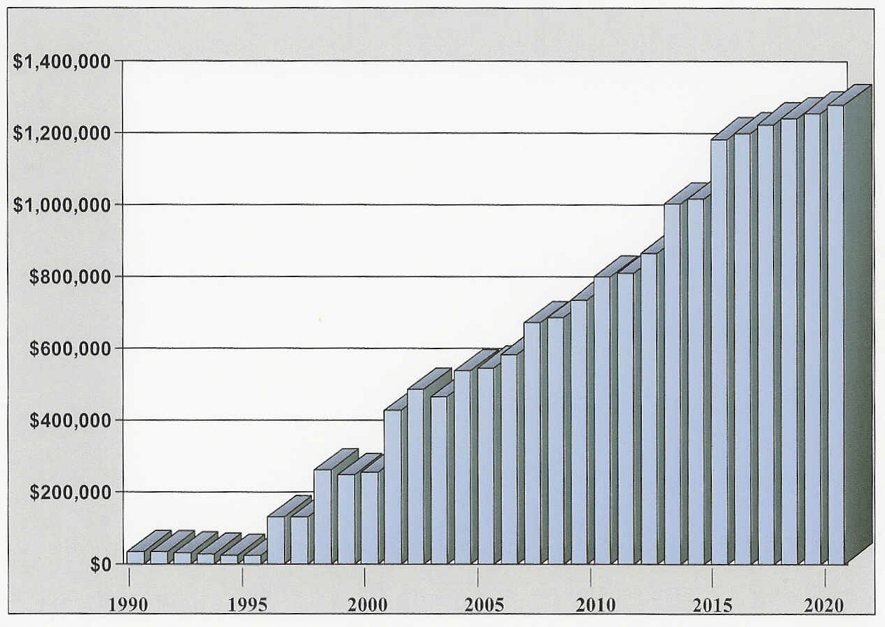
Figure 5, Tax Revenue Generated by the Campanelli Business Park, 1990-2020
Source: The Campanelli Business Park of Middleborough

Table 17, Types of Commercial Areas*

Commercial Area Types | Primary Trade Area | Population Market Area | Square Footage | Uses/Number of Stores
- Neighborhood | 1/4 mile | 2,500 - 4,000 | 1,000 - 5,000 | Convenience and service
- Community | 1/3 - 5 miles | 20,000 - 40,000 | 150,000
Highway Strip Commercial |  |  | 5,000 - 30,000 | - Convenience, service, drug store, groceries  - General Merchandise, Apparel, Other Shopping Goods
Shopping Center | 3 miles |  | 30,000 -100,000+ | - Groceries  - General Merchandise, Apparel, Other Shopping Goods, Furniture & Home Furnishings, Entertainment
Town Center | 5 miles |  | 250,000 | - Convenience, Eating & Drinking, Drug, Food, Banking, Personal Service, Professional Service, Government, Religious, Entertainment
- Regional | 8 - 12 miles | 200,000 | 1.5 million | 2 anchors
Town Center | 10 miles |  |  | - Convenience, Eating & Drinking, Drug, Food, Banking, Personal Service, Professional Service, Government, Religious, Entertainment
Regional Mall | 12 miles |  |  | - 2 anchors (full line Sept. stores)  - Convenience, Eating and Drinking, Entertainment, Banking
Power Strip Center | 12 miles |  |  | - Category Killers
- Super Regional | 15 - 20 miles | 1 million + | 1.5 million + | 4 anchors
Central Business District |  |  |  | - Convenience, Shopping Goods, Furniture and Home Furnishings, Government, Religious, Office, Medical, Entertainment
Regional Mall |  |  |  | - 4 anchors  - Convenience, Shopping Goods, Furniture and Home Furnishings, Government

*Adapted from an Urban Land Institute publication

Topic 4: Issues and Opportunities: Where can/should economic growth go?

What are the opportunities and barriers for local economic growth? As the following discussion indicates, the limited opportunity to provide the basic infrastructure required to accommodate large scale economic development (access, public water and sewer) in addition to a broad variety of natural resource constraints, together with the regional competition and market limitations, will minimize the town’s potential to develop a substantially larger economic base.

Of critical concern, therefore, will be the need for the town to 1) confirm the recommended priority areas for economic growth, 2) coordinate staff capacity to attract the desired mix of business, and 3) provide the best possible package of enticements including infrastructure, permitting, and tax policy. The model of the Taunton Industrial Park would be one (but not the only) approach for the town to consider. Identified below are the town’s major opportunities for economic development.

Priority Economic Development Areas
The Buildout analysis identified on Table 4 indicated the potential for in excess of 10 million square feet of commercial/industrial space. This is far more space than could be serviced with sewer and water and substantially more than current market projections would consider. It is also more space than would be permitted by the current zoning. This buildout does, on the other hand, provide a bench mark for considering where and how much growth the town should promote.

The six priority areas for economic development are the Downtown, the Development Opportunity Area at Route 44, the Rotary at Route 44, the Route 44 corridor, and the GU areas along Route 28 adjacent to the Downtown; Downtown West and Downtown Southeast (See Table 18 below and the Economic Development Opportunities Map). These sub areas have the best access and the highest visibility for commercial activity. Due to limitations of the town’s sewer system, only three of these areas are or will be adequately served by the town–the Downtown, the Route 44 rotary, and the DOD North Area. This will result in more limited growth potential for the three other areas, Downtown West, Downtown Southeast, and the Route 44 Corridor.

The Route 44 Corridor is expected to be the next area of growth potential. It is essential to identify the vision, modify the zoning, and assemble the organizational framework to address in a fashion similar to the DOA district, new development in this corridor. The current lack of a vision, infrastructure and zoning will greatly limit the area from achieving its full commercial potential.

The GU district located along Route 28 is adjacent to the Downtown, Downtown West and Downtown Southeast areas. This area has better access to I-495, is close to the Lakeville Station, and has greater visibility than the Downtown. The Downtown Southeast and portions of the Downtown West lack sewer infrastructure. Larger scale developments may find these locations attractive but will require the developer to provide their own infrastructure such as was developed at the Ocean Spray facility.

Rockville Village, Wareham Highway Commercial, and South Middleborough Village have long term growth potential which will be lost if the continued pattern of sprawl and permitting of marginal uses continues. While there is some water service in this area, especially Rockville, there are no prospects for public sewers.

Given the town’s large land area and its limited fiscal capacity to develop and manage roads, water, sewer and other public facilities to serve the entire town, it is essential that the town manage sprawl and focus new growth in targeted sub-areas as identified below.

Table 18, Business District Issues/Opportunities

Location |  | Opportunities | Barriers
1 | Downtown
 | Manufacturing  Office  - Retail  - Housing  - Tourist Attractions | - Ocean Spray on Wood St.: Juice manufacturing plant has been retrofitted to continue large scale manufacturing employing 30 new positions  - Read Screenall: To be redeveloped with office and light manufacturing  - Washburn Grain Mill: Mix of retail, office, light manufacturing  - St. Lukes Hospital: 40B housing – rental and condos  - Bay State Specialty: 40B condo – 33 units at end of Pierce St.  - Gerson Industrial: Pierce St. – re-use with 40B  - ? | - Need active economic development committee and funding for marketing/ promotion  - Vacant Jr. High: School Department to retain
2 | Downtown West | Encourage focused mixed use district | Water & Sewer improvements needed; Zoning/regulatory changes: Highway Business district, site plan standards
3 | Route 44 Rotary | Opportunity for lodging, business services, retail | Impact of Route 44 ramps on existing businesses
4 | DOD North | Work with developer on a more high tech orientation | Southpointe –Public leadership and Infrastructure needed to stimulate development of 1.85 million square feet of mostly warehouse/accessory office space
5 | Route 44 Everett to Plymouth St. | Tourism Study Area: Encourage a large scale user to create a master planned tourist/convention orientated facility | Route 44 widening will facilitate change; Town might consider an IPOD overlay district to protect area while zoning changed.
6 | Route 44/Everett St. | Convenient to Lakeville T stop | Small area, limited highway commercial opportunity; Town might consider an IPOD overlay district to protect area while zoning changed
7 | Route 44 Plymouth St. | - Access to Route 44 infrastructure  - Convenient to Bridgewater T stop | Route 44 widening will facilitate change; Town might consider an IPOD overlay district to protect area while zoning changed; No infrastructure
8 | Downtown Southeast | Encourage Highway orientated commercial and multifamily | No sewer; Zoning reforms needed
9 | Rock Village | Encourage a mixed use residential/commercial village center | No sewer; Zoning (site plan review)
10 | Wareham Street Highway Business | Encourage Highway orientated commercial | No sewer; Limited water
11 | South Middleborough | Encourage a mixed use residential/commercial village center | No sewer; Zoning (site plan review)
12 | DOD South | Explore opportunity to create a planned campus style industrial park; warehouse distribution | Water supply; no sewer
13 | Oak Point Village | Opportunity for limited neighborhood commercial | Isolated site; Potential for residential sprawl

- The Southpointe property is a major potential development site located off Routes 44 and 495. A 1.85 million square foot industrial development has been proposed, with a projected mix of 4 or 5 warehousing to 1 light manufacturing. Development of this property requires utilities, i.e., municipal water, sewer and gas. Access to Route 495 is a major attraction for this parcel. There is a suit underway concerning the development of a sub-parcel which has slowed the development process.

Resource and Economic Development Conflicts Emphasize the Need for a Coordinated Planning Process
Sound economic growth will require the protection of the town’s resources. The town’s sewer system is dependent upon the flows in the Namesket River. The town’s agriculture limits the need for government services and infrastructure while providing a small amount of local employment. The town’s historic resources and open spaces create a sense of place and character that attracts a growing number of tourists to the region. Protecting these resources while facilitating development to areas targeted for growth and infrastructure will ensure the long term fiscal and environmental health of the town. Close coordination is needed between all those boards concerned with resource protection, economic development, and planning.

Table 19, Resource Protection Conflicts

Conflict | Concern/Strategy
Need to Protect Agriculture | - Have local Agricultural Commission to work with farmers, town on developing support tools including new zoning, development rights funding, and technical support.  - Retreat Lots – keep land together. In residential districts, minimum lot size is 9.1 acres for RR, 6.89 acres for RA, and 2 acres for RB. Does this accomplish the objective to preserve agricultural land?  - Cranberry owners
Zoning issues | Existing commercial/industrial zones are located in environmentally sensitive areas or land that cannot support such development. GU district promotes chaotic, sprawling development, rather than defined nodes. Need to change zoning districts allowed uses and/or zoning map to focus commercial development in appropriate areas.
Nemasket River/ Assawompet Pond | River borders economic growth areas and Town Center with potential impacts on New Bedford water supply.
Route 44 Expansion | Pressure for economic development in areas where there are important agricultural and historic resources which need to be protected.

- VISION/GOALS

An economic development vision is identified below along with a series of goals to carry out this vision. More specific visions have been developed, as shown on Table 20, for each of the town’s proposed commercial areas.

Vision

Promote the growth of commercial activity which addresses the town’s need for a mix of high quality employment for local residents, provides for the expansion of the tax base, protects the environment, facilitates the expansion of tourism and the protection of a productive and sustainable base of local agriculture, without unduly impacting the town’s rural character and limited infrastructure.

Goals/Objectives

Continue Middleborough’s historic role as both a regional commercial center and a rural community
- Maintain the town’s rural character by providing the opportunity to combine natural resources with economic development such a recreation, eco-tourism, and agribusiness:
  - Promote Middleborough’s equestrian community, and cranberry production. Recreational facilities, 4-H, Soule Homestead, Pratt Farm, and other productive rural settings, as an agricultural and lifestyle niche.
  - Support and promote privately-owned open space areas that meet this goal.
    - Designate areas of town that would be most suitable for commercial development for uses which require the workforce skills of local residents as well as provide fiscal benefits to the town government:
- Reinforce the downtown as a healthy economic area that continues to function as the vital center of Town government and the community as a whole.
- Develop strategies to strengthen village areas as local centers of business and social activity.
- Identify appropriate locations for promoting new high tech, office, health care and services, as well as manufacturing and warehouse uses.
- Adopt an economic development strategy which makes Middleborough a destination:
- For retail activity, by diverting regional pass-by traffic
- For tourism, by showcasing natural resources, historic homes, sites and museums
- For industrial activity, by developing industrial parks with necessary infrastructure and support services
- Prepare strategic economic development plans for priority economic development areas which include:
  - Zoning
  - Design review and guidelines
  - Infrastructure planning
  - Workforce training
  - Phasing/build-out
  - Incentives such as TIF
- Aggressively pursue and support appropriate business development by reviewing and revising strategies to encourage the expansion and attraction of new businesses including TIF, streamline permitting, inter-Board coordination, workforce training, etc.

Table 20, Economic Development Visions for Middleborough

Location |  | Zoning | District type | Vision
1 | Downtown | B, RB | Mixed Use Business/  Residential | Downtown with mix of single family and multifamily residential; retail with residential uses above; commercial and institutional uses. Downtown overlay to encourage affordable housing, infill housing, greater densities.
2 | Downtown West | GU | Highway oriented mixed use | Highway oriented commercial and multifamily residential; buffers, shared parking, shared curb cuts, pedestrian connections to Downtown. Downtown Affordable Housing Overlay
3 | Route 44/Route 18 Rotary | GU, DOD | Highway oriented commercial | Highway Oriented commercial, hospitality, retail
4 | DOD, North | DOD | Campus Industrial/  Commercial | Planned, campus style industrial park; office, light manufacturing, warehouse, with accessory commercial
5 | Tourism Study Area (Route 44--Everett St. to Plymouth St.) | RA | Planned Development Area | Encourage large scale use which could preserve and protect resource areas concentrating tourist/convention orientated facilities on up-land portion of site
6 | Everett St. Highway Commercial | GU RA | Highway Commercial | Business services
7 | Route 44/Plymouth St. | RA, RR | Highway Commercial | Quality R&D office park, large scale commercial uses, and retail uses in a planned campus setting
8 | Downtown Southeast | GU |  | Highway oriented commercial and multifamily residential; buffers, shared parking, shared curb cuts
9 | Oak Point Village | RR | Village Center | Through zoning change, allow the development of neighborhood servicing commercial uses
10 | Rock Village | GU, GUX,  WRPD Z 2 | Village Center | Create a new residential/business zoning district for village centers (Rock Village and South Middleborough) that allow for a mix of commercial and residential uses. Allow for a Planned Unit Development (PUD) within these areas.
11 | Wareham Street | GUX | Highway Commercial | Larger scale commercial uses, retail, and support services
12 | South Middleborough | GUX |  | Create a new residential/business zoning district for village centers (Rock Village and South Middleborough) that allow for a mix of commercial and residential uses. Allow for a Planned Unit Development (PUD) within these areas.
13 | DOD, South | GUX, GUA |  | Planned, campus style industrial park; office, light manufacturing, warehouse, with accessory commercial

- RECOMMENDATIONS: TOOLS FOR ECONOMIC GROWTH

Appropriate economic development will not take place in the Town of Middleborough unless a six pronged strategy as outlined below takes place. These strategies are focused at promoting five types of growth:
- Industrial Development
- Mixed Use Village Centers
- Commercial Development
- Tourism
- Agriculture

  - Establish consensus and priorities for economic development
The first priority for the Town of Middleborough is to establish a consensus on the locations and types of economic development which should be promoted in town. Should the Town pursue a public industrial park at Soutepointe, rezone the Route 44 corridor, and pursue economic development in South Middleborough? Where is new infrastructure going to go? Economic Development areas and priorities need to be established. Most communities have developed a hierarchy of commercial and industrial districts to attract the desired mix of desired economic development. The benefits of targeted development strategies are clearly evident as one views the mix of uses and the quality of infrastructure present in the Campenelli Industrial Park. Fourteen proposed development areas are described below and located on the Economic Development Opportunities Map.

Table 21, Development Area Visions

Location |  |  | District type | Vision
1 | Downtown | Mixed Use Business/  Residential |  | Downtown with mix of single family and multifamily residential; retail with residential uses above; commercial and institutional uses  Downtown overlay to encourage affordable housing, infill housing, greater densities.
2 | Route 28/Downtown West | Highway oriented mixed use |  | Highway oriented commercial and multifamily residential; buffers, shared parking, shared curb cuts, pedestrian connections to Downtown  Downtown Affordable Housing Overlay
3 | Route 44/Route 18 Rotary | Highway oriented commercial |  | Highway Oriented commercial, hospitality, retail
4 | DOD, North | Campus Industrial/  Commercial |  | Planned, campus style industrial park; office, light manufacturing, warehouse, with accessory commercial
5 | Tourism Study Area (Route 44--Everett St. to Plymouth St.) | Planned Development Area |  | Encourage large scale use which could preserve and protect resource areas concentrating tourist/convention orientated facilities on up-land portion of site
6 | Route 44/Everett St. | Highway Commercial |  | Business services
7 | Route 44/Plymouth St. | Highway Commercial |  | Quality R&D office park, large scale commercial uses, and retail uses in a planned campus setting
8 | Route 28/Downtown Southeast |  |  | Highway oriented commercial and multifamily residential; buffers, shared parking, shared curb cuts
9 | Oak Point Village | Village Center |  | Through zoning change, allow the development of neighborhood servicing commercial uses
10 | Route 28/Rock Village | Village Center |  | Create a new residential/business zoning district for village centers (Rock Village and South Middleborough) that allow for a mix of commercial and residential uses  Allow for a Planned Unit Development (PUD) within these areas
11 | Route 28/Wareham Street | Highway Commercial |  | Larger scale commercial uses, retail, and support services
12 | Route 28/South Middleborough |  |  | Create a new residential/business zoning district for village centers (Rock Village and South Middleborough) that allow for a mix of commercial and residential uses  Allow for a Planned Unit Development (PUD) within these areas
13 | DOD, South (Routes 495/28) | Campus Industrial/  Commercial |  | Planned, campus style industrial park; light manufacturing, warehouse, distribution with accessory commercial
14 | Taunton River Live/Work Space | Live/Work Space |  | Estate lots for environmentally sensitive live/work space
  - Reorganize public oversight of economic development activities
The Town of Middleborough currently has two committees concerned with economic development: the Business & Industrial Commission and the Downtown Committee. Both of these committees have a long history and were at one time directly involved in pursuing grants and attracting new business. Currently, neither group has a clear mandate from the Board of Selectmen, any staff support, or a clear plan of action supported by the town. For economic development to proceed, the Board of Selectmen must initiate a reorganization of these Committees. This reorganization would then be supported by and give direction to a comparable restructuring of the staff function for this activity.

  - Broaden staff support for carrying out economic development program
The Town of Middleborough’s Office of Economic and Community Development is not adequately staffed to address the full range of tasks required to pursue an economic development program. The Town of Middleborough, on the other hand, can learn from the City of Taunton. The city of Taunton utilized the services of SERPDD to prepare numerous grants for the development of the Myles Standish Industrial Park. An Economic Development Board provides direction and public support for the activities of the two person industrial park staff. A separate Community Development and Housing office with a staff of four and a part time secretary utilize a range of state grants to manage some $2-$3 million in program funds to carryout housing and economic development programs.

  - Prepare new zoning for economic development priority areas
The fourth change needed to adequately address the town’s program of economic development is new zoning. Table 21 and the Existing and Proposed Commercial Opportunity Areas Map identify and locate a proposed hierarchy of commercial districts. These include DOA, Mixed Use Centers, Highway Commercial Development Areas, Downtown, Retail/Service/Residential (similar to GU), Mixed Use Village Center areas, Agricultural District, Tourism District, Neighborhood Retail, and Live/Work Estate areas. Preparing the new zoning would be a substantial undertaking which will require staff support and the cooperation of a variety of Boards. Priorities must be established so that this process can proceed incrementally.

- Development Opportunity Districts
  - North Middleborough
    - Change the boundaries of the DOD in North Middleborough–Make district smaller to set back from residential streets
    - Work with owners of Southpointe. Consider establishing a public Industrial Park. A good model to follow is the Taunton Industrial Park.
- South Middleborough
  - Prepare a development plan
  - Proposed new zoning
  - Seek public funding for infrastructure
  - Prepare a simplified permitting process
  - Adopt design guidelines

    - Mixed Use Centers
      - Establish new zoning in Rock Village and South Middleborough for the following purposes
        - Permit a mix of residential and commercial uses in a village setting
        - Encourage a more pedestrian friendly environment
        - Develop retail and service uses which are needed for the adjacent residential areas
        - Discourage strip commercial uses that are more appropriate within the Highway Commercial district

- Highway Commercial
  - Adopt new district for Highway Commercial Development Areas at key locations to encourage dense, highway-oriented office, hotel, and destination retail uses. Coordinate new zoning with infrastructure planning.
- Route 28/44 the Rotary
- Route 44 at Everett Street
- Route 44 at Plymouth Street
- Route 28, Wareham Street, between Rock Village and South Middleborough

  - Downtown
    - Affordable Housing in Downtown Target Area
- Consider modifications to Business District, General Use and RA districts to facilitate affordable housing through TDR or other forms of inclusionary housing
- Modify General Use zoning in the Downtown West and Downtown Southeast districts to encourage mixed use and planned highway-commercial development to replace strip-oriented commercial development of GU district

  - Tourism District
    - Modify zoning to encourage development of hotels, motels, and bed & breakfasts within designated rural residential areas. Allow as a conditional use.
- Allow within estate areas development of ecotourism and cultural activity centers
- Establish historic protection policies, i.e. adopt Demolition Delay bylaw

  - Estate Live/Work Space
    - Change zoning in the northern part of town from Industrial to environmentally sensitive, large lot, live-work space

- Adopt Agriculture District Zoning
  - There are a number of strategies to consider, including establishing a TDR District. Other non-zoning strategies might also need to be considered.

    - Adopt policies and incentives to govern economic development
A number of policies have been suggested in response to the key questions asked in this analysis. A clarification of these policies will foster economic growth.

- Tax Increment Financing (TIF) and District Improvement Financing (DIF): The Town should consider establishing benchmarks for the discounts which will be considered for high, medium, and low priority projects. High Priority projects need to be identified. The policy statement should formalize current policy which is to provide tax breaks in exchange for developer funded off site public improvements and the provision of quality jobs assuming in the mid and long term the Town will obtain substantial tax benefits. Additionally, the Town should consider establishing District Improvement Financing (DIF) for the Downtown to provide infrastructure funding for Affordable Housing and Village Center Districts.
      - Balanced land use/Split Tax Rate: The Board of Selectmen should consider adopting as a matter of policy the goal of retaining a 20%:80% ratio of industrial to residential valuation. Given this goal, the Town will be encouraged to more aggressively pursue economic development. A related policy would consider the extent to which the town might increase the tax burden on commercial/industrial property given the inflation in residential values and the current split which is considerably below the town’s largest commercial competitor, the city of Taunton.

- Water and sewer service to industrial areas: It is essential that the limited treatment capacity be allocated to attract important industrial users. This strategy should be closely coordinated with improvements to the water supply and to proposed re-zoning.

- Protect agriculture: The town’s agriculture base generates the least public costs and the highest relative taxes. This industry provides numerous additional benefits including local employment. The Town’s Agricultural Commission needs to promote the implementation of additional strategies to protect this land use such as Community Preservation Act adoption, Land Trust, TDR, acquisition of development rights from a dedicated capital budget set-aside, and a local capital budget set-aside tied to the continued development of the Trailer Park.

- Streamline Permitting: More needs to be done to ensure that in priority development areas, all the Boards can work together to assist in facilitating appropriate economic development.

    - Marketing
      - Work with local museums, theaters, cultural institutions, Historic Districts, natural resource groups, and service clubs to promote tourism
      - Obtain regional economic development grants to promote tourism
      - This function needs to be assigned to a group with the capacity to fund and carry out a program.
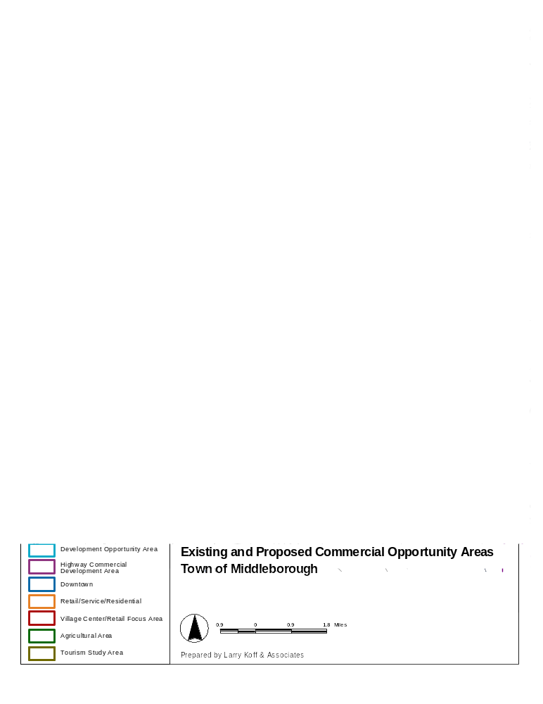
APPENDIX 1: EOEA Buildout Analysis

Summary of Buildout Capacity

Zoning District (% of total land zoned for district) | Single Family  (d.u.) | Two Family  (d.u.) | Total  (d.u.) | Future Residents | Future Students | Commercial/ Industrial  (sq. ft.) | Potential Employees | New Roadway  (miles)
Residence A (RA)  (15.5%) | 2,097 | - | 2,097 |  |  | 2,442,806
Residence B (RB)  (3.1%) | 699 | - | 699 |  |  | - | -
Residence Rural (RR)  (65.5%) | 6,271 | - | 6,271 |  |  | - | -
Business  (0.2%) | - | - | - | - | - | 118,299
Industrial  (1.4%) | - | - | - | - | - | 4,262,082
General Use  (14.3%) | 614 | 328 | 942 |  |  | 12,156,136
General Use X (GU-X)  (8.7%) | 430 | 149 | 579 |  |  | 12,395,018
General Use A (GU-A)
(5.6%)
Total
Note: Potential employees based on 1 employee per 400 square feet for commercial use and office use, and 1 employee per 500 square feet for retail uses.
Source: EOEA Buildout Analysis, 1999

APPENDIX 2: Middleborough Zoning
Zoning Summary
Use/District | RA | RB | RR | B | I | GU | GU-A | GU-X
Single Family Dwelling | Y | Y | Y | - | - | Y | Y | Y
Mobile Home Parks – Age Restricted | - | - | SP | - | - | SP | SP | SP
Conversion of single family to up to three dwelling units | SP | SP | SP | - | - | SP | SP | SP-
Multiple dwelling units in upper floors of existing buildings | - | - | - | SP | - | - | - | -
Multifamily | - | - | - | - | - | SP | - | SP
Institutional Uses | Y | Y | Y | Y | Y | Y | Y | Y
Agriculture, sale of agricultural products | Y | Y | Y | Y | Y | Y | Y | Y
Outdoor Recreation | SP | SP | SP | - | - | Y | Y | Y
Commercial Establishments | - | - | - | Y | - | Y* | Y* | Y*
Light Manufacturing | - | - | - | Y | Y | Y* | Y* | Y*
Manufacturing or Industrial use | - | - | - | Y | Y | SP | SP | SP
Zoning Districts: RA=Residential A, RB=Residential B, RR=Residential Rural, B=Business, I=Industrial, GU=General Use, GU-X=General Use X
Y = A use allowed by right in the District
SP = A use allowed by special permit.
(-) = A use which is not allowed in the District
Y* = A use which is allowed by right but limited to 20,000 square feet of gross floor area per lot
Zoning Characteristics
Zoning District | % of Town covered by this zoning district | Minimum Lot Area  (sq. ft.) | Effective Floor Area Ratio | Max Coverage
Residence A (RA) | 15.5% | 60,000
Residence B (RB) | 3.1% | 20,000
Residence Rural (RR)  Mobile Home Park | 65.6% | 80,000  20 acres (2 units/acre)
Business | 0.2% | NA | 2.0 | NA
Industrial | 1.4% | NA | NA | NA
General Use A  Single Family  Mobile Home Park  Commercial | 8.7% | 30,000  20 acres (2 units/acre)  NA | 0.34 | 60%
General X  Single Family  Multifamily  Mobile Home Park  Commercial | 5.6% | 30,000  40,000/unit  20 acres (2 units/acre)  NA | 0.34 | 25%  60%
General Use  Single Family  Multifamily  Mobile Home Park  Commercial | 14.3% | 30,000  30,000/unit  20 acres (2 units/acre)  NA | 0.34 | 25%  60%
Water Resource Protection Overlay Districts | 100% | 60,000 (Zone 2) |  | 25%
DOD | 00 |  | 3.0 | 50%

Overlay Districts
Development Opportunities District (DO): Provides for economic development expansion in a planned multi-use district. Uses allowed by special permit include any combination of manufacturing, high tech, warehouse, municipal, transportation, hotel, R&D, office, trade school, or country club. In addition, where the DO overlays a GU district, additional uses are allowed by special permit, including retail sales, service establishments, theaters, restaurants, and other places of public assembly. Minimum of 10 acres is required.

Open Space and Resource Preservation Development District: allows for an alternative to conventional subdivision within the RA, RR GU, and GUX Districts. A minimum of 5 acres is required. All dwelling units must be detached single family homes. The number of buildings may not exceed the number of lots that could be constructed with a conventional subdivision. The minimum lot size is 30,000 square feet (or 60,000 square feet within the WRPD), while 40% of the land area must be set aside as open space.

Flood Plain District: Regulates development within Flood Plain areas identified by FEMA.

Water Resource Protection Districts: Regulates development within areas that impact the town’s water resources. District A requires minimum lot size of 60,000 square feet where not connected to Town sewer. District B requires Special Permit for all uses allowed in underlying district. Both districts prohibit structures within 100 feet of several specified surface waters; a disturbance of areas within 100 feet is allowed by Special Permit if it does not exceed 15% of lot area within buffer.

Adult Entertainment District: Superimposed over Industrial District that abuts Rochester Town line, allows development of businesses which provide “Adult Entertainment”.
Appendix 3: EO 418 Profile for Middleborough

 |  |  | Massachusetts | Middleborough
A | Total households, 2000 Census |  | 2,443,580 | 11,623
B | Total households, 1990 Census |  | 2,247,110 | 11,018
C | Total household growth, 1990 - 2000 | C=(A/B)-1 | 8.7% | 5.5%
D | Average annual household growth, 1990 - 2000 | D=C/10 | 0.9% | 0.55%
E | Total housing units, 2000 Census |  | 2,621,989 | 11,945
F | Total housing units, 1990 Census |  | 2,472,711 | 11,584
G | Total housing unit growth, 1990 - 2000 | G=(E/F)-1 | 6.0% | 3.1%
H | Average annual housing unit growth, 1990 - 2000 | H=G/10 | 0.6% | 0.3%
I | Total occupied year-round ownership units, 2000 Census |  | 1,508,052 | 6,650
J | Total occupied year-round ownership units, 1990 Census |  | 1,331,493 | 6,276
K | Growth in year round ownership units, 1990-2000 | K=(I/J)-1 | 13.3% | 6.0%
L | Total occupied year-round rental units, 2000 Census |  | 935,528 | 4,973
M | Total occupied year-round rental units, 1990 Census |  | 915,617 | 4,742
N | Growth in year round rental units, 1990-2000 | N=(L/M)-1 | 2.2% | 4.9%
O | Vacancy rate for year-round ownership units, 2000 Census |  | 0.7% | 0.5%
P | Vacancy rate for year-round rental units, 2000 Census |  | 3.5% | 2.8%
Q | Vacancy rate for year-round ownership units, 1990 Census |  | 1.7% | 1.1%
R | Vacancy rate for year-round rental units, 1990 Census |  | 6.9% | 6.3%

APPENDIX 4: Attachment A Grant Programs Subject to EO 418 FY2004

Link between Housing Certification and Discretionary Grant Programs
This chart below lists the discretionary grant programs and the annual grant funds available for which Executive Order 418 Housing Certification is a threshold for application or for which bonus points are awarded in FY 2004.
- Competitive discretionary grant programs - Communities that attain housing certification will receive a 10% scoring bonus when applying for certain competitive discretionary grant programs administered by the Executive Office of Transportation and Construction, Executive Office of Environmental Affairs, Department of Housing and Community Development, and the Department of Economic Development. Bonus points are awarded based on the community’s housing certification status 15 calendar days after the grant program’s due date.
- Non-competitive and/or rolling applications - Communities that have attained housing certification are eligible to receive certain discretionary grant funds administered by the four agencies that are non-competitive, not scored, and/or are accepted on a rolling basis. The community’s certification status 15 days after submittal of a rolling grant application will determine whether the grant application will be reviewed.

Program & Funding Agency Annual Amount

Rolling Application Grant Programs (Housing Certification required but may be submitted at time of

application)

Department of Housing and Community Development
- Massachusetts CDBG - Ready Resource Fund (RRF) | $ 2,000,000
- Massachusetts CDBG - Community Capital Fund (MCCF) | 750,000
- Community Development Action Grant (CDAG) | 7,000,000
- Affordable Housing Trust Fund | 20,000,000
- Capital Improvements Preservation Fund | 45,000,000
Executive Office of Transportation and Construction
- Public Works Economic Development (PWED) | 15,000,000
- Small Town Rural Assistance Program | 1,000,000
Grand Total Rolling Application Programs (annual) | $90,750,000

Competitive Grant Programs (Housing Certification triggers approximate 10 percent bonus)

Department of Housing and Community Development
- Federal Low-Income Housing Tax Credits (LIHTC) | $11,000,000
- State Low-Income Housing Tax Credit | 4,000,000
- HOME | 15,200,000
- Housing Stabilization Fund (HSF) | 14,000,000
- Housing Innovations Fund (HIF) | 9,000,000
- Soft Second Loan Program | 4,000,000
- Lead Paint | 600,000
- Massachusetts CDBG-Community Development Fund I & II (CDF) | 24,250,000
- Massachusetts CDBG-Housing Development Support Program (HDSP) | 2,500,000

Executive Office of Environmental Affairs
- Self-Help Program | 5,000,000
- Urban Self-Help Program | 5,000,000
- Massachusetts Clean Water State Revolving Fund Program | 270,000,000
- Massachusetts Drinking Water State Revolving Fund Program | 120,000,000
- Massachusetts GIS Parcel Data Program | 500,000
Department of Economic Development
- The Minority Economic and Community Development Grant Program (MECD) | 525,000
- The Massachusetts Tourism Competitive Grant Program | 1,289,931
Grand Total Competitive Grant Programs (Annual) | $486,864,931
Grand Total All Grant Programs (Annual) | $577,614,931
APPENDIX 5: EO 418 Standards for Affordability

What is affordable housing?
There are now two standards for identifying what is considered affordable housing. Executive Order 418 has provided a broader benchmark for communities so as to include the substantial unmet needs for providing middle income housing which would support teachers, public safety personnel and other residents currently living and working in our communities.

Low/Moderate Income Standard
Standards for subsidized affordable housing typically target low and moderate income households earning up to 80% of the median family income. Various housing subsidy programs have their own requirements for affordability and income eligibility for specific housing developments differently, but for the most part housing that meets 40B requirements serves households in this income group. Middleborough is in the Brocton Primary Metropolitan Statistical Area (PMSA), for which the median family income in 2002 was estimated to be $63,500. Under this standard, low/moderate income households earn up to $50,800. Households with this income are assumed to afford a maximum monthly rent of $1,270, or 30% of their income.

Middle Income Standard
Some state programs which do not rely on subsidized housing allow for a higher income standard in their definition of affordability. Executive Order 418 states that rental units are considered affordable if they cost a middle-income household earning 100% of median family income no more than 30% of the household income or $1,590/month (in 2002). Owner-occupied housing units have been defined as affordable if they can be purchased by middle-income households earning up to 150% of the median income, or $95,250 (in 2002). Homes valued at up to $314,491 are considered to be affordable under this standard.

Town vision, another standard for assessing housing needs.
What type of community do the residents of Middleborough vision for themselves? Should there be a mix of housing types, affordable to individuals and families with a range of incomes? Are there locations where density can be accommodated in order to meet the housing needs of individuals or families who do not need to live in single family homes? Are those with disabilities offered opportunities to live in town? Are there housing choices for young families, the elderly, public employees? Are there opportunities for inclusive patterns of housing occupancy regardless of race, color, religion, sex, familial status, disability and national origin? What role should local government and local non-profit organizations play in protecting and improving the mix of housing to retain town character?
APPENDIX 6: EO 418 Strategies to Develop Affordable Housing

Identifying Strategies to Develop Affordable Housing
Under Executive Order 418 the town must obtain Housing Certification in order to qualify for a variety of state grants. The town will again need to submit material to obtain certification, including Category A, a listing of recent sales as well as rental housing, Category B, an identification of strategies to achieve affordable housing identified below, and a Housing Action Plan. There are 36 identified tasks under Category B of which communities must undertake 14 within the next year. Category B strategies, listed below, will provide a framework for preparing the required Affordable Housing Plan.

CATEGORY B: Planning, Removing Barriers, and Creating a Positive
Atmosphere for Housing Development

Activities the community has undertaken to raise public awareness of the housing issue and plans completed including strategies to address identified housing needs, such as:

1. Within the past year, held a local or regional forum open to the general public on the housing needs or strategies to address housing needs in the community or region.  Provide the location, date, and number of attendees from the community for each meeting. Briefly describe the purpose of the meeting and how it was publicized. | - The focus should be on existing housing needs and development of housing to address those needs.  - Credit for regional forums will be awarded as long as the attendance list shows participation from both residents and officials from the subject community.  - Project specific meetings do not qualify as a forum.
2. Completed a local or regional plan that includes information on how the community/region will provide housing for people across a broad range of incomes?  List the name of the plan(s) or study(s), date of completion, and describe actions taken to implement the plan(s) within the past five years. | - For example, community development plan, housing needs study, or master plan Public Housing Authority (PHA) or HUD Consolidated Plans limited to the use of HUD or state housing funds, which do not include related strategies to address housing for households across a broad range of incomes are not acceptable.  - The plan or study must be current (within 5 years) and active.  - Credit for plans older than 5 years may be awarded if implementation activities have taken place within the past two years.
3. Within the past year, created and funded a full or part time municipal position to address housing issues, process permitting applications, or otherwise facilitate or encourage housing development?

Describe the position, its responsibilities, the date created, and funding source.

4. Within the past two years, identified municipally owned or controlled land and/or buildings that are suitable for the development of housing?

List the parcel(s) including location and estimate the number of affordable units that could be created.

5. Within the past two years, identified other publicly owned or controlled land and/or buildings that are suitable for the development of housing?  List the parcel(s) including location and estimate the number of affordable units that could be created. | - For the purpose of question #5 use the definition of "affordable related to E0418. See page 17 and Attachment B of Instructions. List may include tax title properties.
6. Formed and currently participate in a local or regional housing partnership or other housing group?  When was the partnership created? What types of individuals or organizations are members? Describe the relationship between the partnership and the municipal chief executive. If the organization is not a housing partnership, describe the purpose(s) of the organization. Describe recent activities that show that the partnership is active (include dates of activities and meetings.) | - Purposes of such groups must be similar to those for housing partnerships.  - Information on creation of housing partnerships is available on the MHP Fund website http://www.mhpfund.com.  - HOME consortium is covered in question #7.
7. Within the past year, acted as the lead for, or actively participated as a member of, a HOME consortium?

Describe the community's direct responsibilities as a lead or member community. Describe the number and type of units created through the consortium in the past year. Please specify the communities in which the units were created.

8. Within the past year, interested residents or organizations in the community or region raised money for the rehabilitation or development of housing?  For each fundraising activity describe the activity, its goal or purpose, date(s), and the amount raised. | - Question #8 does not include municipal appropriation. Provide that information in question #19.
9. Within the past year worked with local lenders or non-profit agencies to provide first time homebuyer education and counseling, housing search to assist people to buy their first home?

Describe the program and identify who was involved and the number of households or individuals assisted.

10. Within the past two years completed an analysis of the impediments to development of housing affordable to households over a broad range of incomes.

Summarize the findings.

11. Within the last year undertook activities related to Fair Housing?  Describe what was accomplished. | - This may include completing an analysis of the impediments to Fair Housing.

Grants or other public funds for housing production, affordability, or rehabilitation which the community has applied for and received, such as:

12. Within the past year, received grants for technical assistance expressly for the purpose of finding ways to produce housing and/or to streamline the permitting process?  Describe funding or technical assistance source, date of award, amount of grant award, if any, purpose or goal of assistance and list activities resulting from assistance. | - Such grants may include: Peer to Peer, Municipal Incentive Grants (MIG) Massachusetts Housing Partnership Technical Assistance grants, or any comparable regional or municipal technical assistance.
13. Within the past year, received grant or public funds that increased the supply of low- and moderate-income housing and/or assisted the promotion of affordable homeownership, e.g., HOME, HSF, and HIF? These grants could also include activities that assisted in the preparation of sites in order to make them suitable for housing production (e.g., brownfields, HOME, CDBG HDSP).  Describe funding program source, date of award, amount of funding, purpose or goal of assistance, and describe what was accomplished as a result of the funding. | - Entitlement communities should include HUD funds in this question. If funds have been received as pail of a regional consortium, information must be provided showing that a portion of the funds were used within the applicant community. Describe housing rehabilitation grant awards in question #13 not here.
14. Within the past year, received grant or other public funds to take part in a local or regional program for housing rehabilitation and/or septic system repair program to preserve existing housing stock or enable housing production?  Describe the program and funding source, the amount of grant or other funding dedicated to the program. What was accomplished through the program? | - Entitlement communities should include HUD funds in this question If funds have been received as part of a regional consortium, information must be provided showing that a portion of the funds were used within the applicant community.

Activities which the community has undertaken to improve the affordability of housing, such as:

15a. Within the past year, worked with private lending institutions or other financial service establishments to make available concessionary financing or other mechanisms that improve housing affordability and/or provide homeownership opportunities for low- and moderate income families?  15b. Within the past year, worked with MHFA or other quasi and nonprofit agencies to make available concessionary financing or other mechanisms that improve housing affordability and/or provide homeownership opportunities for low- and moderate-income families?  Please list the institution(s), and describe the city's or town's relationship with the institution(s). Describe the products created and indicate how many individuals, families, and/or units are expected to be affected annually. | - One point possible for question #15 even if community has accomplished both a and b.  - Do not include grants or loans for housing rehabilitation loans here. Provide that information in question #13.  - Examples of mechanisms include: First Time Homebuyer and Soft Second Mortgage programs.  - The intent of these questions is to show how lenders and/or non-profits or quasi-public agencies have assisted in making housing more affordable.  - For the purpose of question #15 use the definition of “affordable” related to E0 418. See page 17 and Appendix B of the instructions.
16. Within the past two years, provided municipally owned or controlled land or buildings at no cost or below market cost to a housing developer for the purpose of creating low- and moderate income housing? (For example, Habitat for Humanity or other nonprofit organizations).

For each donation identify: Location, developer, amount of land (or size of building), projected total number of units to be created, and the projected number of low- or moderate-income affordable units to be created. Provide the date of vote of town meeting or council meeting authorizing the transfer of the property.

17. Formed a local or regional Affordable Housing Trust that can receive tax-deductible, charitable and other donations that would be used to develop or rehabilitate housing?  Provide the date of the IRS letter certifying the trust's IRS tax exemption and a description of the purpose of the trust; or if the trust is a municipal fund account, cite statute under which the trust was created. What is the value of the development account? Provide evidence that the trust is active. Include recent activities and additions to the development account, including dates. | - Communities that demonstrate that the trust and the development account have been used for housing during the past two years, will receive two points for question #17.
18. Within the past year, voted to adopt the Community Preservation Act?  Provide the date of adoption and the percentage of the funds to apply towards affordable housing. | - One point for adoption and a community that has applied 25% or more towards affordable housing will receive 2 points for question #18.
19. Within the past year, raised or appropriated municipal funds for the rehabilitation or development of housing?  Provide the date, the amount, and the purpose of the appropriation. What is the value of the development account? | - Include information on grant funds the municipality has received in questions #11 -13.
20. Within the past year, taken steps to open additional land to development through the use of alternate technology under Title 5, or other environmental regulations, use of package treatment plants, or extension of sewer lines to reduce the cost of housing development?  a. Describe the technology that was encouraged, how it was encouraged, and who was involved. Provide the dates and types of alternative technology or other environmental regulation permitted within the past year.  b. Describe the community's actions to extend sewer lines or utilize package treatment plants, when it was done, and how it will impact housing development, the number of potential additional units that could be created. | - Up to two points possible for this question if a and b are addressed. If technology was encouraged but resulted in no permits, no point will be given for a. Information on DEP approved alternative technology can be found on the following website: http://www.state.ma.us/dep/brp/wwm/t5pubs.htm.
21. Established a concessionary fee structure for applications for subdivision, comprehensive, or special permits for housing development, which is lower for low- and moderate-income housing development and/or for non-profits developing affordable rental housing?

Please describe the fee structure.

22. Established a concessionary fee structure for building permits and other permits associated with the creation of housing, which is lower for low- and moderate-income housing development and/or for nonprofits developing affordable rental housing?

Please describe the fee structure.

23. Secured and within the past year utilized the services of a pro bono real estate attorney, or other professional, to assist in affordable housing efforts and reduce development cost barriers to affordable housing?

Describe services provided and how they were acquired/provided. Explain how this activity reduced the cost of housing.

Activities to streamline local processes and expedite decisions on proposals/requests for housing development, such as:

24. Formally appointed a designee who can negotiate low-and moderate-income housing proposals between the developer and municipal land use boards (such as comprehensive permit applications)?

Identify the designee by name and/or title. Describe the designee's powers and responsibilities.

25. ZBA adopted the model local rules put forth by the Housing Appeals Committee (HAC), or local guidelines which substantially incorporate the HAC guidelines, for responding to comprehensive permit applications?  Please provide the date of the meeting during which the guidelines were adopted. | - A community whose ZBA has adopted comparable local rules must describe any variation from the model rules.
26. Implemented administrative procedures to expedite the permitting process for housing development, especially for projects requiring special permits?  Please describe how the community expedited the process. | - For example: developed a guide for developers on how the process works, created a development advisory board to meet with developers, etc.
27. Implemented administrative procedures to expedite the inspectional services process relating to development of housing?

Describe how the community has streamlined the process.

28. Expedited the local administrative process for foreclosing on tax title properties for creating or restoring housing that results in foreclosure within 18 months of "demand for taxes."  Provide information on how the community has expedited this process and the total time to foreclosure. | - For information see CILVA publication “Back on the Roll” available at http://www.chapa.org.

Adopted zoning provisions to expedite the housing development process or expand the housing options available within the community, or dealt with Ch. 40B Comprehensive Permit Applications, such as:

29. Adopted Incentive Zoning Provisions to Increase Housing Density such as:  - Density bonus provisions for the creation of more housing units in return for the landowner providing open space or other municipal amenity;  - Density bonus provisions for cluster development;  - Density bonus provisions for low- and moderate-income housing;  - Zoning provisions that allow for more intensive housing development such as Planned Unit Developments and Planned Residential Developments.  - Provisions to allow infill-housing development on lots that do not meet current dimensional requirements.  Provide name and location (chapter and section) of each housing density bonus provision, include in the zoning bylaw/ordinance. Describe how this provision would result in additional units. | - Multiple points are possible for this question. One point is possible for each type of housing density bonus provision.  - Do not attach a copy of the bylaw unless it was recently adopted. DHCD will use the “Munilaw” CD Rom to confirm that the community has the provision claimed.
30. Adopted As of Right Zoning/Land Use Regulations addressing such areas as:  - Duplexes or two family units  - Accessory or in-law apartments  - Three family units  - Multifamily housing (more than three family)/apartment buildings  - Co-housing  - Single room occupancy housing  - Cluster by right  Relate each provision to the list above and indicate what term is used in your bylaw or ordinance. Indicate whether it is allowed as a matter of right or through special permit. Provide name and location (chapter and section) of each. If a provision is claimed by special permit where actual permits were granted in the past year, include the date of the permit and number of units allowed under each permit. | - Multiple points are possible for this question. One point is possible for each type of provision.  - If a community allows a type of housing listed in several districts or as matter of right in one district and by special permit in another, group and list the provisions by type of housing created. Note that only one point will be allowed for each type of housing.  - A community that authorizes housing development only by special permit will receive a point if special permits were granted for housing during the previous year. If no special permits were issued no point will be awarded.  - Do not attach a copy of the bylaw unless it was recently adopted. DHCD will use the “Munilaw” CD Rom to confirm that the community has the provision claimed.
31. Adopted zoning provisions authorizing: Live-and-work units (e.g. artisan studios or home occupation) Housing units for seasonal employees Dormitories (college or university) Mixed uses such as commercial, office, or industrial with residential use Congregate care facilities or assisted living facilities Manufactured housing (mobile home) parks. Conversion of large single family structures, vacant mills, industrial buildings, commercial space, or schools, etc. into multifamily developments.  Provide name and location (chapter and section) of each type of provision specified in the list above. | - Multiple points are possible for this question. One point is possible for each type of provision.  - Do not attach a copy of the bylaw unless it was recently adopted. DHCD will use the “Munilaw” CD Rom to confirm that the community has the provision claimed.  - If a definition has been provided to cover a specific use, i.e., nursing homes also cover assisted living facilities, provide both references.
32. Within the past year, defeated a building cap or moratorium proposal?

Explain why the cap was proposed and the results of the vote.

33. Within the past year, eliminated any building caps or building moratoriums?

Explain why the cap or moratorium was in place and why it was changed or eliminated.

34. Have a phased growth or other development bylaw that provides exemptions and/or incentives for affordable housing that has been utilized within the past two years?  Describe the provision. If it is a zoning provision, include the title of the provision and its location with chapter and section. Describe how it has been used in the past two years, indicate date and number of units developed. | - One point possible if such a provision has been utilized within two years.
35. Dealt with Comprehensive Permit applications and/or achieved 8% on the Subsidized Housing Inventory?  a. If, within the past twelve months, any comprehensive permit(s) were issued by the ZBA, describe the total number of units, the number of units affordable to low- and moderate-income households, the type of units (rental or ownership), and the term of affordability.  b. Attained a high percentage (at least 8%) of subsidized housing listed through the Chapter 40B subsidized housing inventory. Provide current percentage: ___%. If the comprehensive permits described above will increase the percentage to 8% or more, indicate here what the new percentage will be: ___%. | - Multiple points are possible for question #35.  - Details of the housing inventory are available at http://www.state.ma.us/dhcd/components/hac/subhous.htm.

Other activities undertaken for planning, removing barriers, and creating a positive atmosphere for housing development not listed elsewhere in this request for certification:

36. Describe other activities that promote planning, remove barriers, and create a positive atmosphere for housing development affordable to individuals and families across a broad range of incomes. | - Multiple points are possible for question #36.  - This question is provided to cover items not previously addressed by specific questions in the checklist.

APPENDIX 7: Chapter 40B Checklist

1. Has the ZBA Promulgated rules for administering the Comprehensive Permit Process?

Local Zoning Boards of Appeal should adopt their own rules and regulations with regard to the application procedures for 40B projects. These rules and regulations need to address application requirements, fees for outside consultants, the hearing process, performance guarantees, etc.

2. Pro Forma Analysis of 40B Projects:

All review, analysis, and discussion should begin with and focus on the pro forma (the developer’s projected income/expense/profit estimate).

The ZBA might well require a full compilation and certification of total development costs and total revenues, on a federal income tax basis, prepared and certified by a CPA.

3. Use Restrictions and Related Affordability Issues

One of the requirements for an Affordable Housing Plan is that it considers use restrictions for low and moderate income housing. Appendix 6 identifies on pages 36-37 a number of questions concerning use restriction guidelines for sales and rental housing. A model Development Agreement has also been prepared by CHAPA which the Committee should subsequently consider after it has answered the use restriction questions. Neighboring towns might have such agreements for the Housing Committee to consider.

See checklist attached (Appendix 8) including:
- Calculation of sale and resale price of affordable units
- Income Mix: Number and % of affordable units
- Duration of Affordability

4. Zoning and Subdivision Rules and Regulations Conformity Analysis

The Planning Board should determine the extent to which the proposed development conforms to the local subdivision laws as well as other site planning and environmental regulations.

5. Site Design and Environmental Impact Checklist (see Appendix 9)

6. Preferences for local residents

Under the Local Initiative Program, 40B projects which have been approved by the Board of
Selectmen and which have applied for and received DHCD approval, can provide for “local
preferences,” i.e., up to 70% of the units, as long as local preferences are not discriminatory.
APPENDIX 8: Checklist of Affordability Issues Under Chapter 40B

Prepared by CHAPA's Chapter 40B Legal Subcommittee
June 2000

Introduction
Availability of construction funding for affordable housing through the New England Fund, which is not subject to state agency review, is giving rise to new levels of responsibility for municipalities in their consideration, review, documentation and enforcement of such proposed projects.

CHAPA's 40B Legal Subcommittee has considered:

- Current enforcement of affordability requirements
- Potential monitoring of New England Fund projects
- Existing and potential documentation, including regulatory agreement documents
- Periods of affordability of units
- Underlying zoning and comprehensive permit considerations
- Current concerns in home ownership/condominium and rental projects
- Related state and local policy and implementation concerns

We have developed a checklist of affordability parameters. This will aid municipalities in addressing the complex range of issues of affordability for both homeownership and rental affordable housing developments. We have made separate checklists for homeownership and rental projects.

We hope this checklist will be a useful starting point for municipalities and developers seeking to tailor a project to particular subsidy programs. With respect to Chapter 40B projects, it is intended to supplement the Chapter 40B guidelines issued by the Massachusetts Housing Appeals Committee. In any event, it is a working document designed to trigger talking points. It is not intended to be a complete list of affordability parameters.

Although this checklist is principally intended for informing municipalities, including their elected and appointed officials, board and committee members, and employees, we also hope it will be useful for initial discussions between municipal officials and potential developers (and their attorneys) about the development of affordable housing in a particular community.

Homeownership Projects

I. General Project Information
- Who are the parties involved in the project?
- What are the sources of public subsidy?
- What percentage of the units in the project is designated as affordable? Are specific unit types designated as affordable?
- Where are the affordable units located within the project? Are they dispersed throughout the project so that they are indistinguishable from the market rate units? How comparable are the affordable housing units (size, amenities) with the market rate units?
- What is the length of the affordability restriction?

II. Income Restrictions for Buyers
- Who is eligible to occupy the units (e.g., first-time homebuyer definition, are students eligible)?
- What is the maximum income for a household to be eligible to purchase a unit? Is it adjusted for household size or for number of bedrooms in the unit?
- How is income determined (e.g., three years of tax returns, etc.)?
- What is the household asset limit, if any, to be eligible for affordable units?
- Is the development creating opportunities for a range of incomes (e.g., households between 50 and 80% of area median income)?
- What geographic area is being use to set income limits (e.g., HUD definition of area median income, county income, local median income, other)?

III. Initial Sales Price
- What are the initial sales prices and how are they set?
- Is the sales price being set based on size of the unit (number of bedrooms) or household size? What is the assumption regarding the number of persons per bedroom?

IV. Resale Restrictions, Ongoing Buyer Restrictions, and Recapture Provisions
- What is the formula for determining maximum resale price?
- Does the municipality have an option to purchase or a right of first refusal in the event of a resale?
- What happens if an eligible purchaser who qualifies to buy the unit cannot be found?
- What are the recapture provisions for the municipality should the property need to be sold (as a last resort) for fair market value to a non-income eligible buyer?
- How do you address or anticipate potential foreclosure problems?
- What are the restrictions on additional debt, refinancing, or home equity loans?
- Will the affordability restrictions have the protection of M.G.L. Chapter 184, Sections 3 1-33? (In some cases, this protection is needed to assure that the restriction will be enforceable against future owners)
- What is the restriction on owners of affordable units being able to rent their units?

V. Developer Restrictions
- What are the restrictions on developer's fee, profit, equity, etc.?

VI. Selecting Buyers
- What is the method for selecting buyers (lottery, residency and minority preferences)?
- What are the affirmative marketing requirements?
- What are other fair housing requirements?

VII. Condominium Issues
- How are condominium fees structured?
- How are affordable buyers treated vs. market rate buyers in terms of voting power and decision making?

VIII. Monitoring and Enforcement
- Is the municipality a party to the regulatory agreement between the developer and the subsidy provider and/or does it have rights to enforce the affordability restrictions?
- Who is responsible for monitoring and enforcement?
- What is the payment for monitoring services? How/when is the payment made?
- What are the reporting requirements of the owner and developer?
- What are the mechanisms for enforcement of the resale and use restrictions?

Rental Projects

I. General Project Information
- Who are the parties involved in the project?
- What are the sources of public subsidy?
- What percentage of the units in the project is designated as affordable?
- Where are the affordable units located within the project? Are they dispersed throughout the project so that they are indistinguishable from the market rate units? How comparable are the affordable housing units (size, amenities) with the market rate units?
- What is the length of the affordability restriction?

II. Income Restrictions for Renters
- Who is eligible to occupy the units (are students eligible)?
- What is the maximum income eligibility for the project? Is it adjusted for household size or for number of bedrooms in the unit?
- Is the development creating opportunities for a range of incomes (e.g., households below 30% of median income, 30-50% of median income, and 50-80% of median income)?
- How is income determined? Are assets counted?
- What is the household asset limit, if any, to be eligible for affordable units?
- What if the tenant's income increases over time?
- What geographic area is being use to set income limits (e.g., HUD definition of area median income, county income, local median income, other)?

III. Initial Rental Prices
- What are the initial rental prices and how are they set?
- Is the rent being set based on size of the unit (number of bedrooms) or household size? What is the assumption of number of persons per bedroom?

IV. Developer Restrictions
- What are the restrictions on developer's fee, profit, equity, etc.?
- What is the restriction on the sale of the rental property?
- Are there restrictions on additional debt or mortgages on the rental property?

V. Selecting Tenants
- What is the method for selecting renters (lottery, residency preferences)?
- What are the affirmative marketing requirements?
- What are other fair housing requirements?

VI. Monitoring and Enforcement
- Is the municipality a party to the regulatory agreement between the developer (and the subsidy provider) and/or have rights to enforce the regulatory agreement?
- Who is responsible for monitoring and enforcement?
- What is the payment for monitoring services? How/when is the payment made?
- What are the reporting requirements of the developer?
- Does the monitoring agent have a right to inspect the property and the owner's tenant files for compliance?
- Will the affordability restrictions have the protection of M.G.L. Chapter 184, Sections 31-33? (In some cases, this protection is needed to assure that the restriction will be enforceable against future owners.)
APPENDIX 9: Chapter 40B Guidelines for Planned Production Regulation (Summary)

According to these guidelines, the local Zoning Board of Appeals may deny comprehensive permit applications during a period of certified compliance as long as the municipality meets the following requirements:

- Development and adoption of an affordable housing plan, which then must be approved by DHCD
- Demonstrate production of an increase in at least ¾ of 1% of total year round housing units in low and moderate income units that are eligible for inclusion on the Subsidized Housing Inventory

A community certified to be in compliance with an affordable housing plan may deny comprehensive permit applications for a one year period following certification that it has produced ¾ of 1% of total year round housing units, or two years if it has produced 1.5% of total housing units.

Affordable Housing Plan
For DHCD approval, the affordable housing plan must be consistent with the following regulations.

- The affordable housing plan must be based upon a comprehensive housing needs assessment that includes:

  - An analysis of the most recent census data for the municipality’s demographics and housing stock
  - An analysis of development constraints and the municipality’s ability to mitigate them
  - An analysis of the municipality’s infrastructure

- The affordable housing plan must address

  - A mix of housing that is consistent with local and regional needs and feasible within the housing market
  - The strategy by which the municipality will meet its housing goals
  - A description of use restrictions that will be imposed to ensure the long-term affordability and occupation of these units by low or moderate income households

- The affordable housing plan must address one or more of the following:

  - The identification of zoning districts or geographic areas in which land use regulations will be modified for low and moderate income housing developments
  - The identification of specific sites for which comprehensive permits will be sought
  - Preferred characteristics of proposed developments, i.e., cluster developments, transit-oriented housing, mixed use developments)
  - Municipally owned parcels for which comprehensive permits will be sought

Summary Document
Affordable housing plans must be accompanied by a document that summarizes the plan elements, identifies the specific location of any materials cited in the planning documents, and states why the community believes the submitted materials meet DHCD’s requirements. This summary document must be submitted in the following format.

Section 1. Comprehensive Housing Needs Assessment (see 760 CMR 31.07(1)(i)(1))
Section 2. Affordable Housing Goals (see 760 CMR (31.07(1)(i)(2)(a)
Section 3. Affordable Housing Strategy (see 760 CMR 31.07(1)(i)(2)(b) and 760 CMR 31.07(1)(i)(3))
Section 4. Description of Use Restrictions (see 760 CMR 31.07(1)(i)(2)(c))

Approval of Affordable Housing Plan
All affordable housing plans must be submitted by the municipality’s chief elected official. DHCD will approve or disapprove the plan within 90 days of submission. If DHCD disapproves a plan, the notification will include a statement of reasons for disapproval. If a plan is disapproved, a municipality may submit a new or revised plan at any time. Communities may also amend a plan at any time if DHCD approves the amendment.

Certification of Compliance with Affordable Housing Plans
Communities with an approved affordable housing plan may request DHCD certification of compliances by submitting evidence that housing units have been produced in the calendar year for which certification is requested that are eligible to be counted on the Subsidized Housing Inventory and total at least ¾ of 1% of the total housing units in the community. DHCD will determine whether a community is in compliance with its plan within 30 days of receiving the request for certification.

An approved plan shall take effect only when DHCD certifies that the municipality has approved permits resulting in an initial annual increase in its low or moderate income housing units of ¾ of 1% of total housing units in accordance with its plan. In order for the units to be counted as part of the municipality’s affordable housing stock, the municipality must submit evidence and certify to DHCD that building permits have been issued for those units.

For the initial certification period, qualifying housing units produced between August 1, 2002 and December 31, 2002 shall be credited toward the municipality’s low and moderate income housing stock for the first year of planned production regardless of the date the plan is submitted to or certified by the Department. In subsequent certifications, compliance will be determined based on production of qualifying housing units within the calendar year for which certification is requested.

Plan Submission
Communities should submit the plan to: | Jane Wallis Gumble, Director  MA Department of Housing and Community Development  Office of Sustainable Development  1 Congress Street  Boston, MA 02114  MaryJane.Gandolfo@ocd.state.ma.us

The Department would prefer an electronic copy of the plan for its review, submitted via e-mail attachment or on disc.

Sample Chronology
March 15, 2003
Step 1: Completion and submittal of affordable housing plan to DHCD.
Community X completes an affordable housing plan and submits it to DHCD for approval.

Prior to June 15, 2003 (within 90 days)
Step 2: DHCD review period.
DHCD determines that the plan is complete, reviews it and approves Community X’s housing plan and notifies the community.

November 8, 2003
Step 3: Municipal request for certification of compliance with plan for first year.
Community X requests DHCD certification of compliance with their plan based on permitting and/or production of units within calendar year 2003, that are
· Eligible to be counted on the Subsidized Housing Inventory
· In accordance with the approved plan, and
· Total more than ¾ of one percent of their total housing units.

Prior to December 8, 2003 (within 30 days)
Step 4: DHCD certification review period for first year.
DHCD certifies that Community X is in compliance with its approved plan based on production of housing within calendar year 2003 and from August 1, 2002 through December 31, 2002, retroactive to November 8, 2003 and effective until November 7, 2004.

January 2, 2004
The Zoning Board of Appeals in Community X denies an applicant for a comprehensive permit based upon their certification. If appealed, the HAC will uphold the denial.

May 11, and June 6, 2004
The ZBA in Community X approves two comprehensive permits for projects with units that are eligible for inclusion on the inventory and that total at least ¾ of one percent of their total housing units.

November 8, 2004
Step 5: Municipal request for certification of compliance with plan for second year.
Community X requests DHCD certification of compliance with their plan based on permitting and/or production of units within calendar year 2004 that are
· Eligible to be counted on the Subsidized Housing Inventory
· In accordance with the approved plan, and
· Total more than ¾ of one percent of their total housing units.

Prior to December 8, 2004 (within 30 days)
Step 6: DHCD certification review for second year.
DHCD certifies that Community X is in compliance with its approved plan based on production of housing within calendar year 2004, retroactive to November 8, 2004 and effective until November 7, 2005.

Planned Production Unit Timeline (Draft Schedule for first two years of certification)

First Year | Plan Submission and Approval (90 days) |  | Aug. 30,2003-Nov. 30, 2003
First Year | Certification of compliance Submission and Approval (30 days) |  | Nov. 30, 2003-Dec. 30, 2003
First Year | Local discretion over 40B proposals |  |  | Nov. 30, 2003-Nov. 29, 2004
First Year | Units Counted on Subsidized Housing Inventory |  | Aug. 1, 2002- Dec. 31, 2003
Second Year | Certification of compliance Submission and Approval (30 days) |  |  | Nov. 30, 2004-Dec. 30, 3004
Second Year | Local discretion over 40B proposals |  |  |  | Nov. 30, 2004-Nov. 29, 2005
Second Year | Units Counted on Subsidized Housing Inventory |  |  | Jan. 1, 2004-Dec. 31, 2004
 |  | 2002 | 2003 | 2004 | 2005

APPENDIX 10: Local Initiative Program Guidelines

The Local Initiative Program is a state housing program administered by the Department of Housing and Community Development (DHCD) that was established to give cities and towns more flexibility in their efforts to provide low and moderate income housing. The program provides technical and other non-financial assistance to cities and towns for the development of two types of housing: Local Initiative Units, which are developed through the conventional zoning process, and Comprehensive Permit Projects, which are developed according to Chapter 40B. All low and moderate income units developed through the Local Initiative Program are counted towards the town’s affordable housing stock under Chapter 40B.

The Local Initiative Program allows most of the financing, design, and construction decisions to be made by local public officials. Only the incomes of housing residents, the quality of housing provided, fair marketing, and level of profit are subject to state review.

Local Initiative Units
Local Initiative Units must meet the following requirements:

- The units must be for households at or below 80% of median household income.

- The units are subject to Use Restrictions of a substantial duration to ensure that the units remain available exclusively to those with qualifying incomes. A use restriction is a legal document that guarantees that the housing units will remain affordable during a specified “lock-in” period; under the Local Initiative Program, this lock-in must be for the longest period feasible. The initial lock-in period must be no less than 30 years for new construction and 15 years for substantially rehabilitated units. Local Initiative Units must have been created or converted to affordable housing for the explicit purpose of serving low or moderate income people, and may not qualify unless there are income restrictions that resulted directly from municipal action. Local actions include:

  - Zoning-based approval (rezoning, special permits, density bonuses, site plan approval, subdivision approval)
  - Financial assistance from funds raised, appropriated, or administered by the community
  - Provision of land or buildings that are owned or acquired by the community and conveyed at a below-market cost

- The units must be sold or rented on a fair and open basis. The owners of the units must execute an equal housing opportunity agreement with DHCD for existing units or adopt an affirmative fair marketing plan for new units.

Application Forms: Applications for approval of Local Initiative Units must be submitted in the form provided by DHCD. The application must include documentation of the local actions that created the affordable units, a copy of the use restriction, and executed equal opportunity agreement for existing units, and an affirmative marketing plan for new units developed after February 1, 1990.

Comprehensive Permit Projects
The purpose of allowing Comprehensive Permit Projects within the Local Initiative Program is to enable communities to develop low and moderate income housing through the flexible zoning and local approval process provided by Chapter 40B. These projects must meet the following requirements:

- The Project must have the written support of the chief elected official and local housing partnership.

- At least 25% of the units must be affordable to households at or below 80% of regional median household income.

- The developer must agree to a long term lock-in period for the affordable units that is enforced by a regulatory agreement with DHCD. In a regulatory agreement, the developer agrees to construct and maintain the units in accordance with the requirements of the Local Initiative Program and be limited to a reasonable profit. The lock-in period must be for the longest period of time allowed by law.
A “reasonable profit” is defined as limits the distribution of return to all partners and owners to no more than 10% of equity per year during the lock- in period for rental and cooperative housing, and limits the profit and developer’s fees to all partners and owners to no more than 20% of total development costs for homeownership projects.

- The project developer and/or owner(s) must agree to develop and implement an affirmative fair marketing plan in a form approved by DHCD.

Application Forms: Applications for approval of a Comprehensive Permit Project must be submitted in a form provided by DHCD. After an application is filed, a DHCD site visit and project evaluation will occur. Applications must be accompanied by the following:

- Documentation of the developer’s interest in the site (a deed, option, or purchase and sale agreement)
- A site plan showing the footprint of all proposed buildings, roads, parking, and other improvements
- Sample floor plans and elevations for each building and unit type
- A tabulation of the proposed units by size, type, number of bedrooms, location within the project, and proposed rent or sales price
- A financial pro forma
- A brief description of existing site conditions, any required permits, and proposed efforts to mitigate environmental impacts
- An appraisal of the site reflecting the site’s value under existing “by-right” zoning without a comprehensive permit
- Information regarding the relationship of the proposed project to local or regional growth management plans

Other Program Components
The Town should become familiar with the following components of the Local Initiative Program, described in detail in the Local Initiative Program Guidelines published by DHCD.

- Marketing and Buyer/Tenant Selection
- Affirmative Marketing Plans
- Local Preference
- Lottery process
- Minimum Design and Construction Standards
- Consistency with Growth Planning Criteria
- Consistency with Critical Housing Needs
- Fees
- Monitoring and Oversight of units
- Subsidized Housing Inventory
- Qualified Housing Types
APPENDIX 11: Sample Development Evaluation Checklist

The following guide is a tool for City/Town boards and departments to evaluate development proposals. The checklist will also prove useful to developers and builders as it identifies which aspects of their proposals will be examined closely. The intent of the guide is to give order to the development review process, promote high quality residential developments, and ensure that the development will have no adverse impacts upon the environment.

ENVIRONMENTAL CHECKLIST

A. GR0UNDWATER
- Will the project alter the water cycle (the natural movement of water through the natural system) in any way?
- Will the project adversely impact in any way upon existing wells or future well sites?
- Are there any existing or potential water supply problems in the general area (quality or quantity concerns)?
- Is the project area part of a municipal water distribution system? If not, what will be the source of water?
- Will the water supply needs of the completed development be adequately met?
- What is the average depth of the seasonal water table? Minimum and maximum depth?
- Is the percolation rate acceptable?
- Will the project be served by a municipal or other sewer system? If not, what will be the method of sanitary waste disposal?
- Are there any existing or potential problems concerning sanitary waste disposal in the general area?
- What is the relationship on site to the provision of water and the disposal of sanitary waste?
- Are any special safeguards necessary to ensure future groundwater protection?

B. SOILS/SLOPES
- If no sewer, is the soil type conducive to efficient septic system operation?
- What is the depth to bedrock?
- Will the soil type(s) provide good structural support?
- Is the soil subject to erosion? If so, what safeguards will be taken?
- What are the existing drainage patterns? Will or should these be altered?
- Will the topography be changed due to excavating, grading or filling? Why?
- Is the degree of slope conducive to development?

C. WETLANDS/SURFACE WATER
- What is the proximity of wetlands or surface water to the project site?
- What is the direction of any surface water flow?
- Are there adequate setbacks from surface water/surface flow?
- Will there be any changes or potential changes in the direction of water movement or the configuration of salt or fresh water bodies?
- Will the project generate pollutants that could damage surface waters or wetlands?
- Is there a "track record" of the developer/builders regarding environmental protection sound?
- Is a buffer necessary or recommended to protect environmentally sensitive areas?
- Is wetland vegetation on site or very close to proposed development?
- Will construction expose people or property to hazards?
- What is the source of runoff water?
- What is the runoff rate and destination?
- Will the proposed project impair the capacity of the land to serve as a home, breeding, or feeding habitat for animal or marine life?
- Is conservation or other restriction appropriate to ensure the protection of surface water or wetlands?
- Is the stability of a coastal or inland bank threatened?

D. SIGNIFICANT AND UNIQUE FEATURES
- Will scenic vistas be preserved?
- Will historical landmarks (buildings or sites) be protected?
- Is the site archaeologically significant?
- Does the site have unusual mineral or geological formations?
- Are rare plants or animals present on or near the site?
- Will the site be in close proximity to an existing public recreation area?

SITE DESIGN CHECKLIST

A. THE LANDSCAPE
- Is the project in harmony with the landscape and does it blend in with the natural surrounding?
- Is the project complementary to the existing character of the neighborhood?
- Will the development pose any conflicting land use concerns?
- Is the scale of the project consistent with the immediate area?
- Will the development block scenic vistas with buildings, signs or parking lots?
- Does the plan keep as much the existing ground covered as possible?
- Should additional planting be required?
- Will the plan preserve all significant natural features?
- Will the development destroy the natural quality and attractiveness of the area?
- What means will be used to protect the site from poor drainage, erosion, etc.?
- What consideration has been given to construction damage to the site?
- What precautions will be taken to eliminate construction damage both on and off site?

B. SUBDIVISION DESIGN
- Does the proposal meet all structural requirements?
- Is the plan well organized for good lot arrangement?
- Does siting of structures promote energy conservation?
- Does construction avoid hilltops?
- What is the planned construction sequence and timetable?
- What is the relationship of the project to commercial shopping areas, schools, etc?
- Does the project abut conservation land?
- What precautions will be taken to protect conservation land?
- Is there a buffer that separates the development from major roads, commercial areas or conflicting land uses?
- Should a buffer be considered?
- Are dwellings placed to look away from unsightly views?
- How much of the site is dedicated to open space? (For aesthetic, safety and privacy reasons.)
- Is the open space arrangement good?
- Is an active recreation area planned (i.e. playground)?
- Could setbacks be improved or be more effective?
- What are the existing and/or proposed storm drainage systems/structures?
- What is the planned utility placement?
- Are the landscaping plans for structures, parking lots, open space, and buffers sufficient?
- Is the proposed development attractive?
- Are the placement and size of the signs appropriate?

C. FACILITIES, UTILITIES AND SAFETY
- Does the circulation pattern follow natural contours?
- Are there any traffic safety concerns?
- What is the public access?
- Does the circulation design discourage outside traffic?
- What is the street capacity?
- Does the design meet the projected need?
- Does the traffic plan meet the community's design standards?
- Are the parking plans for residents and visitors adequate?
- Does the traffic plan provide good vehicular movement?
- Will pedestrian movement be both safe and convenient?
- Are any adverse traffic impacts possible?
- What is the utility capacity of the site?
- What will the energy source be for the development?
- Is emergency access adequate?
- Are the plans for exterior/safety lighting adequate?
- Are there any potentially hazardous areas in the immediate vicinity of the planned development?

APPENDIX 12: Housing Questionnaire Draft (To be edited by the Committee)

Defining Housing Need in the Town of Middleborough
Please respond to as many questions as possible using additional pages if needed.

- Do our elderly residents have adequate alternatives for remaining in the community as they age? Yes/No What is the nature of the elderly housing needed? Would more housing alternatives that are not age-restricted be attractive to seniors and households of other ages?

- Can our children afford to remain in or return to the community as they form new households? Yes/No What kind of housing is needed?

- Do we provide the type of housing that promotes local economic development in our Town Center? For example - are there enough apartments and condominiums in the Business District to support Town Center businesses?

- How will municipal employees be affected by current housing market trends?

- Are there substandard, overcrowded or other undesirable living conditions (septic related) that should be addressed?

- What is the impact upon our community if we do not provide a broader cross-section of housing types and prices? For instance, do you think the lack of housing options for seniors and elderly might lead to residents being forced to leave town to seek housing?

- What should the town’s vision be with respect to providing a variety of housing?

- What are the impediments to meeting this vision?

- Following are some housing approaches, some of which are not currently permitted in Middleborough, which could help to meet the housing needs of local residents. Please comment on this list, and note any additional options you can think of that might be appropriate for Middleborough.

OWNERSHIP OPTIONS
Rental:
Private Rental
Middleborough Housing Authority
Market
Condo or co-op
Single family
HOUSING STYLES
Single Family dwelling
In Law Apartment
Duplex/townhouse
Cluster Housing
Multifamily
Mixed Residential/Commercial
QUALITY MANAGEMENT

Privately Owned
For Profit
Non-Profit
Town sponsored non-profit
Public
Middleborough Housing Authority
TOOLS
40B - The Comprehensive Permit Process
Zoning Variance
Public-Private Partnership
Public Land or facilities to leverage affordable housing development
Public/private land swaps
State Housing Assistance Programs
Division of Private Housing
Division of Public Housing
MHFA ownership/improvement

As part of its housing certification program, the State is requiring towns to develop housing strategies in each of the following categories. Please suggest any specific tools or opportunities to achieve what you perceive to be Sherborn’s housing goals.
- Raise Public Awareness of housing issues and prepare plans:

Apply for Grants

Undertake community activities to improve affordability

Initiate activities to streamline local processes and expedite decisions re: housing proposals

Adopt zoning provisions to facilitate affordable housing and negotiate the use of friendly Chapter 40B developments; allows developers to override local zoning for the creation of affordable housing, both sales and rental.
APPENDIX 13: Housing Demand Analysis

Housing Demand: Alternative Housing Types
Household Types | Actual % of Households (2000) | Total House-holds | % Estimated Housing Type Preference⁽¹⁾
Household Types | Actual % of Households (2000) | Total House-holds | Single Family Homes | Two Family Homes | Condo | Multi-family | Mobile Homes | Other⁽²⁾
Individuals or Couples, Age 85+ | 1.6% | 113 | 10 | 10 | 10 | 10 | 20 | 40
Individuals or Couples, Age 65-84 | 15.4% | 1,075 | 30 | 10 | 20 | 10 | 20 | 10
Indiv./Couples, Age 35-64, No Children | 22.1% | 1,544 | 50 | 10 | 30 | 10 | 0 | 0
Young Adults, up to age 34 | 20.6% | 1,439 | 15 | 25 | 30 | 30 | 0 | 0
Households with Children/Families | 29.8% | 2,082 | 60 | 20 | 10 | 10 | 0 | 0
Single Parent Families | 10.5% | 736 | 15 | 30 | 20 | 35 | 0 | 0
Total (% of total) | 100.0% | 6,989 | 30 | 17.5 | 20 | 17.5 | 7 | 8
⁽¹⁾ Approximately half of the two-family homes and all of the multifamily homes are assumed to be rental units. Condos and single family homes are assumed to be for ownership.
⁽²⁾ May include assisted living, or other group living arrangement.

Other activities

APPENDIX 14: Additional Economic Profile Data

Journey to Work

Table 1, Place of Work and Place of Residence

Place of Residence of Middleborough Workforce |  |  |  | Place of Work of Middleborough Residents
Town | Number | % |  | Town | Number | %
Middleborough | 2,626 | 39.4 |  | Middleborough | 2,626 | 25.7
Lakeville | 494 | 7.4 |  | Brockton | 689 | 6.7
Taunton | 379 | 5.7 |  | Boston | 589 | 5.8
Brockton | 314 | 4.7 |  | Bridgewater | 496 | 4.9
Wareham | 236 | 3.5 |  | Lakeville | 415 | 4.0
Bridgewater | 184 | 2.8 |  | Taunton | 407 | 4.0
Plymouth | 170 | 2.6 |  | Plymouth | 347 | 3.4
Carver | 147 | 2.2 |  | Raynham | 263 | 2.6
New Bedford | 145 | 2.2 |  | Quincy | 251 | 2.5
Raynham | 143 | 2.2 |  | West Bridgewater | 224 | 2.2
Other | 1,821 | 27.3 |  | Other | 3,898 | 38.2
Total | 6,659 | 100.0 |  | Total | 10,205 | 100.0
Source: 2000 US Census

- Despite the fact that more jobs are available in the town of Middleborough, fewer Middleborough residents are working in their own community than a decade ago. More Middleborough residents are traveling longer distances to other towns, and thus are spending more time traveling to work than a decade ago.

Table 2, Travel Time to Work

Distance | 1990 |  | 2000
Distance | Number | Percent | Number | Percent
Less than 5 minutes | 402 | 4.8 | 341 | 3.4
5 to 9 minutes | 1,114 | 13.4 | 944 | 9.5
10 to 14 minutes | 1,399 | 16.9 | 1,219 | 12.3
15 to 19 minutes | 1,004 | 12.1 | 999 | 10.1
20 to 29 minutes | 1,156 | 13.9 | 1,776 | 17.9
30 to 44 minutes | 2,017 | 24.3 | 2,521 | 25.4
More than 45 minutes | 1,198 | 14.5 | 2,116 | 21.3
Total Commuters | 8,290 | 100.0 | 9,916 | 100.0
Mean travel to work (minutes) | 23.8 |  | 30.5
Source: Census Transportation Planning Package 2000

Table 3, Means of Transportation to Work

Means | 1990 |  | 2000
Means | Number | Percent | Number | Percent
Drove Alone | 7,027 | 82.3 | 8,486 | 83.2
Carpooled | 857 | 10.0 | 944 | 9.3
Public Transportation | 24 | 0.3 | 325 | 3.2
Bicycle or Walked | 317 | 3.7 | 107 | 1.0
Motorcycle or Other | 65 | 0.8 | 54 | 0.5
Worked at home | 247 | 2.9 | 289 | 2.8
Total | 8,537 | 100.0 | 10,205 | 100.0

Changing family structure and importance of dual family incomes and related social services
- Middleborough has 5,170 families; 76% are married couples, 7% are male headed households, and 17% are female headed households (2000 Census).
- Of the 3,947 married couples, 64% of the households have two earners. 24% of married-couple family households report having one worker (either the husband or wife) while neither work in 11% of these households.
- Of the 1,223 other families, 69% contain one or more workers, while 31% have no household members in the labor force.
- 181 families in Middleborough fall below the poverty line (3.5% of all families); of families in poverty, 8% are married couples and over 70% are female-headed households.
- The median income for a family household headed by a male with no wife in Middleborough is $44,722, for a single female-headed household this figure drops to $37,218. Both are significantly less than the median family income for a married-couple family, which is $65,216.
- Middleborough’s family structure reflects state-wide trends. State-wide the typical married couple earned $45,000 more than then typical female headed family; in Middleborough this figure is close to $27,000 (Table 7). (US Census)
- Families are working longer hours to reach the middle and upper classes; increased time away from families, especially children, necessitate that proper social services be in place to accommodate for the lack of parental supervision (MassINC).

Table 4, Median Incomes by Family Type and Presence of Children in Middleborough
 | Married-couple family | Other family types |  | All types
 | Married-couple family | Male-headed family (no wife) | Female-headed family (no husband) | All types
With children under 18 | $65,282 | $35,500 | $29,056
Without children under 18 | $65,028 | $54,444 | $49,886
Average | $65,216 | $44,722 | $37,218
Total average | $65,216 | $38,494 |  | $59,173

APPENDIX 15: Lodging Properties in Plymouth County

In total, Plymouth County had 1,460 rooms of which 60% are year round and 40% seasonal. Middleborough has two major properties each containing 100 rooms.

Table 1, Lodging Properties in Plymouth County, 2000

Town | Properties by Number of Rooms
Town | 0-49 | % | 50-99 | % | 100- | % | 150+ | % | Total
Brockton | - |  | 2 | 67 |  |  | 1 | 33 | 3
East Wareham | 1 | 100 | - |  |  |  | - |  | 1
Kingston | - |  | - |  | 1 | 100 | - |  | 1
Marshfield | 1 | 100 | - |  |  |  | - |  | 1
Middleborough | - |  | - |  | 2 | 100 | - |  | 2
Plymouth | 2 | 29 | 4 | 57 |  |  | 1 | 14 | 7
Rockland | - |  | 1 | 50 | 1 | 50 |  |  | 2
Scituate | 1 | 100 | - |  | - |  | - |  | 1
Total | 5 |  | 7 |  | 4 |  | 2 |  | 18

APPENDIX 16: Regional Competition for Development

Table 1, Industrial Parks, Middleborough Region

City/Town | Name & Location | Access Route | Total Acres
Carver | Carver Industrial Park/Route 58  Airport Industrial Park/South Meadow  Decas Industrial Park | Route 44  Route 3  Route 58 | 127  125  40
Kingston | Kingston Industrial Park  South Shore Commute Rail Park  Jones River Industrial Park/Wapping Road  North Industrial Park/Summer Street | Route 3  Route 3  Route 3  Route 3 | 400  135  8  36
Middleborough | Abby Lane/Route 28  Campanelli Business Park/Bedford Street  Middleboro Park/Bedford Street  Southpointe/Route 44 | I-495  I-495  I-495  I-495 | 20  193  110  223
Plymouth | Plymouth Industrial Park/Route 44 | Route 3 | 450
Plympton | Plympton Industrial Park/Spring Street | Route 44 | 130
Wareham | Cranberry Industrial Park/Tremont Street  Industrial Park Phase I/Kendrick Road  Industrial Park Phase II/Paterson Brook Road | I-195  I-195  I-195 | 24  60  46
Sources: SRPEDD; Larry Koff & Associates

Table 2, Middleborough: Indices of Competitiveness for Commercial and Industrial Zoned Land

 | INFRASTRUCTURE |  |  |  |  | INCENTIVES
Towns | Direct Rail Connection | Interstate Highway Connection | Public Water | Public Sewer | Telecom. | Tax Increment Financing | Staff Econ. Dev. Planner | Econ. Dev./ Industrial Commission | Streamlined Permitting | Training/ Labor Retention | Public Industrial Park
Brockton | Yes | No | Yes | Yes | Yes | Yes | Yes | Yes | No | Yes | No
Carver | No | No | No | No | No | No | No | Yes | No | No | No
Kingston | Yes | No | Yes | No | No | No | No | Yes | No | No | No
Plymouth | Yes | No | Yes | Yes | Yes | No | Yes | Yes | No |  | Yes
Plympton | No | No | No | No |  |  | No |  |  |  | No
Middleborough | Yes | Yes | Yes | Yes | No | Yes | Yes | Yes | No | No | No
Rochester | No | No | No | No |  |  |  | Yes | No |  | No
Raynham | No | Yes | Yes | Yes | No | No | No | No | No | No | No
Taunton | No | Yes | Yes | Yes | Yes | Yes | Yes | Yes | No | No | Yes
Wareham | No | No | Yes | Yes | Yes | Yes | Yes | Yes | No | Yes | No

APPENDIX 17: Tax increment Financing Guidelines, Town of Middleborough

General considerations When Reviewing TIF Applications

1. Minimum one million-dollar investment project to be eligible for TIF

2. Total Project dollar value influences the duration of a TIF Agreement

1-5 Million $ 5 Years
6-10 Million $ 10 Years
11-15 Million $ 15 Years
16 + Million $ 20 Years

3. Financial Benefits to Town
a. Property Taxes
b. Personal Property Taxes
c. Motor Vehicle Excise Taxes
d. Mitigation Fees
e. Secondary Services

4. Building Use/ % of Space
a. Corporate Headquarters
b. Professional Office
c. R& D
d. High Tech
e. Manufacturing
f. Retail
g. Warehouse/Distribution

5. Site Location
a. Within an EOA
b. Outside an EOA but within an established industrial area
c. Located outside an EOA (Site Specific)

6. Job Creation
a. Number of new jobs to be created within first two years of operation
b. Availability of on-the-job training jobs
c. Hiring preference given to local residents for newly created jobs
d. Employee hourly earnings
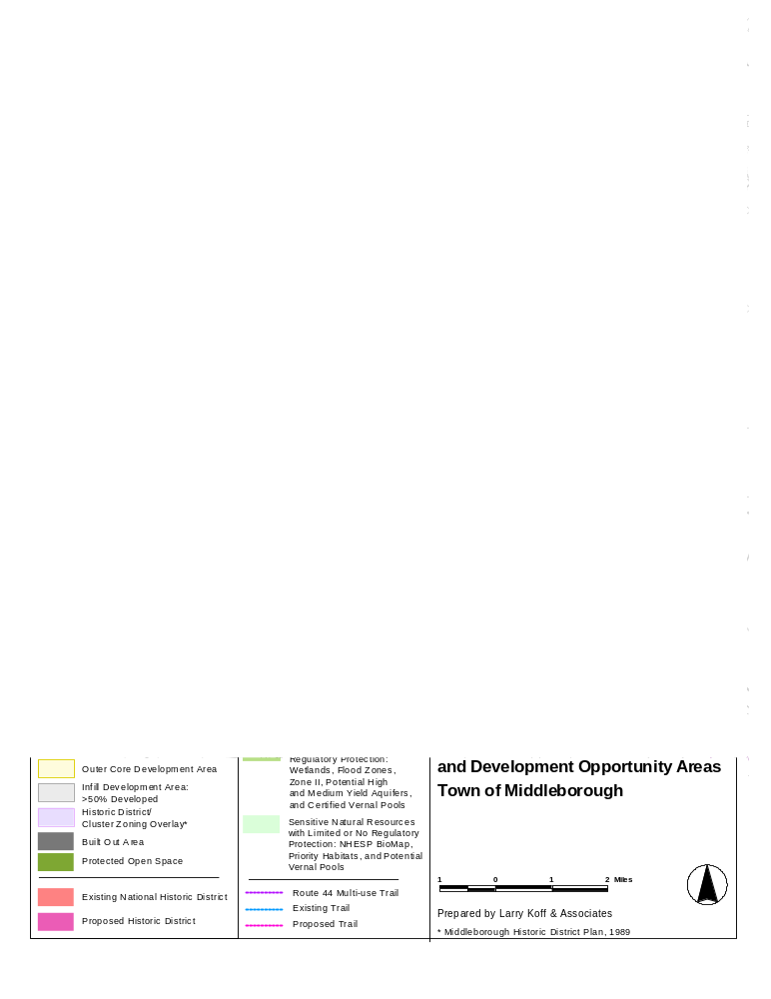
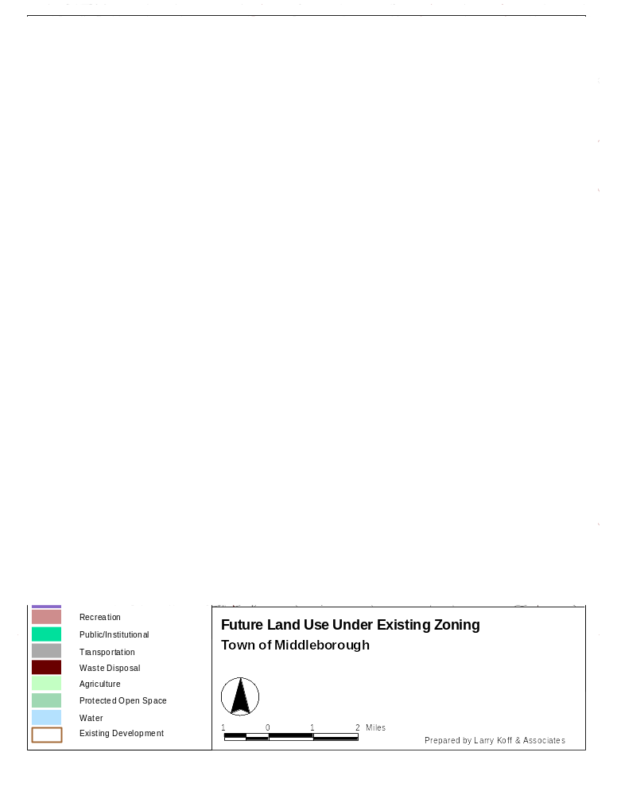
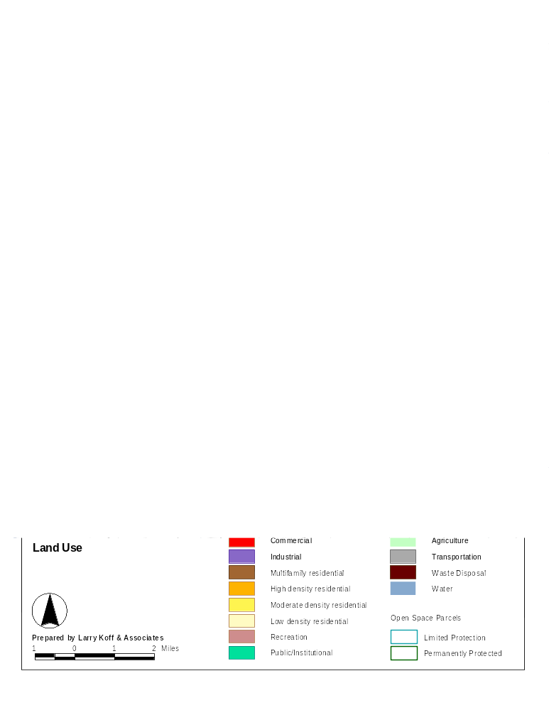
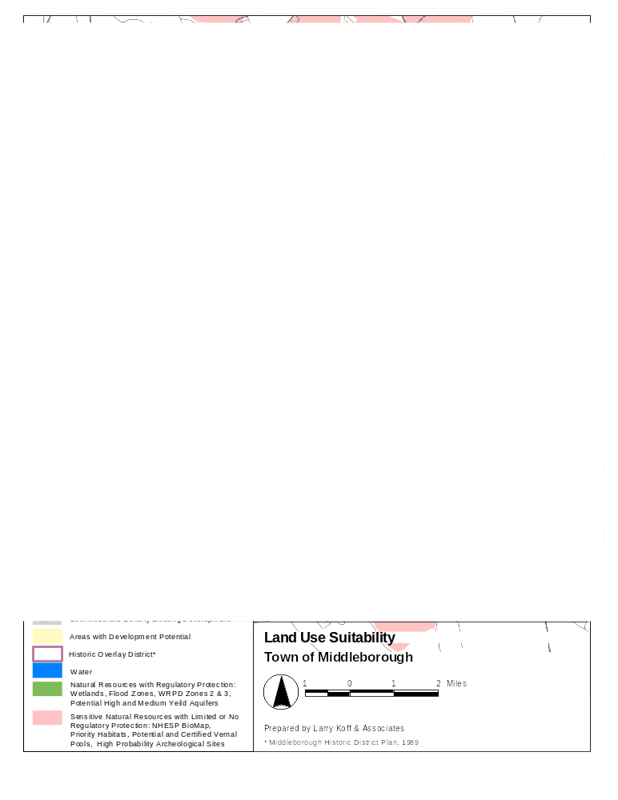

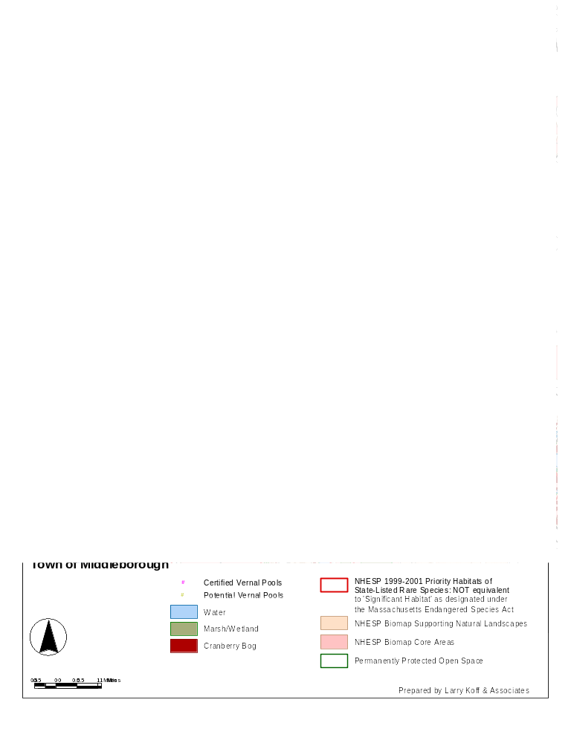
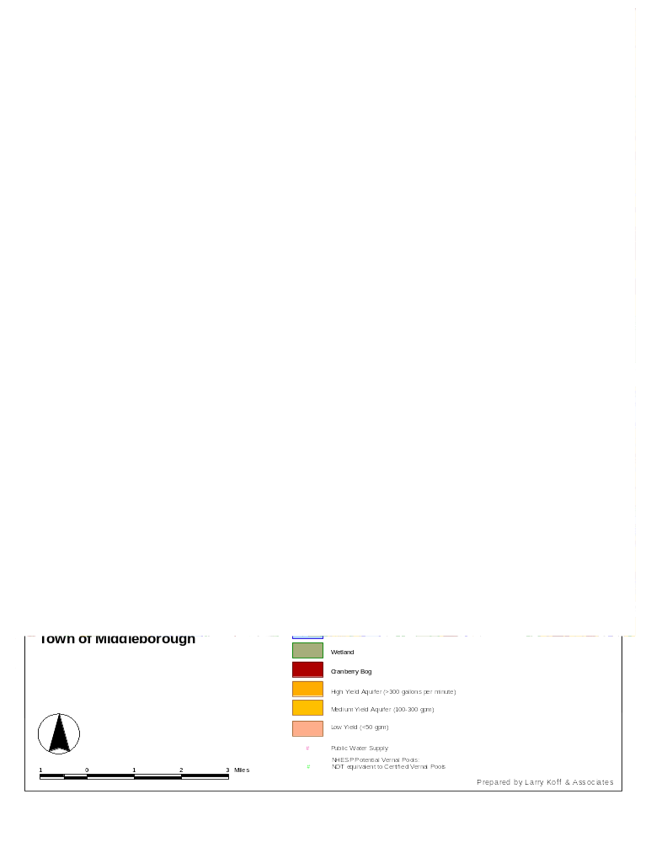

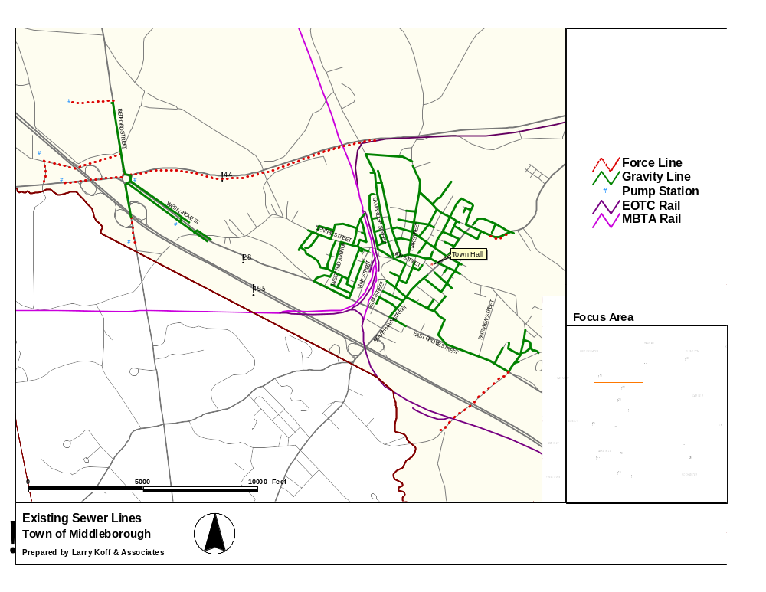
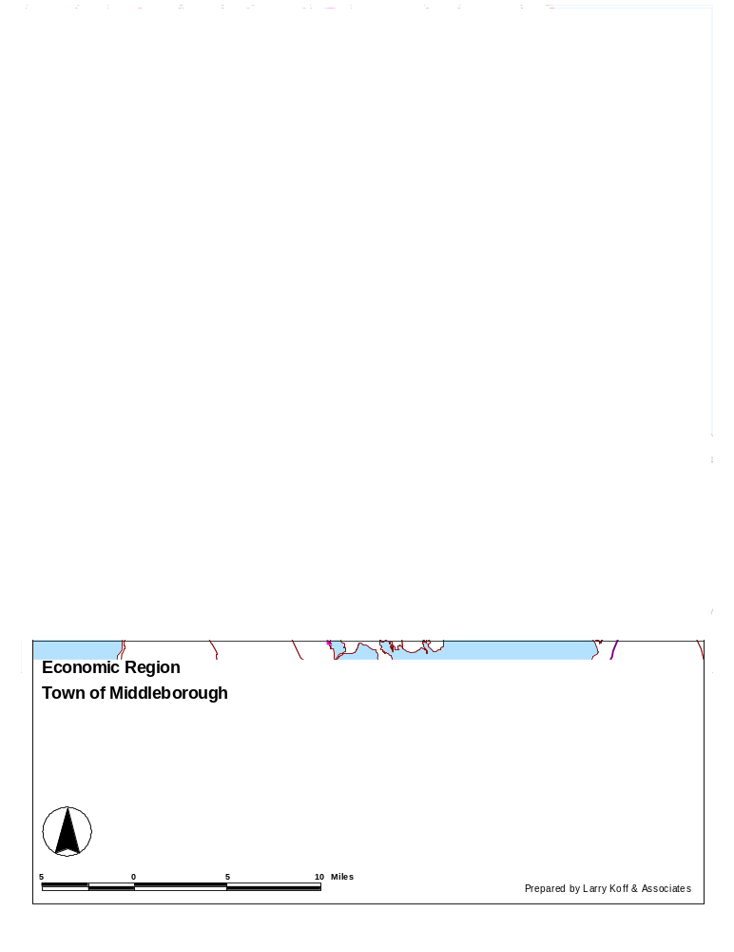

Middleborough Master Plan: Report On Findings and Alternatives, Revised, Cecil Group, February,2002
Median sales price indicates that 50% of home sales were above this level and 50% were below. Median is used rather than average so that the figure is not skewed by unusually high or low sales prices.
A Decade of Change: Growth Trends in the Greater Boston Area – 1990 to 2000. Metropolitan Area Planning Council, 2001.
"Toy towns" from CommonWealth, Special Issue 2002: Education Reform.
According to HUD, the median income for 2002 is $70,300 (see Appendix 5). This figure is used for many housing subsidy programs; however DHCD has chosen to retain the 2000 median income figure for EO 418 planning purposes.
Home prices are from Banker and Tradesman; median incomes are from the 2000 U.S. Census.
FY2004 was intentionally left out because of an unusually high jump in residential values that year. We assume that residential values will continue to increase at the more moderate pace.
Water System Distribution Analysis, Amory Engineers, PC, July, 2003, pps vi-xi.
How to Evaluate a Project Under GL Chapter 40B, Horsley & Whitten, Inc., July 2001 p. 4
Comprehensive Permits and the Anti-Snob Zoning Act, Edith M. Neetter & Associates, April 2000, p. 6
Checklist of Affordability Issues Under Chapter 40B, CHAPA, June 2000
M.G.L. 760 CMR 31.07(1)(i) See also MGL Chapter 40B Guidelines for Planned Production Regulation, Department of Housing and Community Development.
Local Initiative Program Guidelines. Department of Housing & Community Development. August 2002.
Getting Started: Building Local Housing Partnerships, Appendix F

